Multiple Choice: Write your answers on the answer sheet provided. Allow thirty minutes. (2 points each for 60 points total)

1. A revolver would be considered a:
a. | handgun | c. | shotgun
b. | rifle | d. | air gun

2. A single shot or bullet in a shotgun shell is called a:
a. | shot | c. | slug
b. | gauge | d. | bore

3. Which of the following leave marks on the cartridge?
a. | extractor | d. | chamber
b. | ejector | e. | all of these leave marks
c. | magazine | f. | only c and d leave marks

4. As a bullet leaves the muzzle of a weapon, it carries along with it some of the unburned particles as well as combustion products primarily coming from:
a. | citrates | c. | the oxygen in the air
b. | nitrates | d. | any of these

5. Which of the following shows an individual characteristic of shoe prints.
a. | manufacturer | c. | damage to the sole
b. | shoe type | d. | shoe size

6. Which of the following is NOT a class characteristic of tire impressions?
a. | a tear in the tread | d. | model
b. | size | e. | all of these are class characteristics
c. | type | f. | none of these are class characteristics

7. Bitemarks were the prime evidence against which of the following serial killers.
a. | BTK | c. | The Green River Killer
b. | Ted Bundy | d. | Son of Sam

8. A color test for the presence of nitrite in gunpowder residue is called:
a. | Greiss | c. | Greer
b. | Glaister | d. | sodium rhodizonate test

9. A color test for the presence of lead in gunshot residue is called:
a. | Greiss | c. | Greer
b. | Glaister | d. | sodium rhodizonate test

Use this diagram to answer 10 – 13

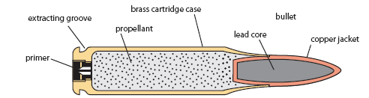
B
D
C

A

10. “A” in the above picture is the:
a. | cartridge casing | c. | primer
b. | propellant | d. | projectile

11. “B” in the above picture is the:
a. | cartridge casing | c. | primer
b. | projectile | d. | propellant

12. “C” in the above picture is the:
a. | cartridge casing | c. | primer
b. | propellant | d. | projectile

13. “D” in the above picture is the:
a. | cartridge casing | c. | primer
b. | projectile | d. | propellant

Use this diagram to answer 14 - 17
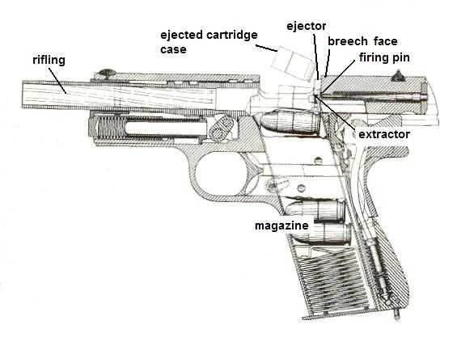
B
C
D
A

14. “A” in the above picture is the:
a. | firing pin | c. | magazine
b. | extractor | d. | rifling

15. “B” in the above picture is the:
a. | firing pin | c. | magazine
b. | extractor | d. | rifling

16. “C” in the above picture is the:
a. | firing pin | c. | magazine
b. | extractor | d. | rifling

17. “D” in the above picture is the:
a. | firing pin | c. | magazine
b. | extractor | d. | rifling

Use this diagram to answer 18 – 20
C
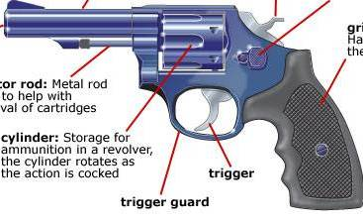

A

B

18. “A” in the above picture is the:
a. | hammer | c. | trigger
b. | cylinder | d. | ejector rod

19. “B” in the above picture is the:
a. | hammer | c. | trigger
b. | cylinder | d. | ejector rod

20. “C” in the above picture is the:
a. | hammer | c. | trigger
b. | cylinder | d. | ejector rod

21. The diameter of the bore of a firearm or the cartridge that is fired is called the (a)
a. | bore | c. | caliber
b. | rifle | d. | gauge

22. The interior diameter of a shot gun barrel as determined by the number of lead balls of a size exactly fitting the barrel that are required to make one pound.
a. | bore | c. | caliber
b. | rifle | d. | gauge

23. Parallel sets of scratches on a bullet caused by unique markings in the bore of a rifled weapon.
a. | striae | c. | breech
b. | magazine | d. | stance

24. The distance from the centerline of the right tire to the centerline of the left tire.
a. | striae | c. | breech
b. | magazine | d. | stance

25. A container that holds cartridges under spring pressure to be fed into the gun’s chamber.
a. | striae | c. | breech
b. | magazine | d. | stance

26. The standard method documenting impression evidence is
a. | casting | c. | putty
b. | biogreen | d. | photography

27. The part of the tooth DNA can usually be extracted from:
a. | pulp | c. | enamel
b. | cementum | d. | crown

28. Number of teeth in a healthy adult:
a. | 20 | c. | 28
b. | 32 | d. | 36

29. Which of the following is NOT relevant in postmortem dental examinations?
a. | presence/absence of tooth | c. | path of bullet
b. | unerupted teeth | d. | fillings or crowns

30. Which of the following would be true of a antemortem bite?
a. | diffused bruise | c. | defined bruise
b. | no bruise | d. | easy to make an impression of

Calculation: Interpol has asked for evidence from your file to compare similarities to crimes in France. You must convert your investigation measurements to metric. Write your answers on the answer sheet provided. Allow five minutes. (2 points each for 10 points total)

Helpful Hints and Formulas
(F - 32) x 5/9 = C  (C x 1.8) + 32 = F  1floz = 29.6ml | 1ft = 30.5cm  1in = 2.54cm  1oz = 28.3g

31. Your room measured 11 feet by 13 feet. How many squared meters?

32. The knife was 5.5 inches. How long is that in cm?

33. There were 8 ounces of methamphetamine recovered. How many g?

34. You recovered 9 fluid ounces of liquid explosive. How many ml?

35. The room was 78 degrees. What is the Celsius temperature?

Short Answer/Essay: 30 total points. Allow for fifteen minutes. Use the answer sheet to record your response. 10 points each.

1. Describe a way in which a cartridge could be individual evidence.

Describe a way in which a cartridge could be class evidence.

2. Give an example of how a tool could produce individual evidence.

3. A body is discovered that appears to be a suicide using a semiautomatic handgun shot to the temple inside a house. There is no apparent exit wound.

How would you prepare the body for transport to the morgue?

How would you handle/collect the gun?

What would you look for at the crime scene (specifically related to this unit of study)?

Once at the morgue what tests would be run on the victim?

