In this lab you will work with a partner to complete the following labs. Sections of the lab can be answered without the use of the equipment.
Each individual will complete their own packet. Be sure to draw your own conclusions based up what you observed. Equipment should be shared and combine efforts for the hands-on portion.

Forensic Anthropology Application

Parts of this lab came from Carolina Biological Supply Company (used with permission www.carolina.com)

Introduction
Forensic anthropologist can discern a great deal from bones. Gender, race, height, and sometimes even cause of death can be determined using scientific methods. However the methods used reflect a general estimate in most cases. Variation in the human species is quite broad; complications are not uncommon for a person to have a number of racial lineages. Nonetheless, these methods do provide investigators with important insight to identify of the deceased and often provide critical evidence in criminal cases.

Materials
- Tape measure
- Sample bones
- Sample skull
- Carolina Guide to Bone Forensics – reference
Case:
A landscaper cutting weeds on the campus has uncovered some bones and a skull on the edge of the athletic field. The principal recalls that a student who lived in the nearby neighborhood disappeared and was presumed a runaway just a few years ago. That student, Ben Gone, was a black male aged 15 and was around 5’9” in height. Could these bones be him? Only 2 long bones and the skull were found.
Procedures
Step One: Estimation of height
- To determine height one must first determine which bones one has. Look at the diagrams on the next page and determine which the “long bones” are.
Long Bones of the Human Arm and Leg

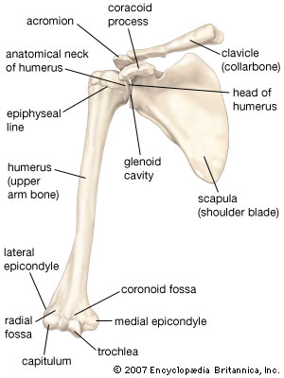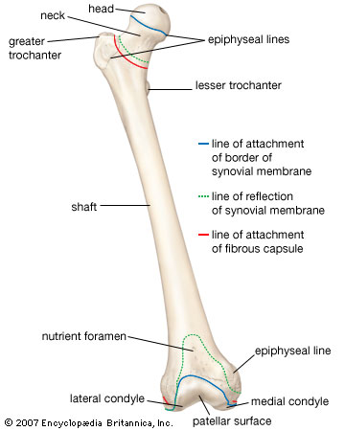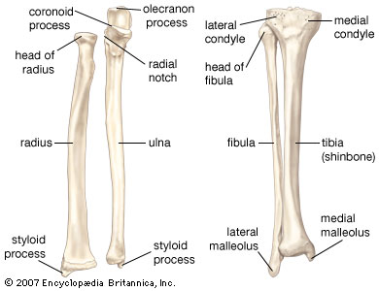
Femur

- Now measure the bones from the furthest point to furthest point in centimeters.
- Use the chart to calculate the estimated height. Remember that these are estimates and that age, race, nutrition, disease and other conditions in the variation of the human body can cause variations (think about Michael Phelps with his long legs and arms but short torso – great for swimming yet his bones would make us think he was much taller). The calculated height is generally accurate within 4cm. Since we do not yet know gender, calculate for both.

Bone | Male | Female
Humerus | 2.985 x H + 72.42cm | 3.22 x H + 61.32cm
Radius | 3.573 x R + 80.843cm | 3.756 x R + 74.72cm
Ulna | 3.5 x U + 76.338cm | 3.79 x U + 66.57cm
Femur | 2.27 x F + 67.985cm | 2.375 x F + 57.13cm
Tibia | 2.365 x T + 80.97cm | 2.675 x T + 65.625cm
Fibula | 2.4425 x F + 78.358cm | 2.71 x F + 65.255cm

Long bone #1 (the one with the hook looking end) calculations – show work below:

Estimated Height (in cm): Male: Female:

Estimated Height (in foot/inches): Male: Female:

Long bone #2 (the long and narrow one with rounded ends) calculations – show work below:

Estimated Height (in cm): Male: Female:

Estimated Height (in foot/inches): Male: Female:
Step Two: Estimation of Race
There are general differences in some anatomical features that are helpful in estimating race based on bones. Yet within any racial group there is great variation. Nonetheless, these differences are common enough to allow investigators to use them in cases. Look at the skull and then look at the chart below to look for clues. On each row make an “X” in each differentiation that you can determine. Ones you cannot determine leave blank. Once finished look at which race you identified differences with the most.
Feature | Caucasoid | Negrroid | Mongoloid
Skull Shape | Small, round | Long, large | Rounded, large
Cranial Length | Long | Long | Short
Cranial Breadth | Narrow | Narrow | Broad
Cranial Height | Medium to high | Low | Medium to high
Orbits | Sloping | Rectangular | Rounded
Interorbital Breadth | Intermediate | Wide | Narrow
Nasal Aperture | Narrow | Inverted heart | Round
Nasal Breadth | Narrow | Large | Medium to large
Inferior Nasal Spine | Sharp | Troughed | Dull
Anterior Nasal Spine | Long, broad, sharp | Short, rounded | Small
Chin | divided, two lobes | Blunt | Blunt
Chin | Prominent | Vertical | Vertical
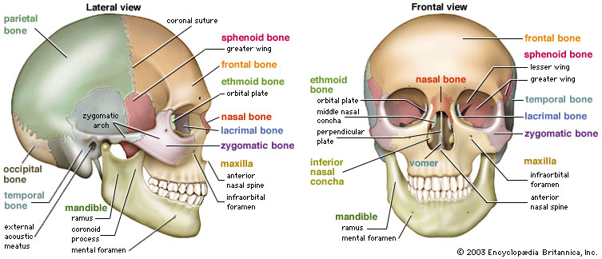
Not all anatomy from chart is identified in the diagram
Estimated Race:

Step Three: Estimation of Gender
There are differences between genders – Sexual Dimorphism. These are useful in determining the sex of unidentified remains. There are some variations within humans where gender is difficult to estimate. Also many bones do not give enough evidence by themselves. The pelvis and the skull give the investigator the best estimates when a complete skeleton is absent. Look at the skull once more and on each row mark the differences you can observe. Leave blank the ones you cannot. When done evaluate the results and estimate the gender. Refer to the skull diagram on the previous page.
Feature | Male | Female
Eye opening | Small in ratio to whole skull, square | Tend to be larger in ratio to skull, round
Brow ridges | Prominent and heavy (think fighter features) | Smooth, flat
Cheekbones | Heavy, laterally | Light, lack lateral arching
Occipital bump | Pronounced | Less pronounced, even non-existent
Chin | U shaped | V shaped
Forehead | Sloping, not as rounded | Vertical, fuller, rounder
Estimated Gender:
Conclusions:
1. Do the bones support the principal’s suggestion that the body might be that of Ben Gone? Explain your answer.

2. What other work at the crime scene might you suggest could uncover more clues?
3. What other lab work might be done to validate your conclusions about Ben Gone as well as lead to a positive identification with other missing persons cases?

4. What might have skewed your results and conclusions from the bone evidence?

