Multiple Choice: Write your answers on the answer sheet provided.

Allow fifteen minutes. (1 point each for 20 points total)

1. Generally, the body cools at a rate of about:
a. | 1 to 1 ½ degrees per hour | c. | 5 degrees per hour
b. | 3 degrees per hour | d. | 10 degrees per hour

ANS: A PTS: 1

2. Livor mortis first becomes fixed after:
a. | 5 hours | c. | 24 hours
b. | 12 hours | d. | 36 hours

ANS: B PTS: 1

3. The stiffening of muscles that occurs from approximately two to thirty hours after death is called:
a. | algor mortis | c. | rigor mortis
b. | livor mortis | d. | liver mortis

ANS: C PTS: 1

4. Which of the following does NOT affect rigor?
a. | environmental temperature | c. | the use of body muscles prior to death
b. | dehydration of the body | d. | all of these affect rigor

ANS: D PTS: 1

5. The rate of cooling of the body after death is called:
a. | algor mortis | c. | rigor mortis
b. | livor mortis | d. | liver mortis

ANS: A PTS: 1

6. The 3rd stage of complete metamorphosis of an insect:
a. | Pupa | c. | larva
b. | egg | d. | adult

ANS: A PTS: 1

7. Which variables would NOT affect the period of development of a particular species of fly?

a. | temperature | c. | rigor mortis
b. | drugs | d. | predators

ANS: C PTS: 1

8. Which conditions would NOT delay insect infestation?
a. | freezing | c. | burial
b. | drugs | d. | drowning

ANS: B PTS: 1

9. From bones, a forensic anthropologist would NOT be able to determine:
a. | race
b. | sex
c. | gender
d. | height
e. | weight
f. | all of these could be determined from bones

ANS: E PTS: 1

10. Human bones can be differentiated microscopically by looking at the osteons. Which of the following statements is true?
a. | in animals, the osteons form a regular pattern
b. | in humans, the osteons form a regular pattern
c. | animals have no osteons
d. | humans have no osteons

ANS: A PTS: 1

11. Which of the following is NOT a function of the skeletal system?
a. | protects vital organs
b. | supplies points of attachment for muscles
c. | produces blood cells
d. | serves as a storage area for minerals
e. | neither c nor d is a function of the skeletal system
f. | all of these are functions of the skeletal system

ANS: F PTS: 1

12. In humans, long bones include:
a. | femur, humerus, and scapula | c. | femur, humerus, tibia
b. | ulna, ribs, and sternum | d. | tarals, carpals, ulna

ANS: C PTS: 1

13. The ventral arc is a bony ridge on the human:
a. | skull | c. | femur
b. | pubic bone | d. | sternum

ANS: B PTS: 1

14. The gender of skeletal remains can be determined by examining:
a. | skull features | d. | only a and b
b. | the os pubis | e. | all of the above
c. | the relative size of bones

ANS: E PTS: 1

15. Sutures help to determine:
a. | height | c. | age
b. | weight | d. | race

ANS: C PTS: 1

16. All of the cranial sutures are usually closed in males by the age of:
a. | 15 | c. | 25
b. | 20 | d. | 35

ANS: D PTS: 1

17. Facial reconstruction is done on an unidentified skull to give:
a. | an accurate depiction of the deceased
b. | the age of the deceased at the time of death
c. | proportioning of facial features to help in recognition
d. | the cause of death

ANS: C PTS: 1

18. Which comes first in an autopsy of the following?
a. | the heart is examined
b. | the skull is opened
c. | the liver is removed
d. | the body is cleaned

ANS: B PTS: 1

19. What is primarily responsible for lividity? :
a. | gravity | c. | insects
b. | bacteria | d. | chemical changes in the muscle

ANS: A PTS: 1

20. What is primarily responsible for bloating? :
a. | gravity | c. | insects
b. | bacteria | d. | chemical changes in the muscle

ANS: B PTS: 1

Matching: Write your answers on the answer sheet provided. Allow fifteen minutes. (1 point each for 20 points total)

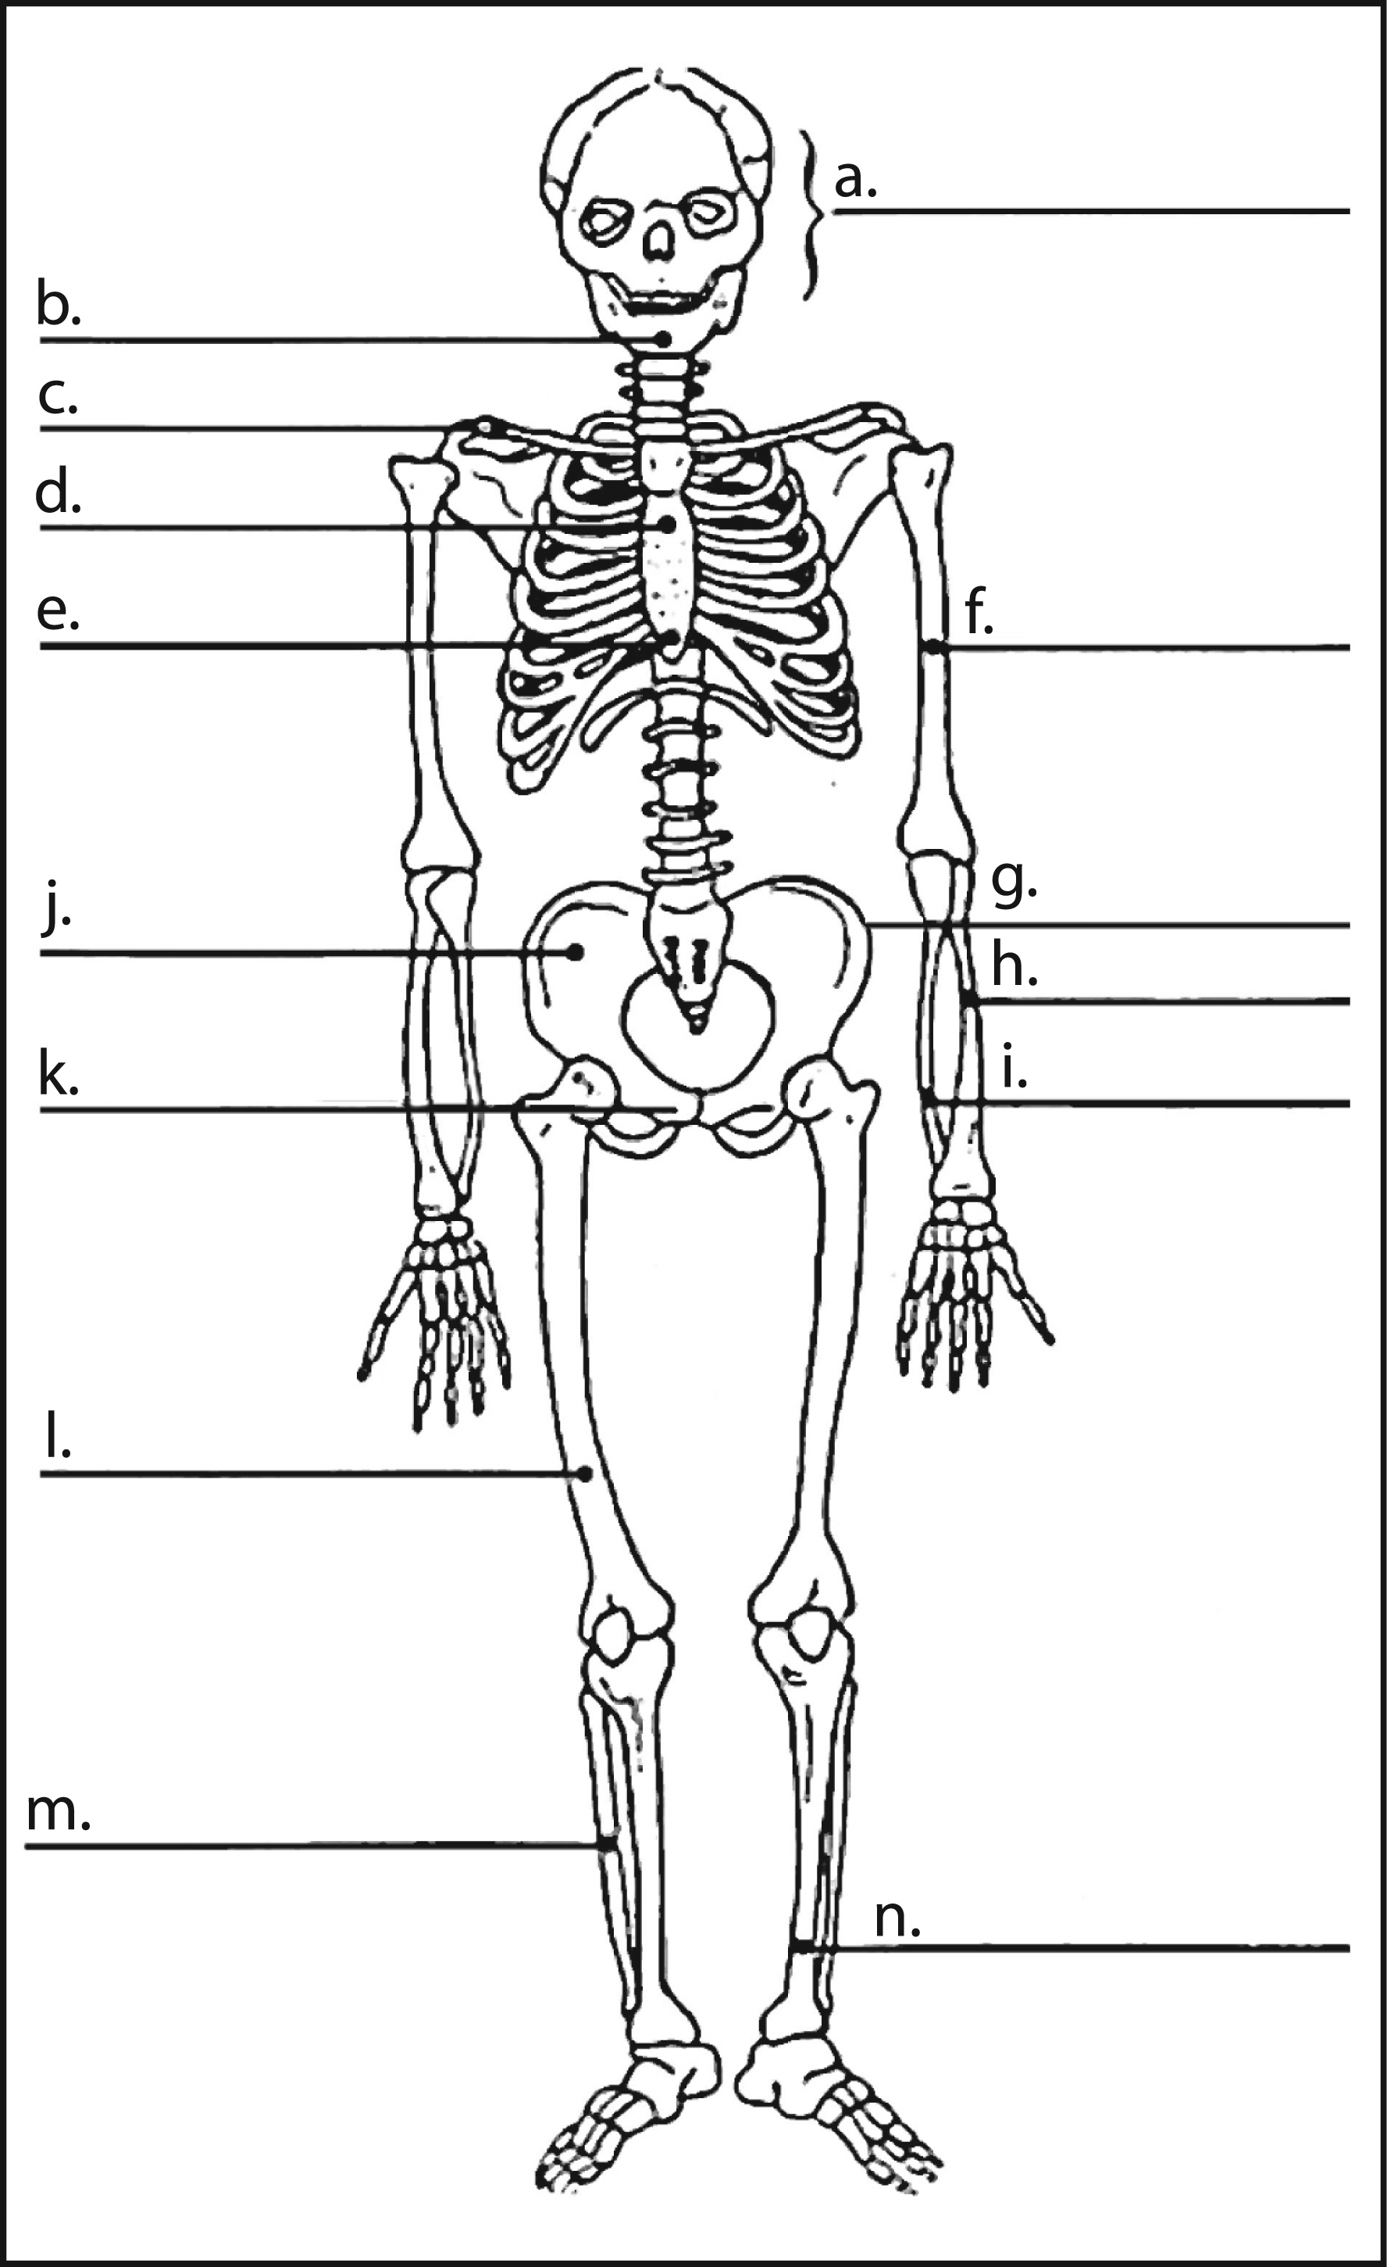
a. tibia
b. fibula
c. radius
d. humerus
e. femur
f. ulna

21. In the diagram letter “h” is:
22. In the diagram letter “l” is:
23. In the diagram letter “f” is:
24. In the diagram letter “m” is:
25. In the diagram letter “n” is:

21 – c
22 – e
23 – d
24 – b
25 – a

a. | livor | d. | rigor
b. | entomology | e. | autolysis
c. | algor

26. The study of insects and other arthropods is called _________b__________.
27. ________c___________ mortis refers to the cooling rate of the body after death.
28. ________a___________ mortis refers to the pooling of blood in the body after death.
29. ________d___________ mortis refers to the hardness of the skeletal muscles after death.
30. Process by which enzymes dissolve cells from the inside out, causing them to rupture and release fluids is called _________e__________.

a. | putrefaction | d. | eclosion
b. | diagenesis | e. | adipocere
c. | Taxonomy

31. Process in which there is destruction of soft tissue by bacteria is called _________a__________.
32. _________e__________ is usually a yellowish-white, greasy, wax-like substance that forms from the fat of the body.
33. The final stage of decomposition is _________b__________ in which the bone is chemically altered and may even mummify.
34. The emergence of an insect from the pupa is called _________d__________.
35. _________c__________ is the study of the classification of things in an orderly way that indicates natural relationships.

a. | Ambient | d. | molting
b. | Necrophagous | e. | carrion
c. | Arthropods

36. The class of animals that is characterized by jointed legs, a segmented body and a hard, outer skeleton is called _________c__________.
37. The carcass of a dead and decaying animal is termed ________e___________.
38. The shedding of an insect’s outer skeleton during a growth stage is called _________d__________.
39. The temperature surrounding the body is called __________a_________.
40. ________b___________ insects are those they feed on dead or dying organisms.

Calculation: While digging the new airport runway several human bones were uncovered. Nine families were notified that some of their relative’s remains may have been found at the old St. Charles Cemetery which was relocated to make room for the new runway. Which of the following deceased could the remains have come from? Use the bone length to compare to their height. Write your answers on the answer sheet provided. Allow ten minutes. (5 points for each correct bone identification for 15 points total)

Male Height, H

H = femur × 2.23 + 69.08
H = tibia × 2.39 + 81.68
H = humerus × 2.97 + 73.57
H = radius × 3.65 + 80.40
Female Height, H

H = femur × 2.21 + 61.41
H = tibia × 2.53 + 72.57
H = humerus × 3.14 + 64.97
H = radius × 3.87 + 73.50
Humerus found that was 27.5 cm, the radius was 23 cm, and the tibia was 26 cm.

DECEASED | Height  (ft. and in) | Height (cm) | Calculated  Humerus | Calculated  Radius | Calculated  Tibia
Willy Worm | 6’ 2”
Eileen Dover | 4’ 9”
Harry Mann | 5’5”
Mary Yeu | 5’ 7”
Evert Green | 5’ 10”
Dillion Pickle | 5’ 1”
(Charles)  C. U. Later | 6’ 3”
Sandra (Sandy) Beach | 4’ 6.5”
Sue Asidal | 4’ 2”

(one inch = 2.54 cm) Calculate and put into the chart only those numbers that help to substantiate your choice of whose bone it is!

Possible owner of the humerus:
Possible owner of the radius:
Possible owner of the tibia:

ANS:
Humerus: Dillion Pickle
Radius: Harry Mann
Tibia: Sandy Beach
PTS: 15

Short Answer/Essay: 45 total points. Allow for fifteen minutes. Use the answer sheet to record your response.

1. List the five stages of decomposition and give one characteristic of each. Five points.

ANS:
autolysis--enzymes dissolve cells from the inside out, skin blisters; skin sloughs off areas of the body
putrefaction--destruction of soft tissues; greenish cast to skin; body swells; gases are released; odor
black putrefaction--flesh of cream consistency; exposed body parts turn black; body collapses as gas escapes; very strong odor
butyric fermentation--cadaver drying out; some flesh remains at first; cheesy odor from the acid
diagenesis--cadaver dries; may mummify; slow rate of decay

2. Appraise the pelvis below and make a best estimate of the sex. Justify your answer. Five points.

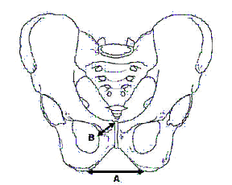
ANS:
Males have a narrower pubic body and arch (angle).

3. Appraise the skull below and make a best estimate of the race and the sex. Justify your answer. Five points.

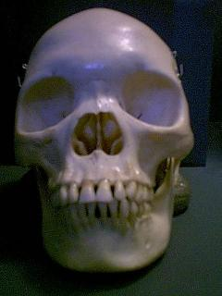
ANS:
Negroids-- | wide nasal aperture
 | rectangular palate
 | square orbits
 | more pronounced zygomatic arches

Male | Pronounced brow
 | Square jaw

4. You are training someone in collecting evidence at a crime scene where the body has been outdoors for 8 days. What are the best five guidelines you could give them for collecting entomology evidence? Five points.

Reasonable answers may vary

5. You work for the Medical Examiner. You are called out to a horse farm. A worker has found the owner at the bottom of the stairs to the loft dead. The call came in at 6:30 AM. The man is coolish to the touch. When you try to roll him over you find it difficult to do so as he is in full rigor. His liver temperature is 83.6 degrees. The autopsy reveals his neck was broken severely enough to stop all body functions.
Using all that you have learned give a best possible estimate of time of death. Also predict what the pathologist investigation conclusion will be for cause of death. Justify your answer. Ten points.

ANS: 8:30 PM, Undetermined or accident are acceptable answers provided they provide a good justification

6. The state mandates notice to the coroner/medical examiners office when a death occurs under eight circumstances. List them and also identify which one requires autopsy. Ten points.

ANS
- Violent
- Suicide
- Sudden w/ apparent good health
- Unattended by physician
- Suspicious, especially under 16 years of age
- Under 7 years of age unless expected REQUIRED AUTOPSY
- Execution
- Inmate of state facility

7. Many feel that the office of the coroner is a relic of the past and should be replaced by regional medical examiner offices. Explain your position. Five points

ANS: answer must be thought out, and should mention something from the history of the coroner.

