1. X B C D E F 26. X B C D E F
Calculation:

Determine the angle of impact for the blood droplet below:

Student answers should be around 20 degrees. Give a little based on their point of measurement.

The blood traveling from the:
- left to the right

- right to left?

2. A B X D E F 27. A X C D E F

3. A B X D E F 28. A X C D E F

4. A B X D E F 29. A X C D E F

5. A X C D E F 30. A B X D E F

6. A B C X E F 31. A X C D E F

7. A B X D E F 32. A B X D E F

8. A B C D X F 33. A B C D E X

9. X B C D E F 34. X B C D E F

10. A B X D E F 35. A B C X E F

11. A B C X E F 36. A B C X E F

12. A X C D E F 37. A B C D X F

13. A B C X E F 38. A X C D E F

14. A B X D E F 39. X B C D E F

15. A X C D E F 40. A B X D E F

16. A B C D X F 41. A B C D E X

17. A B X D E F 42. A B C X E F

18. A B X D E F 43. A B C D X F

19. A X C D E F 44. X B C D E F

20. A B C D X F 45. A X C D E F

21. X B C D E F

22. A X C D E F

23. A X C D E F

24. X B C D E F

25. A X C D E F
1. 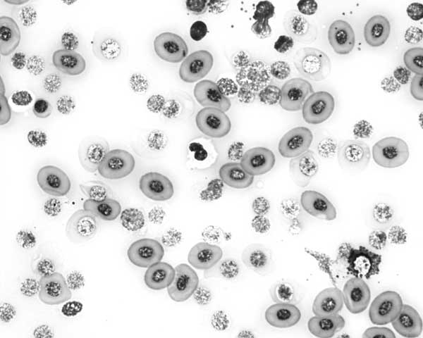

Is this human blood? Yes No

How do you know? Be specific. No, it is not human. The red blood cells are nucleated. Human erythrocytes are non-nucleic.

2. Label a red blood cell, a white blood cell and a platelet:
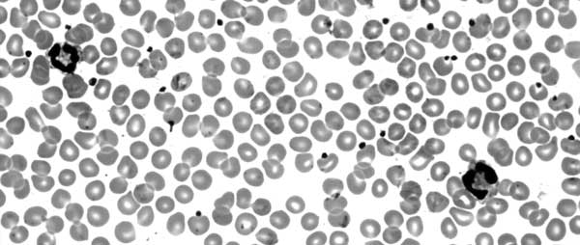
3. Considering how DNA can be process and analyzed what best example would it serve in the following
applications (give one example for each):

Medical: organ donors (others possible)

Civil Court: paternity (others possible)

Criminal Court: ID a suspect (others possible)

4. A woman was hit in the head several times in her bed in the middle of the night knocking her unconscious. She was then sexually assaulted. She is expected to survive. What best methods could you use to identify, analyze, and/or collect evidence for the following?

Semen evidence: collect bedding, others possible

Blood: Photograph, others possible

What personal protection would be best for this type crime scene? Gloves, shoe covers, mask, barrier suit or PPE

