Multiple Choice: Write your answers on the answer sheet provided. Allow twenty minutes. (1 point each for 30 points total)

1. Blood typing is considered
a. | a class characteristic | c. | both of these
b. | an individual characteristic | d. | neither of these

2. Investigators can individualize blood evidence by
a. | determining the blood group | c. | comparing the DNA from the cells
b. | observing the blood cells | d. | using the Kastle-Meyer test

3. To test whether or not a suspected stain is blood, an investigator could use the:
a. | secretor test | c. | Kastle-Meyer test
b. | Marquis test | d. | the precipitin test

4. Which of the following tests is the standard method for determining whether blood is human or animal?
a. | luminol | c. | precipitin
b. | Kastle-Meyer | d. | leucomalachite

5. The person responsible for the ABO classification system for blood is:
a. | Locard | c. | Weiner
b. | Landsteiner | d. | Lattes

6. What percentage of the population is a secretor?
a. | 20% | c. | 60%
b. | 40% | d. | 80%

7. A secretor is:
a. | someone whose blood type is O
b. | someone who can give their blood to anyone
c. | someone whose antigens are found in bodily fluids
d. | all of the above are true

8. A person with O blood could give blood to:
a. | A | d. | O
b. | B | e. | all of these
c. | AB | f. | none of these

9. The clumping of red blood cells is called:
a. | agglutination | c. | metabolism
b. | antibodies | d. | a blood factor

10. A gunshot wound close to the head would produce:
a. | low velocity spatter | c. | high velocity spatter
b. | medium velocity spatter | d. | none of these

11. A “tail” begins to form on blood stains at:
a. | 75 degrees | c. | 45 degrees
b. | 60 degrees | d. | 30 degrees

12. Acid phosphatase is a major constituent of:
a. | blood | d. | perspiration
b. | semen | e. | all of these
c. | saliva

13. The sequence of base pairs for all humans is:
a. | 0.1% the same | c. | 90% the same
b. | 10% the same | d. | 99.9% the same

14. Assume that two strands of DNA have been separated and that the base sequence on one strand is TTGC. What is the sequence of bases on the complimentary strand?
a. | GTAC | c. | AACG
b. | CGTT | d. | GCTA

15. A base, a sugar molecule and a phosphate group is called a
a. | protein | c. | gene
b. | nucleotide | d. | functional group

16. Which of the following is NOT a means of DNA typing?
a. | RFLP | d. | mitochondrial
b. | PCR | e. | all of these are means of DNA typing
c. | STR | f. | none of these are means of DNA typing

17. To characterize DNA using RFLP, the DNA must be cut into smaller pieces using:
a. | a probe | c. | restriction enzymes
b. | a prime | d. | all of these

18. A procedure that separates DNA fragments according to size is:
a. | chromatography | c. | electrophoresis
b. | mass spectrometry | d. | a restriction enzyme

19. PCR is a technique scientists use to:
a. | cut DNA into smaller fragments
b. | generate more copies of DNA when only a small amount is available
c. | separate DNA fragments so that they can be characterized
d. | remove mitochondria from the cell

20. Evidence from a crime scene that can be used for DNA typing includes:
a. | saliva | d. | vaginal secretions
b. | semen | e. | all of these
c. | hair follicles | f. | none of these

21. DNA from nucleated cells is inherited from:
a. | the mother and father | c. | only the father
b. | only the mother | d. | none of these is true

22. Mitochondria DNA (mtDNA) is inherited from:
a. | the mother and the father | c. | only the father
b. | only the mother | d. | none of these is true

23. What is used to separate the DNA molecule in the PCR process?
a. | freezing | c. | electrophoresis
b. | heating | d. | cooling

24. STR’s are amplified by using:
a. | PCR | c. | RFLP
b. | electrophoresis | d. | a mass spectrometer

25. The database that stores DNA profiles is:
a. | IBIS | c. | AFIS
b. | CODIS | d. | IAFIS

26. Which of the following is NOT true about mitochondrial DNA?
a. | it is less sensitive technique than nuclear
b. | it is more costly
c. | it can be done with small and degraded quantities of DNA
d. | it contains several loops of DNA
e. | all of these are true

27. Chromosomes are found in the:
a. | mitochondria | c. | cytoplasm
b. | nucleus | d. | cell membrane

28. Humans have:
a. | 23 pair of body chromosomes and 1 pair of sex chromosomes
b. | 22 pair of body chromosomes and 1 pair of sex chromosomes
c. | 20 pair of body chromosomes and 4 pair of sex chromosomes
d. | 22 body chromosomes and 1 pair of sex chromosomes

29. An enzyme that assembles a new DNA strand in the proper base sequence determined by the original strand is called:
a. | polymer | c. | primer
b. | polymerase | d. | restriction enzyme

30. An exact location on the DNA molecule of a gene or area on interest is called:
a. | a chromosome | c. | a loci
b. | a fingerprint | d. | a nucleotide

Matching: Write your answers on the answer sheet provided. Allow ten minutes. (1 point each for 15 points total)

a. | angle of impact
b. | back spatter
c. | BSA
d. | cast-off pattern
e. | directionality
f. | expirated blood

31. blood directed back toward the source of energy or force that caused the spatter
32. A field of forensic science that deals with the properties of blood and the patterns produced under different conditions
33. blood that is blown out of the nose, mouth, or a wound as a result of air pressure
34. the acute angle formed between the direction of a blood drop and the plane of the surface it strikes
35. pattern created when blood is released or thrown from a moving blood-bearing object

a. | flow pattern
b. | high velocity impact
c. | impact site
d. | low velocity impact
e. | point of convergence
f. | arc sin

36. spatter that produces the largest blood droplets

37. common area on a two-dimensional surface over which the directionality of several blood drops can be retraced
38. spatter that produces the smallest blood droplets
39. a change in the shape and direction of a blood stain due to the influence of gravity or movement of the object

40. the point where force meets a blood source

a. | passive drop
b. | point of origin
c. | spine
d. | swipe pattern
e. | target
f. | wipe pattern

41. A bloodstain pattern created when an object moves through an existing stain, removing it or changing its appearance
42. transfer of blood from a moving source onto an unstained surface
43. surface onto which blood is deposited
44. bloodstain formed by the force of gravity acting alone
45. common area in a three-dimensional space to which the trajectories of several blood drops can be retraced

Calculation: 15 Points. Allow for five minutes.

1. Determine the angle of impact for the blood droplet below. Show your work ON YOUR ANSWER SHEET
Selected Sine for solving this problem
Angle (º) Sine
10 .174
12 .208
14 .242
16 .276
18 .309
20 .342
22 .375
24 .407
26 .428
28 .469
30 .500

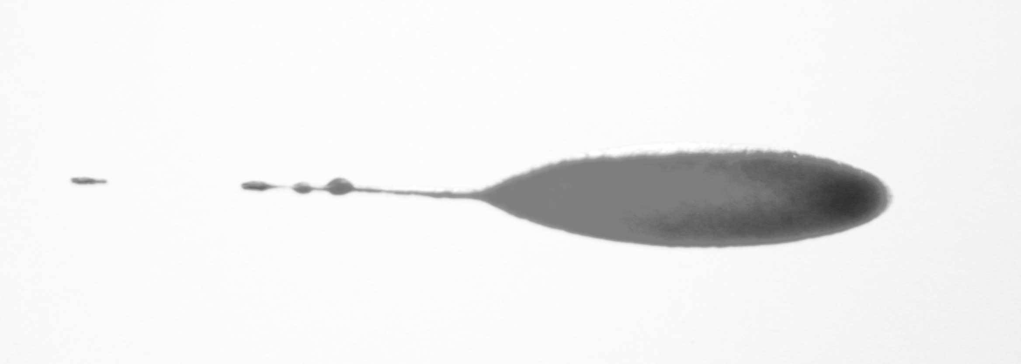
31 mm
21 mm
7 mm

Was the blood traveling from the left to the right or right to left?

Short Answer/Essay: 40 total points. Allow for fifteen minutes. Use the answer sheet to record your response.

1. 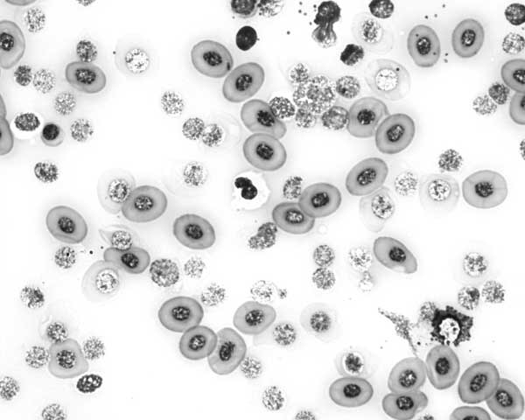

Is this human blood?

How do you know? Be specific.

2. Draw a line and label a red blood cell, a white blood cell and a platelet.

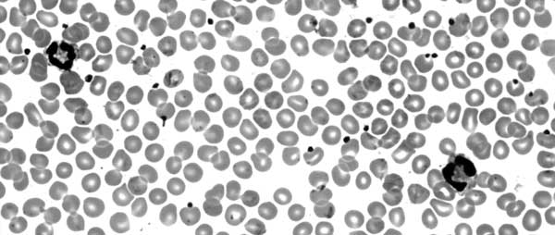

3. Considering how DNA can be process and analyzed what best example would it serve in the following applications (give one example for each):

Medical:

Civil Court:

Criminal Court:

4. A woman was hit in the head several times in her bed in the middle of the night knocking her unconscious. She was then sexually assaulted. She is expected to survive. What best methods could you use to identify, analyze, and/or collect evidence for the following?

Semen evidence:

Blood:

What personal protection would be best for this type crime scene?

