1. A B C D E F 26. A B C D E F
Calculation:

Determine the angle of impact for the blood droplet below:

The blood traveling from the:
- left to the right

- right to left?

2. A B C D E F 27. A B C D E F

3. A B C D E F 28. A B C D E F

4. A B C D E F 29. A B C D E F

5. A B C D E F 30. A B C D E F

6. A B C D E F 31. A B C D E F

7. A B C D E F 32. A B C D E F

8. A B C D E F 33. A B C D E F

9. A B C D E F 34. A B C D E F

10. A B C D E F 35. A B C D E F

11. A B C D E F 36. A B C D E F

12. A B C D E F 37. A B C D E F

13. A B C D E F 38. A B C D E F

14. A B C D E F 39. A B C D E F

15. A B C D E F 40. A B C D E F

16. A B C D E F 41. A B C D E F

17. A B C D E F 42. A B C D E F

18. A B C D E F 43. A B C D E F

19. A B C D E F 44. A B C D E F

20. A B C D E F 45. A B C D E F

21. A B C D E F

22. A B C D E F

23. A B C D E F

24. A B C D E F

25. A B C D E F
1. 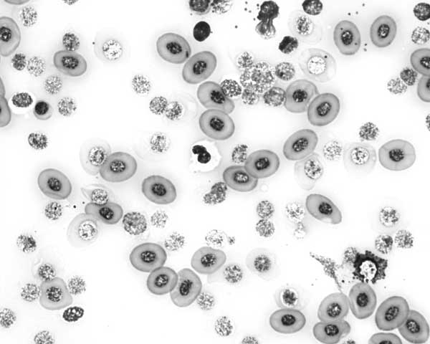

Is this human blood? Yes No

How do you know? Be specific.

2. Label a red blood cell, a white blood cell and a platelet:
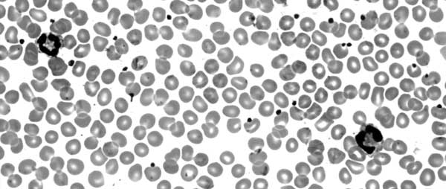
3. Considering how DNA can be process and analyzed what best example would it serve in the following
applications (give one example for each):

Medical:

Civil Court:

Criminal Court:

4. A woman was hit in the head several times in her bed in the middle of the night knocking her unconscious. She was then sexually assaulted. She is expected to survive. What best methods could you use to identify, analyze, and/or collect evidence for the following?

Semen evidence:

Blood:

What personal protection would be best for this type crime scene?

