Multiple Choice: Write your answers on the answer sheet provided. Allow twenty minutes. (1 point each for 30 points total)

1. Blood typing is considered
a. | a class characteristic | c. | both of these
b. | an individual characteristic | d. | neither of these

ANS: A PTS: 1

2. Investigators can individualize blood evidence by
a. | determining the blood group | c. | comparing the DNA from the cells
b. | observing the blood cells | d. | using the Kastle-Meyer test

ANS: C PTS: 1

3. To test whether or not a suspected stain is blood, an investigator could use the:
a. | secretor test | c. | Kastle-Meyer test
b. | Marquis test | d. | the precipitin test

ANS: C PTS: 1

4. Which of the following tests is the standard method for determining whether blood is human or animal?
a. | luminol | c. | precipitin
b. | Kastle-Meyer | d. | leucomalachite

ANS: C PTS: 1

5. The person responsible for the ABO classification system for blood is:
a. | Locard | c. | Weiner
b. | Landsteiner | d. | Lattes

ANS: B PTS: 1

6. What percentage of the population is a secretor?
a. | 20% | c. | 60%
b. | 40% | d. | 80%

ANS: D PTS: 1

7. A secretor is:
a. | someone whose blood type is O
b. | someone who can give their blood to anyone
c. | someone whose antigens are found in bodily fluids
d. | all of the above are true

ANS: C PTS: 1

8. A person with O blood could give blood to:
a. | A | d. | O
b. | B | e. | all of these
c. | AB | f. | none of these

ANS: E PTS: 1

9. The clumping of red blood cells is called:
a. | agglutination | c. | metabolism
b. | antibodies | d. | a blood factor

ANS: A PTS: 1

10. A gunshot wound close to the head would produce:
a. | low velocity spatter | c. | high velocity spatter
b. | medium velocity spatter | d. | none of these

ANS: C PTS: 1

11. A “tail” begins to form on blood stains at:
a. | 75 degrees | c. | 45 degrees
b. | 60 degrees | d. | 30 degrees

ANS: D PTS: 1

12. Acid phosphatase is a major constituent of:
a. | blood | d. | perspiration
b. | semen | e. | all of these
c. | saliva

ANS: B PTS: 1
13. The sequence of base pairs for all humans is:
a. | 0.1% the same | c. | 90% the same
b. | 10% the same | d. | 99.9% the same

ANS: D PTS: 1

14. Assume that two strands of DNA have been separated and that the base sequence on one strand is TTGC. What is the sequence of bases on the complimentary strand?
a. | GTAC | c. | AACG
b. | CGTT | d. | GCTA

ANS: C PTS: 1

15. A base, a sugar molecule and a phosphate group is called a
a. | protein | c. | gene
b. | nucleotide | d. | functional group

ANS: B PTS: 1

16. Which of the following is NOT a means of DNA typing?
a. | RFLP | d. | mitochondrial
b. | PCR | e. | all of these are means of DNA typing
c. | STR | f. | none of these are means of DNA typing

ANS: E PTS: 1

17. To characterize DNA using RFLP, the DNA must be cut into smaller pieces using:
a. | a probe | c. | restriction enzymes
b. | a prime | d. | all of these

ANS: C PTS: 1

18. A procedure that separates DNA fragments according to size is:
a. | chromatography | c. | electrophoresis
b. | mass spectrometry | d. | a restriction enzyme

ANS: C PTS: 1

19. PCR is a technique scientists use to:
a. | cut DNA into smaller fragments
b. | generate more copies of DNA when only a small amount is available
c. | separate DNA fragments so that they can be characterized
d. | remove mitochondria from the cell

ANS: B PTS: 1

20. Evidence from a crime scene that can be used for DNA typing includes:
a. | saliva | d. | vaginal secretions
b. | semen | e. | all of these
c. | hair follicles | f. | none of these

ANS: E PTS: 1

21. DNA from nucleated cells is inherited from:
a. | the mother and father | c. | only the father
b. | only the mother | d. | none of these is true

ANS: A PTS: 1

22. Mitochondria DNA (mtDNA) is inherited from:
a. | the mother and the father | c. | only the father
b. | only the mother | d. | none of these is true

ANS: B PTS: 1

23. What is used to separate the DNA molecule in the PCR process?
a. | freezing | c. | electrophoresis
b. | heating | d. | cooling

ANS: B PTS: 1

24. STR’s are amplified by using:
a. | PCR | c. | RFLP
b. | electrophoresis | d. | a mass spectrometer

ANS: A PTS: 1

25. The database that stores DNA profiles is:
a. | IBIS | c. | AFIS
b. | CODIS | d. | IAFIS

ANS: B PTS: 1

26. Which of the following is NOT true about mitochondrial DNA?
a. | it is less sensitive technique than nuclear
b. | it is more costly
c. | it can be done with small and degraded quantities of DNA
d. | it contains several loops of DNA
e. | all of these are true

ANS: A PTS: 1

27. Chromosomes are found in the:
a. | mitochondria | c. | cytoplasm
b. | nucleus | d. | cell membrane

ANS: B PTS: 1

28. Humans have:
a. | 23 pair of body chromosomes and 1 pair of sex chromosomes
b. | 22 pair of body chromosomes and 1 pair of sex chromosomes
c. | 20 pair of body chromosomes and 4 pair of sex chromosomes
d. | 22 body chromosomes and 1 pair of sex chromosomes

ANS: B PTS: 1

29. An enzyme that assembles a new DNA strand in the proper base sequence determined by the original strand is called:
a. | polymer | c. | primer
b. | polymerase | d. | restriction enzyme

ANS: B PTS: 1

30. An exact location on the DNA molecule of a gene or area on interest is called:
a. | a chromosome | c. | a loci
b. | a fingerprint | d. | a nucleotide

ANS: C PTS: 1

Matching: Write your answers on the answer sheet provided. Allow ten minutes. (1 point each for 15 points total)

a. | angle of impact
b. | back spatter
c. | BSA
d. | cast-off pattern
e. | directionality
f. | expirated blood

31. blood directed back toward the source of energy or force that caused the spatter B
32. A field of forensic science that deals with the properties of blood and the patterns produced under different conditions C
33. blood that is blown out of the nose, mouth, or a wound as a result of air pressure F
34. the acute angle formed between the direction of a blood drop and the plane of the surface it strikes A
35. pattern created when blood is released or thrown from a moving blood-bearing object D

a. | flow pattern
b. | high velocity impact
c. | impact site
d. | low velocity impact
e. | point of convergence
f. | arc sin

36. spatter that produces the largest blood droplets D

37. common area on a two-dimensional surface over which the directionality of several blood drops can be retraced E
38. spatter that produces the smallest blood droplets B
39. a change in the shape and direction of a blood stain due to the influence of gravity or movement of the object A

40. the point where force meets a blood source C

a. | passive drop
b. | point of origin
c. | spine
d. | swipe pattern
e. | target
f. | wipe pattern

41. A bloodstain pattern created when an object moves through an existing stain, removing it or changing its appearance F
42. transfer of blood from a moving source onto an unstained surface D
43. surface onto which blood is deposited E
44. bloodstain formed by the force of gravity acting alone A
45. common area in a three-dimensional space to which the trajectories of several blood drops can be retraced B

Calculation: 15 Points. Allow for five minutes.

1. Determine the angle of impact for the blood droplet below. Show your work.

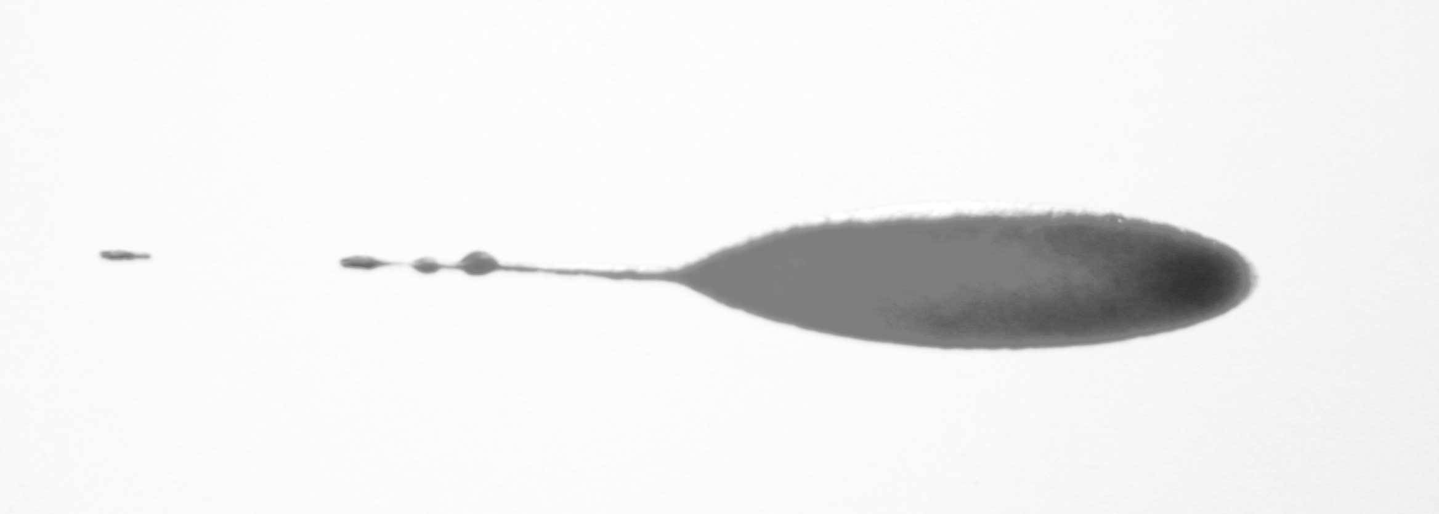
31 mm
21 mm
7 mm

Selected Sine for solving this problem
Angle (º) Sine
10 .174
12 .208
14 .242
16 .276
18 .309
20 .342
22 .375
24 .407
26 .428
28 .469
30 .500

Was the blood traveling from the left to the right or right to left?

ANS:
Student answers should be around 20 degrees. Give a little based on their point of measurement.

The blood was traveling from right to left.

PTS: 15

Short Answer/Essay: 40 total points. Allow for fifteen minutes. Use the answer sheet to record your response.

1. 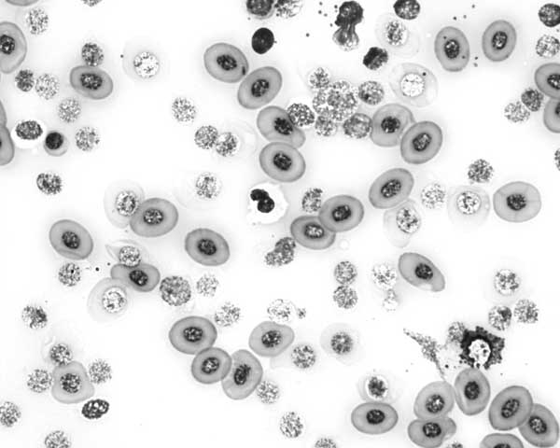

Is this human blood?

How do you know? Be specific.

ANS:
No, it is not human. The red blood cells are nucleated. Human erythrocytes are non-nucleic.

PTS: 10

2. Draw a line and label a red blood cell, a white blood cell and a platelet.

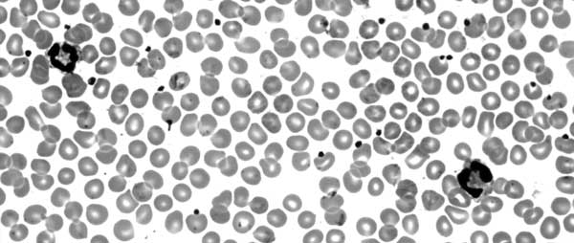

ANS:
Answers will vary, but the two large nucleated cells are white blood cells. The majority of the rest of the cells are red. The tiny dots in the plasma are platelets.

PTS: 10

3. Considering how DNA can be process and analyzed what best example would it serve in the following applications (give one example for each):

Medical:

Civil Court:

Criminal Court:

ANS:
Various – most likely organs, paternity, and ID a suspect

PTS: 10

4. A woman was hit in the head several times in her bed in the middle of the night knocking her unconscious. She was then sexually assaulted. She is expected to survive. What best methods could you use to identify, analyze, and/or collect evidence for the following?

Semen evidence:

Blood:

What personal protection would be best for this type crime scene?

ANS:
Answers will vary, but MUST mention collecting all bedding for first two and gloves/shoe covers/face mask for the last

PTS: 10

