1. A B X D E F 2 Point Questions: 26. A X C D E F

2. X B C D E F 27. X B C D E F

3. A B C X E F 28. A B X D E F

4. A X C D E F 29. A B C X E F

5. X B C D E F 30. A X C D E F

6. A B X D E F 31. A B C D X F

7. A B C D X F 32. A B C X E F

8. A X C D E F 33. X B C D E F

9. A B X D E F 34. A B X D E F

10. A B C X E F 35. A X C D E F

11. A X C D E F
Calculations: Put your final answer in the box
31. Determine the R_{f} for the diagram. Show your work.

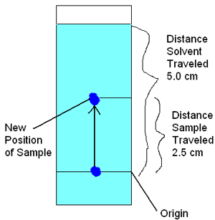

12. X B C D E F

13. A X C D E F

14. A B C X E F

15. A B C D E X

16. X B C D E F

17. A X C D E F

18. A B X D E F

19. A X C D E F

20. A B C X E F

21. A X C D E F

22. A X C D E F
The R_{f} is: 0.5

23. A B X D E F

24. A X C D E F

25. X B C D E F
Short Answer/Essay: 50 total points. 10 points each. Allow for 15 minutes.

1. What is the difference between a presumptive and a confirmatory test?
Presumptive: determine if a substance is present

Example: Examples will vary.

Confirmatory: type of substance is verified

Example: Examples will vary.

- Describe gas chromatography.
A mobile phase of inert gas pushes a sample through a stationary phase of a solid or viscous gas. The sample separates into its components as it goes through. As the components exit the stationary phase they are measured in time through the stationary phase as well as proportion of the sample.
What part does it play in a GCMS machine?
As a part of the GCMS it separates the sample into its components thus allowing for the MS to identify the components.

3. Describe the role of a forensic toxicologist in a post-mortem investigation.
Looks for causes of death that might be related to poisons, drugs and alcohol related.

What limits their ability to successfully investigate a death?
They rely heavily on local investigators, family, and ME/coroners for information.

4. You are training a new crime scene processor. You are at a meth lab with several kilos of processed meth, over $20,000 in cash, and an extensive lab set up. What advice do you give the person you are training?
Call HazMat for clean up
Use general procedures for processing evidence
Vigilant chain of evidence
Watch sharps/needles
Use common sense – don’t taste the drugs

5. In your opinion – which is the worst of the drugs we studied? Be sure to justify your opinion (with things like facts).
Multiple possible – MUST justify their answer

