1. A B C D E F 2 Point Questions: 26. A B C D E F

2. A B C D E F 27. A B C D E F

3. A B C D E F 28. A B C D E F

4. A B C D E F 29. A B C D E F

5. A B C D E F 30. A B C D E F

6. A B C D E F 31. A B C D E F

7. A B C D E F 32. A B C D E F

8. A B C D E F 33. A B C D E F

9. A B C D E F 34. A B C D E F

10. A B C D E F 35. A B C D E F

11. A B C D E F
Calculations: Put your final answer in the box
31. Determine the R_{f} for the diagram. Show your work.

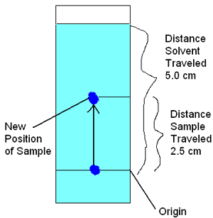

12. A B C D E F

13. A B C D E F

14. A B C D E F

15. A B C D E F

16. A B C D E F

17. A B C D E F

18. A B C D E F

19. A B C D E F

20. A B C D E F

21. A B C D E F

22. A B C D E F
The R_{f} is:

23. A B C D E F

24. A B C D E F

25. A B C D E F
Short Answer/Essay: 50 total points. 10 points each. Allow for 15 minutes.

1. What is the difference between a presumptive and a confirmatory test?
Presumptive:

Example:

Confirmatory:

Example:

- Describe gas chromatography.

What part does it play in a GCMS machine?
.
3. Describe the role of a forensic toxicologist in a post-mortem investigation.

What limits their ability to successfully investigate a death?

4. You are training a new crime scene processor. You are at a meth lab with several kilos of processed meth, over $20,000 in cash, and an extensive lab set up. What advice do you give the person you are training?

5. In your opinion – which is the worst of the drugs we studied? Be sure to justify your opinion (with things like facts).

