Complete the Model (two points per blank): Fill in the FLETC Use of Force Model on your answer sheet. Make sure you specify level color as well as both sides of the steps. Also fill in the blanks in the boxes at the bottom. Allow ten minutes. 34 total points.

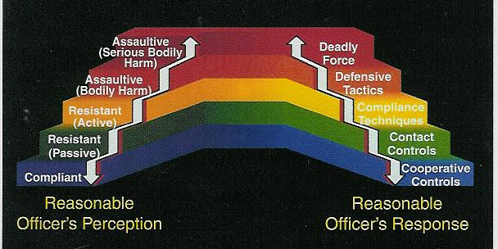

Mark your answers from the Multiple Choice sections below. 2 points each.

Strike through correct answer (do not circle): Ex. 1. A B C D E F

1. A B C D E F 9. A B C D E

2. A B C D E F 10. A B C D E

3. A B C D E F 11. A B C D E

4. A B C D E F 12. A B C D E

5. A B C D E F 13. A B C D E

6. A B C D E F 14. A B C D E F

7. A B C D E F 15. A B C D E F

8. A B C D E F
Scenarios: Evaluate each of the three video scenarios and answer the questions below. Three points for each question for each of the three scenarios. 18 points total.

Scenario #1:
1. Could the officer be justified in using deadly force?

2. Explain why or why not (if why not – what level of force would be best)?

Scenario #2:
1. Could the officer be justified in using deadly force?

2. Explain why or why not (if why not – what level of force would be best)?

Scenario #3:
1. Could the officer be justified in using deadly force?

2. Explain why or why not (if why not – what level of force would be best)?

