Use of Force: Introduction to Law & Justice Unit 6
Federal Law Enforcement Training Center (FLTEC) Use of Force
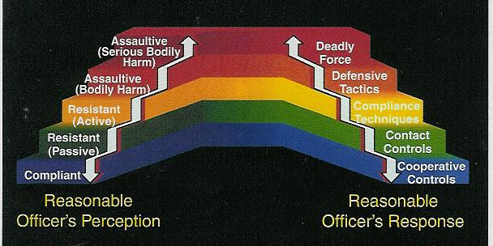

Use of Force Issues
- The purpose of any force use is to gain ______________
- Pain cannot be used to ______________
- Police are allowed to use a ______________level of force than the suspect
- We don’t have to fight ______________
Use of Force Issues
- Must go by what officer ______________at the time
- Gun found to be unloaded not an issue
- Weapon can be ______________: car, chair, or anything else that may cause death or serious injury
- Reasonableness” is the ______________
- ______________force not required
Reasonableness
Factors:
- Degree/______________of force
- Location/______________
- Part of ______________duty
- Totality of ______________
- ______________of crime
- Was suspect immediate ______________to officer/others
- Suspect ______________
- Evasion/______________

Important Deadly Force Case
- Tennessee v. ______________ (1985)
- Cannot shoot a ______________felon
- Can only shoot if they are a ______________to the public
- Shooting is considered a ______________
- Deadly force may be used if the suspect “Uses or _____________to use…”
- ______________– Critical element to justified use of force
Deadly Force Issues
- No ______________shot
- Bullets will travel 500 feet to 2 miles depending on ______________
- Bullets will go ______________walls, doors, and even some metals

Use of Force Continuum:

Levels of Subject Resistance:

Verbal non-compliance - No!
Psychological Intimidation - stare
Passive Resistance - limp
Defensive Resistance - push
Active Aggression-punches
Deadly Force

Reassess!
- You must __________the use of force after each use (i.e. strike, shot, etc.)
- ______________Force – Not using appropriate level in response to threat &/or failure to reassess
- Police ______________- Intentional inappropriate use of force
______________Weapons: Once called Non-Lethal or Less than Lethal
Diversionary Devices
- Used by ______________
- Sound wave and flash cause ______________
- Limited fire ______________
Taser
- Electro-Muscular ______________
- _____foot max range
- Tasercam records from time removed from ______________
Oleoresin Capsicum Spray
- Capsaicin – found in range of plants including ______________
- ______________sensation in nasal/eye area
- ______________is added
- Deactivation ______________
Batons
- Oldest of police ______________
- ______________is a modified martial arts weapon
- Expandable batons more ______________
- ______________metals used for better impact
K-9
- Duty/tactical K-9 is trained to search and ______________
- In 1970’s K-9s not popular due to _______ ______era images
- Most dogs from ______________trainers
Other “Less than Lethal”
- ______________Guns
- Rubber ______________
- Sticky ______________
- ______________Bag Round
- Emerging technology such as microwaves, directed energy, etc
Deadly Force: These will always be considered deadly force
Handguns
- Convenient size, but not the ______________weapon
- 2 types
- ______________
- ______________
- Guns are identified by ______________measurement
- Semi-Autos have key parts
- ______________
- Spring
- Barrel
- Trigger
- Trigger ______________
- Firing pin
- ______________
- Bullet types
- Wad cutter
- ______________point
- Slug
- Talon
- Glazer ______________slug
- Bullets are made of 4 parts:
- ______________
- Case
- ______________
- Primer
Rifles
- Far more ______________and more damage
- Also identified by ______________width
- ______________makes bullet more accurate
- Like a ______________
Shotguns
- Very ______________
- Limited ______________
- Bullets are slugs, pellets, or ______________
- Can shoot gas, bags, etc
- Barrel is by ______________

