Use of Force: Introduction to Law & Justice Unit 6
Federal Law Enforcement Training Center (FLTEC) Use of Force
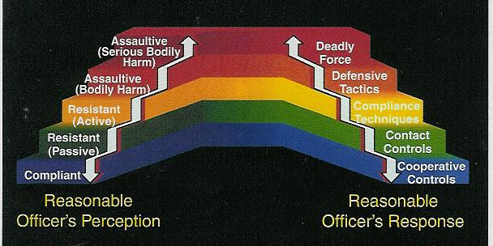

Use of Force Issues
- The purpose of any force use is to gain compliance
- Pain cannot be used to punish
- Police are allowed to use a higher level of force than the suspect
- We don’t have to fight fair
Use of Force Issues
- Must go by what officer knew at the time
- Gun found to be unloaded not an issue
- Weapon can be anything: car, chair, or anything else that may cause death or serious injury
- Reasonableness” is the standard
- Least force not required
Reasonableness
Factors:
- Degree/extent of force
- Location/place
- Part of official duty
- Totality of circumstance
- Severity of crime
- Was suspect immediate threat to officer/others
- Suspect resistance
- Evasion/fleeing
Important Deadly Force Case
- Tennessee v. Garner (1985)
- Cannot shoot a fleeing felon
- Can only shoot if they are a danger to the public
- Shooting is considered a seizure
- Deadly force may be used if the suspect “Uses or threatens to use…”
- Jeopardy – Critical element to justified use of force
Deadly Force Issues
- No warning shot
- Bullets will travel 500 feet to 2 miles depending on weapon
- Bullets will go through walls, doors, and even some metals

Use of Force Continuum:

Levels of Subject Resistance:

Verbal non-compliance - No!
Psychological Intimidation - stare
Passive Resistance - limp
Defensive Resistance - push
Active Aggression-punches
Deadly Force

Reassess!
- You must REASSESS the use of force after each use (i.e. strike, shot, etc.)
- Excessive Force – Not using appropriate level in response to threat &/or failure to reassess
- Police Brutality - Intentional inappropriate use of force
Compliance Weapons: Once called Non-Lethal or Less than Lethal
Diversionary Devices
- Used by SWAT
- Sound wave and flash cause disorientation
- Limited fire risk
Taser
- Electro-Muscular Disruption
- 35 foot max range
- Tasercam records from time removed from holster
Oleoresin Capsicum Spray
- Capsaicin – found in range of plants including peppers
- Burning sensation in nasal/eye area
- Dye is added
- Deactivation required
Batons
- Oldest of police weapons
- PR-24 is a modified martial arts weapon
- Expandable batons more compact
Batons
- Hollow metals used for better impact
- Baton strike chart example here on right
K-9
- Duty/tactical K-9 is trained to search and subdue
- In 1970’s K-9s not popular due to civil rights era images
- Most dogs from European trainers
Other “Less than Lethal”
- Pepperball Guns
- Rubber Bullets
- Sticky Foam
- Bean Bag Round
- Emerging technology such as microwaves, directed energy, etc
Deadly Force
These will always be considered deadly force
Handguns
- Convenient size, but not the best weapon
- 2 types
- Revolver
- Semi-Auto
Handguns
- Guns are identified by barrel measurement
- .22
- .38
- .45
- 9mm (metric)
Handguns
- Semi-Autos have key parts
- Slide
- Spring
- Barrel
- Trigger
- Trigger Guard 
- Firing pin
- Magazine
Handguns
- Bullet types
- Wad cutter
- Hallow point
- Slug
- Talon
- Glazer Safety slug
Handguns
- Bullets are made of 4 parts:
- Bullet
- Case
- Propellant
- Primer
Rifles
- Far more accurate and more damage
- Also identified by barrel width
- Rifling makes bullet more accurate
- Like a football
Shotguns
- Very powerful
- Limited distance
- Bullets are slugs, pellets, or combination
- Can shoot gas, bags, etc
- Barrel is by gauge

