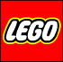Dune Patrol Buggy 7042
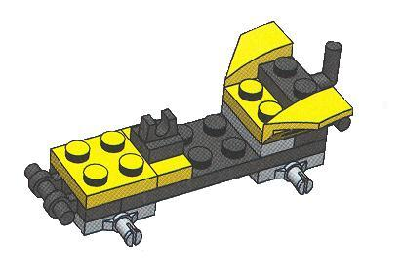
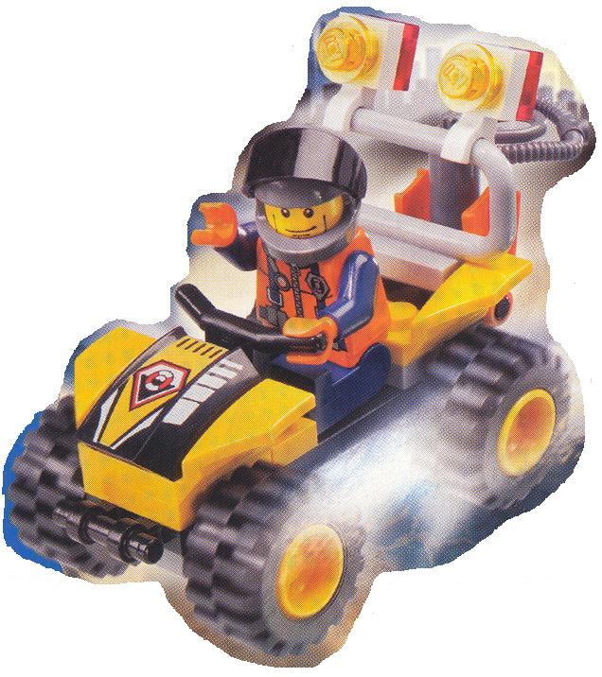
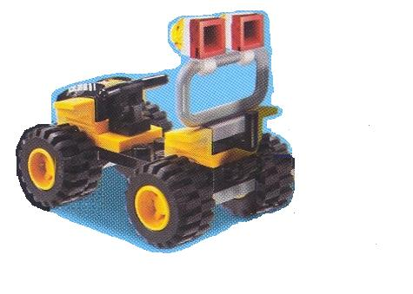
1
6
2
3
4
5
7
8
9
11
13
10
12
15
17
16
14

PARTS LIST

Part Number | Quantity | Color | Part Name
7042-0001 | 1 | Black | Chassis
7042-0002 | 2 | Gray | Axel Plate
7042-0003 | 1 | Gray | Rear Body Plate
7042-0004 | 2 | Black | Bumper
7042-0005 | 2 | Fender | Fender
7042-0006 | 1 | Yellow | Engine Baseplate
7042-0007 | 1 | Yellow | Handlebar Bracket Baseplate
7042-0008 | 1 | Black | Handlebar Bracket
7042-0009 | 1 | Black | Trailer Hitch
7042-0010 | 1 | Black | Handlebar
7042-0011 | 1 | Black | Engine Cover
7042-0012 | 1 | Gray | Roll Bar
7042-0013 | 2 | White | Light Bracket
7042-0014 | 2 | Neon Yellow | Fog Light
7042-0015 | 2 | Red | Brake Light
7042-0016 | 4 | Yellow | Wheel/Hub
7042-0017 | 4 | Black | Tire

Each vehicle requires the parts listed above for complete assembly. Use the symbols below to diagram the assembly line production of ten (10) Dune Patrol Buggies:

Part Assembly Point – Part is added to the vehicle; indicate part number and quantity added. Storage Bin – Staging point for individual parts; indicate the total number for the production run.

Subassembly is added to the vehicle.

5
Individual part (with part number)

Arrow indicates part/ subassembly/assembly flow
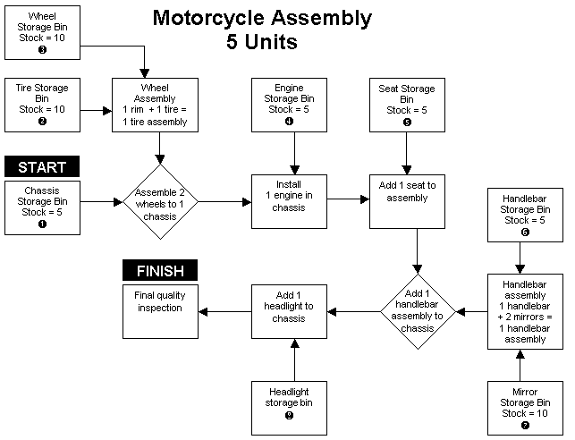

Assignment: Using the motorcycle example above, draw a flowchart that describes the assembly line process to produce ten Lego beach buggies.

Include the following in your flowchart:

- Assembly line and subassembly line(s)
- Individual assembly points for each part
- Quantity of each part to be assembled
- A description of the action to be taken at each assembly point
- A final quality inspection

