Basic Electronic Component Quiz
Name __________________________

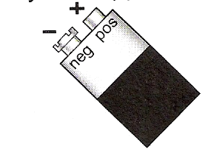  Pictorial Diagram | Component | Function | Schematic
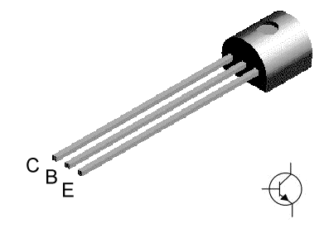
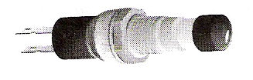
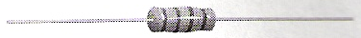
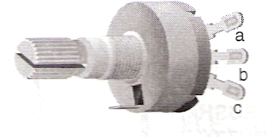
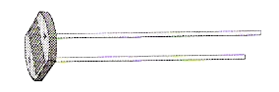
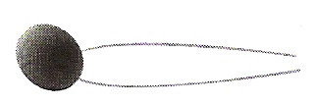
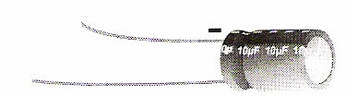
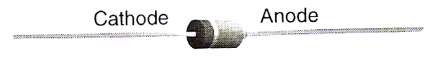
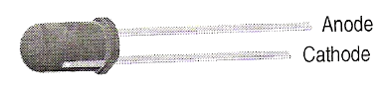
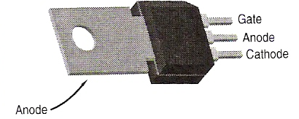

COMPONENT |  | FUNCTIONS
- Transistor  - Switch  - Electrolytic Capacitor  - Light Emitting Diode  - Photocell  - Potentiometer  - Resistor  - SCR  - Diode  - Ceramic Capacitor  - Battery |  | - Limits or controls the amount of current flowing through a circuit  - Device that opens or closes an electric circuit  - Can either be used to switch or to amplify  - Allows current to only flow in one direction  - Allows current to flow through it only after a momentary positive voltage is applied to the gate  - Acts as a temporary battery by storing relatively small amounts of electricity  - Temporary storage of relatively large amounts of electricity and are polarized  - Stores electrical energy  - Special resistor that varies resistance according to the intensity of the light that hits the surface  - Special diode that emits light when current flows through them  - Resistor in which the resistance is adjusted by twisting the shaft

