Drafting – The international language of industry. Symbols, lines and figures have been standardized over most of the world making it possible to interpret or understand drawings made in other countries. It is a precise form of communication containing detailed information from the designer to those who will produce a product. These drawings can be made by hand or through CADD systems.

Drafting Techniques:
- Sketching – a quick way to show an idea that would be hard to describe with words alone. Sketching is intended to be fast and is not perfect. However a good sketch adequately shows the shape of the object along with dimensions and instructions on how to make the object.
- Mechanical drawing – a more precise form of drafting where tools and machines are utilized in the production of a set of plans.
- CADD – Computer Aided Drafting and Design. Most CADD drawings are printed on two-dimensional paper of varying size depending on the job. A new process called Stereo Lithography makes it possible for a Drafter to “print” their design in 3D. The part, designed on the CAD system is actually formed by a laser that fires into a container of liquid plastic hardening it in the shape that was designed on the computer. The designer can actually hold the part in their hand.

Types of Drawings
- Pictorial Drawings: Drawings that represent an object in such a way as to help the person who sees it understand what it looks like.
- Types of Pictorial Drawings:
- Isometric Drawings - Show three sides of an object in a single view. All sides are measurable.
- Perspective Drawing- Shows three sides in a single view but all sides are not the correct dimensions. The object appears to get smaller the farther a point is in the background.
- Assembly Drawings – Show how parts go together.
- Technical Illustrations – Uses to show what the finished product will look like. More and more being done through 3-D modeling.

- Working Drawings: The drawings that are used to direct the production of a product. Contains detailed dimensions details and production notes.
- Types of Working Drawings:
- Multi-view or Orthographic Drawings – Drawings that show more than one sides of an object in order to accurately describe the size and shape of an object. Show no depth. Measurable. Standard views are the objects front, right side and top.
- Architectural Plans: Floor, Foundation, Plumbing, Electrical etc.
- Plot Plans – Show the shape of a lot and where the structure is positioned on it
- Topographical maps – show contours and elevations of the earth surface in a specified area.
- Electrical Schematics – diagram and specify components within an electronic circuit

Drafting Related Careers:
- Drafter – people who make working plans and detailed drawings. They prepare them from specifications and information received verbally, from sketches, and from notes. The process of becoming a drafter is usually done through apprenticeship: trainee drafter to an assistant drafter then drafter and senior, lead or chief drafter. Most drafters specialize in a particular field of work such as aerospace or architecture etc. All drafters must have a thorough understanding of math, science, materials and production processes in their area of specialization. Industries that employee drafters are: manufacturing, architectural and engineering firms, local, state and federal government agencies such as the Department of Transportation.
- Industrial Designers – their job is to simplify and improve the operation and appearance of industrial products. Their work affects the success of the sales of a product.
- Tool Designers – In this job the person is designing special tools and holding devices specifically designed for the manufacture of a product. This person also has to be familiar with CAD/CAM ( Computer Aided Design and Computer Aided manufacturing) where the design is transmitted by code to a machine that produces it.
- Teachers – You’re lookin’ at one. Others in education would be: Drafting, Electronics, Construction, etc.
- Engineers – Provide technical and, many times managerial leadership in industry and government. They are responsible for the design and development of new products and processes, plan structures and highways or work out new ways of transforming raw materials into salable products. Laws require engineers to be licensed whose work may affect life, health, and property. Engineers must graduate from an approved engineering college (GA Tech) and pass an examination before a license is granted.
- Architects – They plan and design structures. They may specialize in a specific field of architecture such as private homes, industrial buildings, schools, or commercial buildings. They, like the engineer must obtain a college degree but must also obtain a master’s degree or spend several years working in an architectural firm - similar to an internship.
- Auto designers/ Model makers – As their title suggests, these people design the automobiles that eventually reach the showroom.
- Technical Illustrators – They convert the plans to art. With a set of house plans comes the Technical Illustrator’s artistic vision of the house. Long before it is built the customer can see a representation of what the house will look like. The same is done in manufacturing. Technical Illustrations of new cars frequently are seen on the cover of popular car magazines such as Motor Trend. These are accurate representations of the product. Aerospace industries use these illustrations as well.

Terms used in drafting:
- Scale – Where a small measurement is used to represent a larger one when an object is too large to draw it full size on the available paper. Such as ¼” = 1’ scale which is used in Architectural drafting.

- Alphabet of Lines – A set of specifically drawn lines that symbolize special features within the drawing of an object.
- Construction Lines/Guide Lines (Very thin and faint) – help to build the drawing by hand. If drawn properly, there will be no need to erase them when the drawing is complete.
- Border Line (Very thick and solid - .07mm) – Continuous. (CAD color – Black) Outline the drawing sheet as well as the title strip.
- Object Line (Thick and solid) – Continuous. (CAD color – Black) Shows the outline of the shape of an object.
- Dimension Line (Thin) - (CAD color – Red) Capped with arrow heads, this line shows the distance between extension lines. The dimension normally breaks the line in the center.
- Extension Lines (Thin) - (CAD color – Red) – Lines that mark where a measurement begins and ends on an object.
- Hidden Lines (Medium) – (CAD color – Cyan or Blue) – This line is composed of approximately 1/8” long dashes with 1/16” spaces between each. It is used to show where the edges of a hidden feature within an object is located.
- Center Lines (Thin) – CAD color – Red) – Used as part of the dimensioning and layout of a part, this line is used to show the centerline of an object or the location of the center of a hole. It should extend only a short distance beyond the circle or view. It is an alternating series of long (3/4” – 1”) and short dashes (1/8”) with 1/16” spaces between.
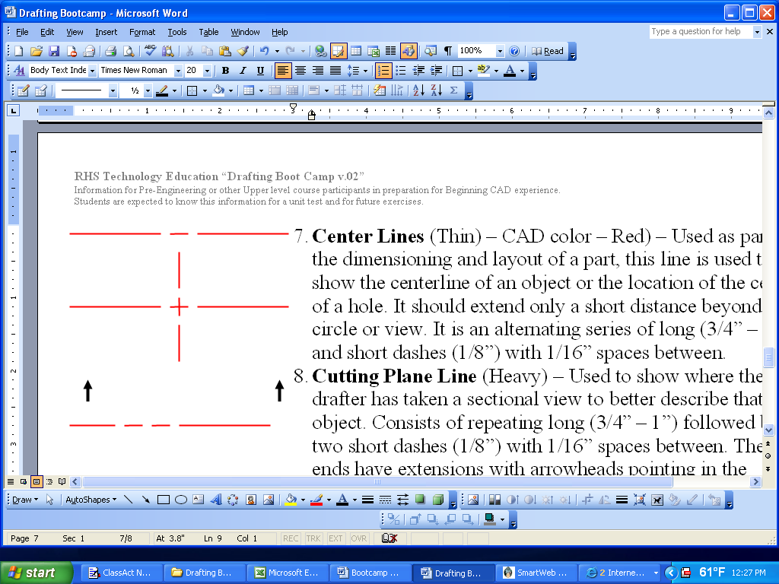
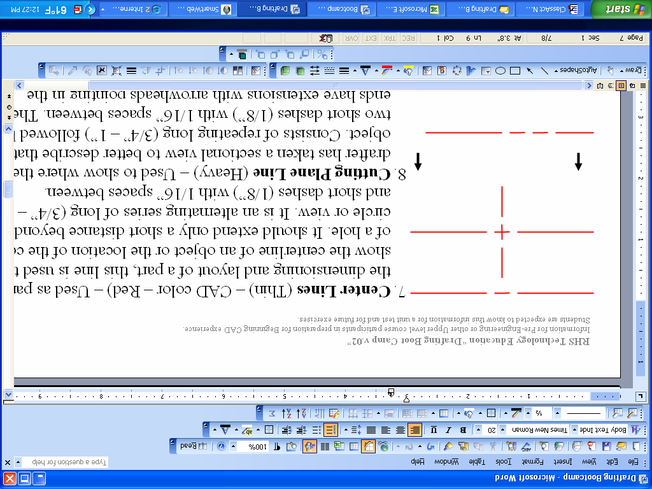
- Cutting Plane Line (Heavy) – Used to show where the drafter has taken a sectional view to better describe that object. Consists of repeating long (3/4” – 1”) followed by two short dashes (1/8”) with 1/16” spaces between. The ends have extensions with arrowheads pointing in the direction that the section was taken.
- Section Line (Thin) – Angled lines spaced equal distance apart that fill the inside of an object that indicate a cut-away view.

