Orthographic Projection Front View Test
90.11 - Assignment # 42

Front View Quiz

Below are pictures of 20 objects. The front view of each of the objects is given in the section at the bottom labeled 1-24. You are to match the above three-dimensional illustration to the correct front view at the bottom. Remember, all of the front views will not be used at the bottom.

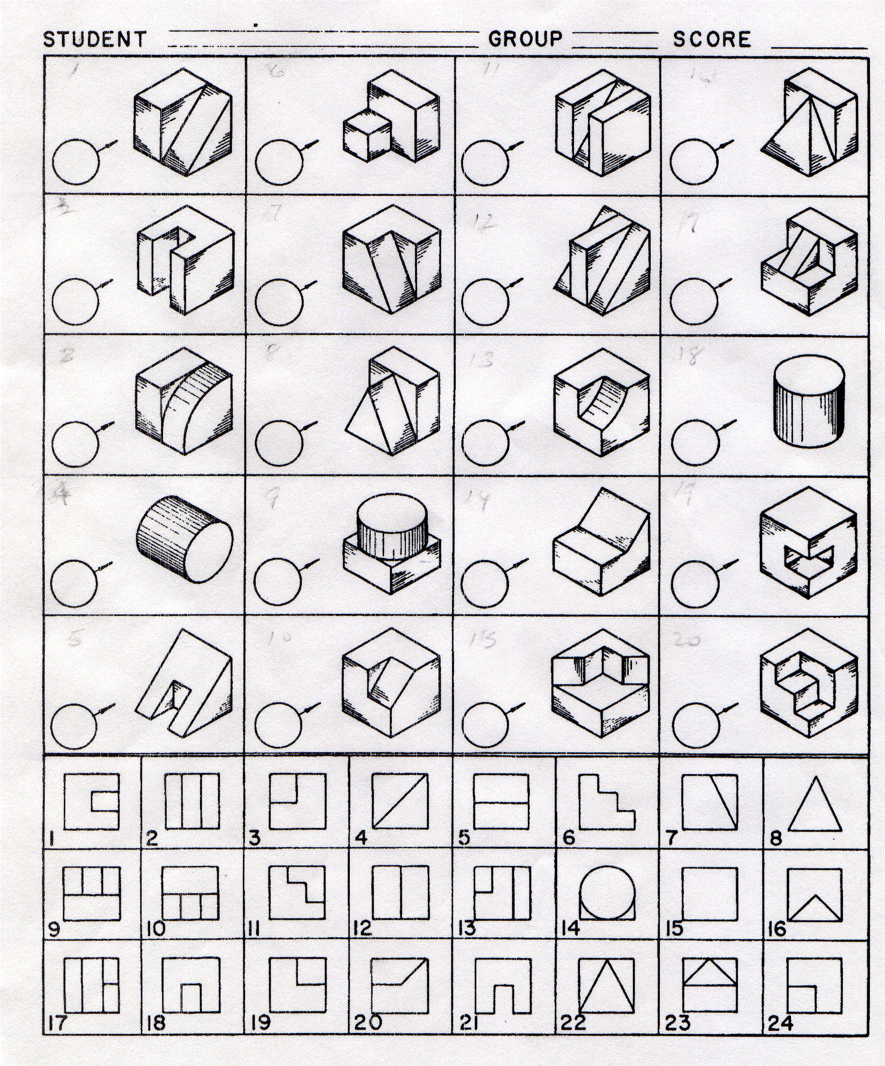
A
B
F
I
H
G
E
DD
C
K
J
P
L
O
N
M
T
S
R
Q

Orthographic Projection Top View Test
90.12 - Assignment # 43

Top View Quiz

Below are pictures of 20 objects. The top view of each of the objects is given in the section at the bottom labeled 1-24. You are to match the above three-dimensional illustration to the correct top view at the bottom. Remember, all of the front views will be not be used at the bottom.
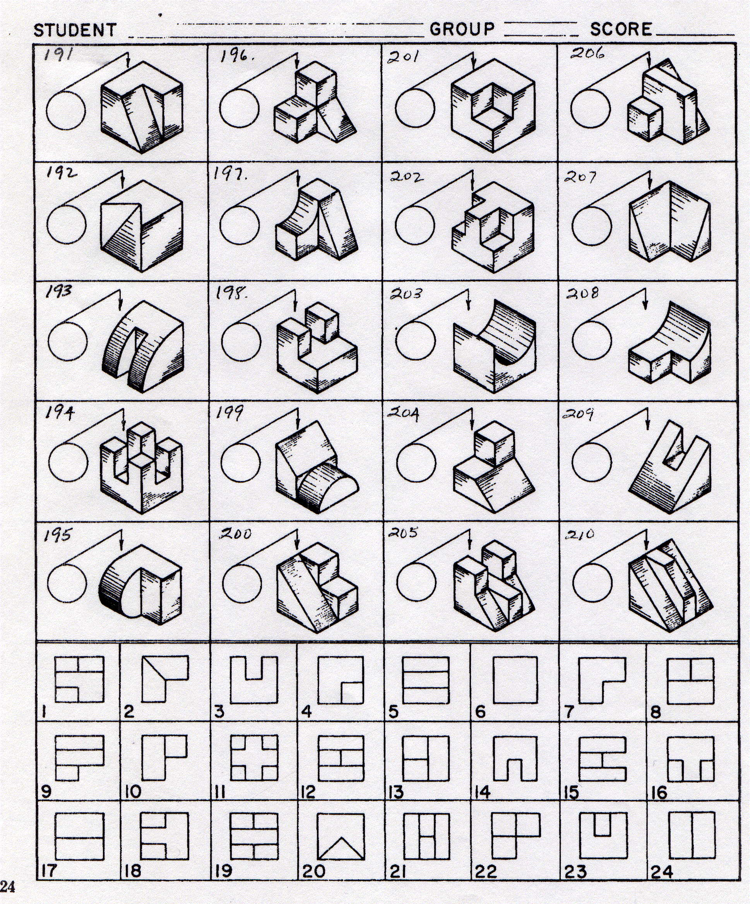
A
B
F
I
H
G
E
DD
C
K
J
L
O
N
M
P
T
S
R
Q

Orthographic Projection Right Side View Test
90.13 - Assignment # 44

Right Side View Quiz

Below are pictures of 20 objects. The Right side view of each of the objects is given in the section at the bottom labeled 1-24. You are to match the above three-dimensional illustration to the correct right side view at the bottom. Remember, all of the right side views will be not be used at the bottom.
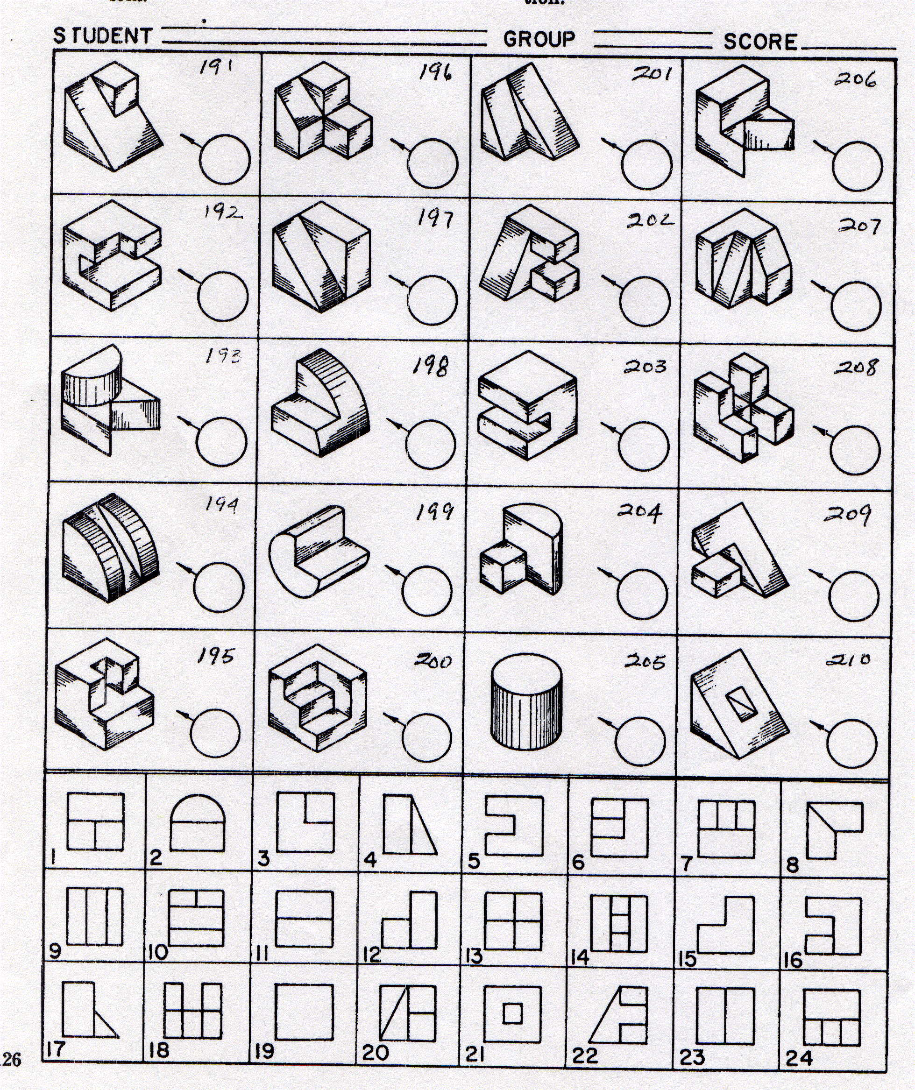
A
B
F
I
H
G
E
DD
C
K
J
P
L
O
N
M
T
S
R
Q

Orthographic Projection Hidden Line Test
90.14 - Assignment # 45

Hidden Line Quiz

Below are pictures of 20 objects. The front view, top, and right side views of each of the objects is given in the section at the bottom labeled 1-24. You are to match the above three-dimensional illustration to the correct front view, top, or right side view at the bottom. Remember, all of the three dimensional views at the bottom of the page will not be used.

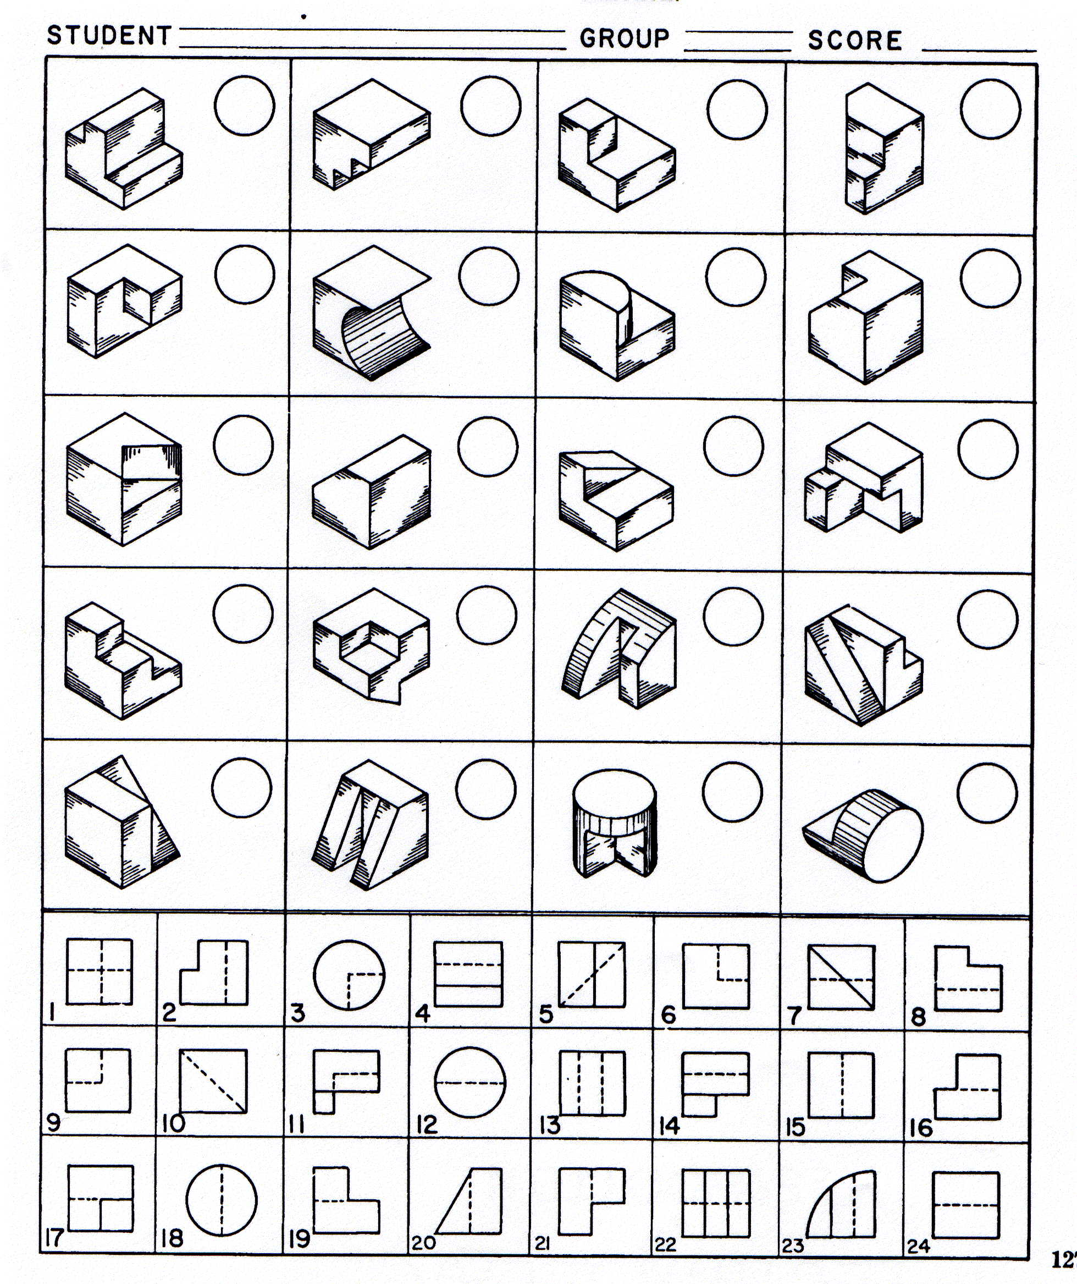
A
B
F
I
H
G
E
DD
C
K
J
P
L
O
N
M
T
S
R
Q

