Drafting Basics Post Test
90.10 - Assignment 1

- Drafting is:
  - the International language of industry
  - drawing that use standardized symbols, lines and figures to describe an object.
  - A precise form of communication containing detailed information from the product designer to the producer.
  - All of the above

- Drafting is called the “International Language of Industry” because:
- it involves several foreign languages.
- It uses standardized symbols, lines and figures that are understood in many countries.
- It is only used inside the U.S.
- Of a federal law.

- A quick way to show an idea without being perfect is called:
- Mechanical drawing
- Isometric drawing
- Orthographic drawing
- Sketching
- CAD

- A more precise form of drafting where tools and machines are used is called:
- Mechanical drawing
- Isometric drawing
- Orthographic drawing
- Sketching
- CAD

- CAD is an acronym (word made of the first letters of other words) for:
- Computer Assisted Drawing
- Computer Aided Drafting
- Collecting All Drawings
- Complex Application of Drafting

- A pictorial drawing:
- represents an object likes it really looks.
- can never be measured
- always contains dimensions
- gives assembly instructions

- Which is not a pictorial drawing?
- Isometric
- Perspective
- Orthographic
- Assembly

- Which drawing shows three sides of an object in a single view and can be measured?
- Isometric
- Perspective
- Orthographic
- Assembly

- Which drawing technique shows depth but no real measurement?
- Isometric
- Perspective
- Orthographic
- Assembly

- Which type of drawing shows how parts fit together?
- Isometric
- Perspective
- Orthographic
- Assembly

- The drawings used to direct the production of a product that contains detailed dimensions are called:
- drafting
- working drawings
- product drawings
- none of these

- This drawing only shows one side per view…
- Topographical
- Schematic
- Orthographic
- Isometric

- Architectural drawings include which of these:
- Floor plans
- Foundation Plans
- Plumbing/Electrical Plans
- All of the above

- Which type of working drawing shows the contours and elevations of the earth’s surface in a specific area.
- Foundation plan
- Typographical map
- Orthographic
- Perspective

- A person that makes working plans and detailed drawings is referred to as:
- A Drawer
- A Plan maker
- An Engineer
- A Drafter

- All drafting–related careers must have a thorough understanding of:
- Math
- Science
- Materials
- Production Processes
- All of the above

- The career field who simplifies and improves the operation and appearance of industrial products is:
- Drafter
- Industrial Designer
- Engineer
- Architect

- An Engineer is responsible for:
- providing technical leadership in industry and government
- designing and development of new products and processes
- planning new structures and highways
- all of the above

- A(n) _________ plans and designs homes, commercial buildings, schools and requires a masters degree.
- Drafter
- Industrial Designer
- Engineer
- Architect

- Which of these drafting-related careers require a person to earn a license before they can work?
- Drafter
- Industrial Designer
- Engineer
- Architect

- When one measurement is used to represent a larger or smaller measurement it is called drawing an object to:
- size
- scale
- dimension
- none of these

- The set of specifically drawn lines that represent special features within the drawing of an object is called:
- The Alphabet of Lines
- International Line List
- The American Standard List
- The Code of Lines

MATCHING (23-30)
- Construction Lines
- Border Lines
- Object Lines
- Dimension Lines
- Extension Lines
- Hidden Lines
- Center Lines
- Projection Lines

- (A)helps to build the drawing

- (B) Outlines the drawing sheet as well as the title strip.

- (F) Used to show the edges of a hidden feature within an object

- (C) Shows the outline of the shape of an object.

- (D) shows the distance between extension lines

- (G) Used to show the centerline of an object or the location of the center of a hole

- (E) Lines that extend from points on the object to show where measurements begin and end.

- (H) The lines used in an Orthographic drawing to transfer the dimensions of one view to another without measuring.

Choose the correct dimension on the ruler to the right
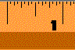
a)
b)
c)
d)
a)
b)
c)
d)
a)
b)
c)
d)

- 1 inch

- ½ inch

33)5/8 inch

Name the dimension on the ruler to the right
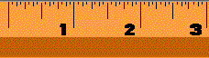
34)
a) 3/16”
b) 3/8”
c) ¾”
d) 1 3/8”

35)

1 ½”
1 ¼”
2”
¼”
Orthographic Projection Front View Test
90.11 - Assignment # 42

Front View Quiz

Below are pictures of 20 objects. The front view of each of the objects is given in the section at the bottom labeled 1-24. You are to match the above three-dimensional illustration to the correct front view at the bottom. Remember, all of the front views will not be used at the bottom.

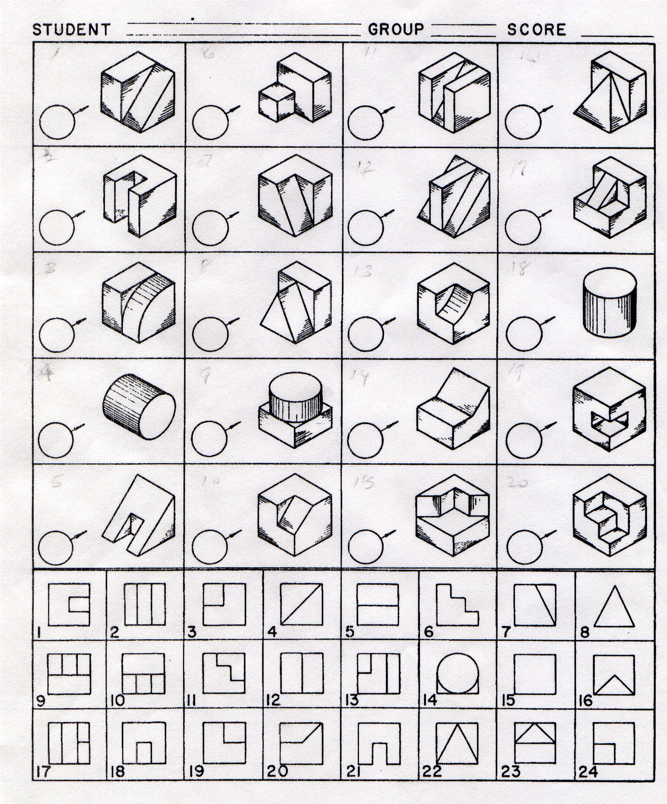
A
B
F
I
H
G
E
DD
C
K
J
P
L
O
N
M
T
S
R
Q

Orthographic Projection Top View Test
90.12 - Assignment # 43

Top View Quiz

Below are pictures of 20 objects. The top view of each of the objects is given in the section at the bottom labeled 1-24. You are to match the above three-dimensional illustration to the correct top view at the bottom. Remember, all of the front views will be not be used at the bottom.
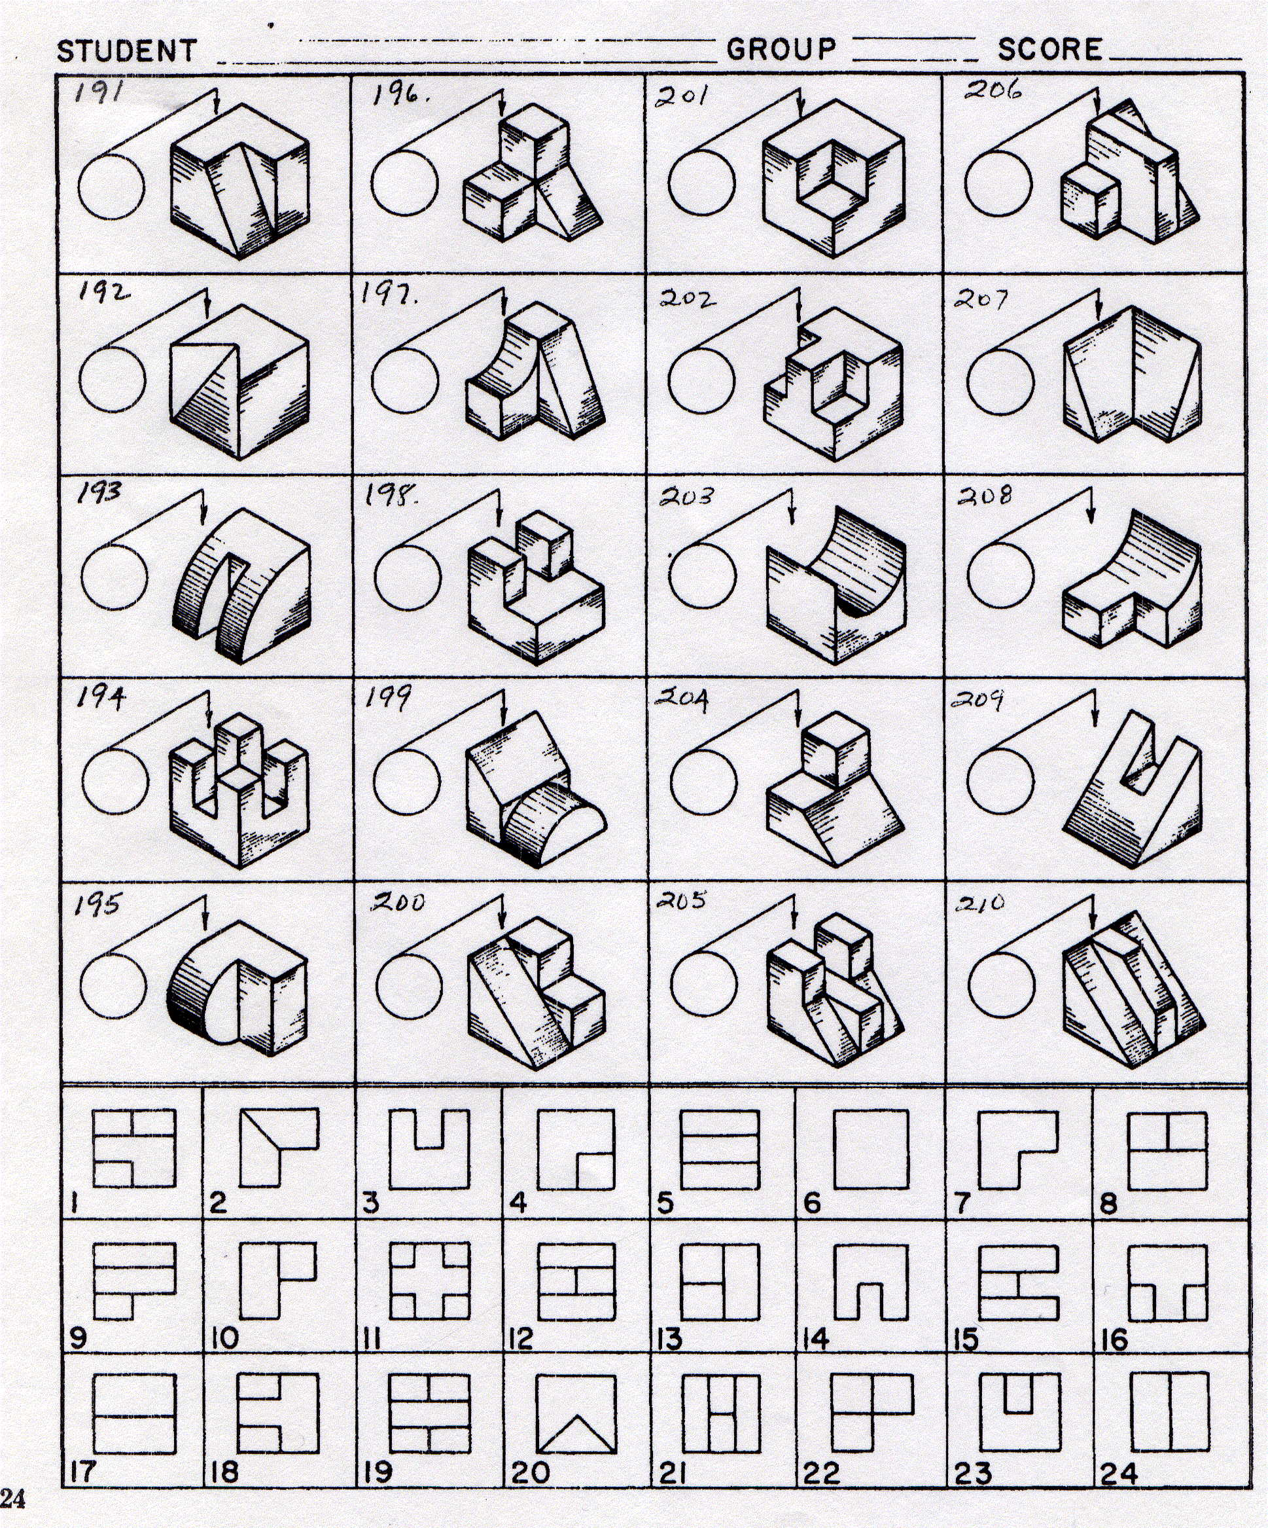
A
B
F
I
H
G
E
DD
C
K
J
L
O
N
M
P
T
S
R
Q

Orthographic Projection Right Side View Test
90.13 - Assignment # 44

Right Side View Quiz

Below are pictures of 20 objects. The Right side view of each of the objects is given in the section at the bottom labeled 1-24. You are to match the above three-dimensional illustration to the correct right side view at the bottom. Remember, all of the right side views will be not be used at the bottom.
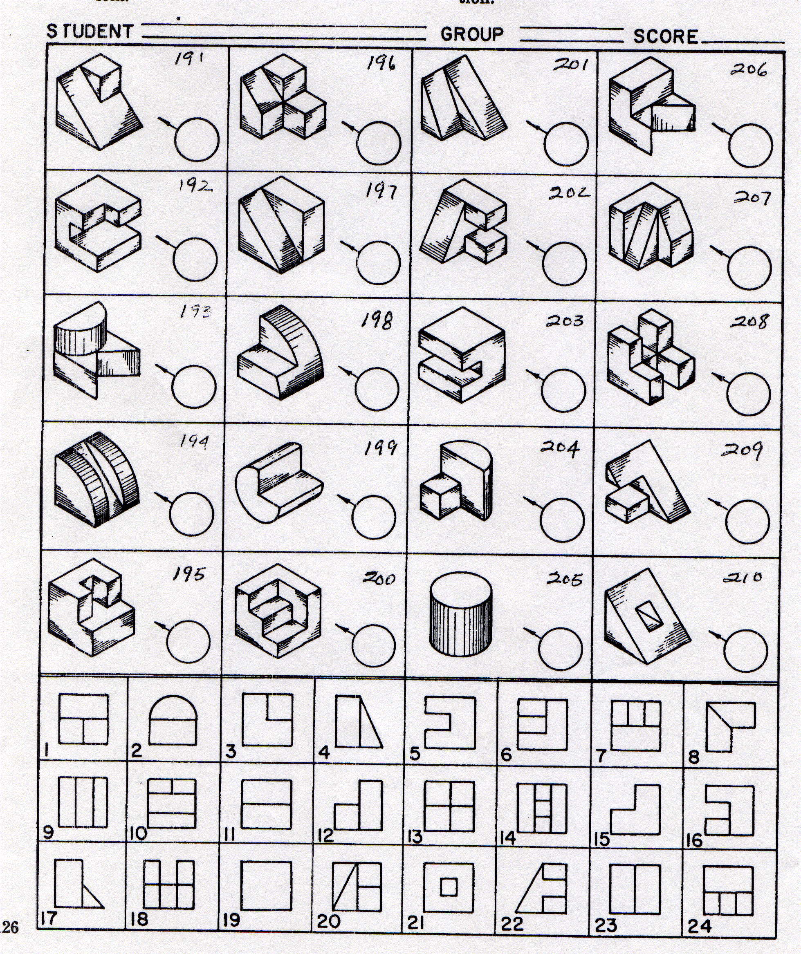
A
B
F
I
H
G
E
DD
C
K
J
P
L
O
N
M
T
S
R
Q

Orthographic Projection Hidden Line Test
90.14 - Assignment # 45

Hidden Line Quiz

Below are pictures of 20 objects. The front view, top, and right side views of each of the objects is given in the section at the bottom labeled 1-24. You are to match the above three-dimensional illustration to the correct front view, top, or right side view at the bottom. Remember, all of the three dimensional views at the bottom of the page will not be used.

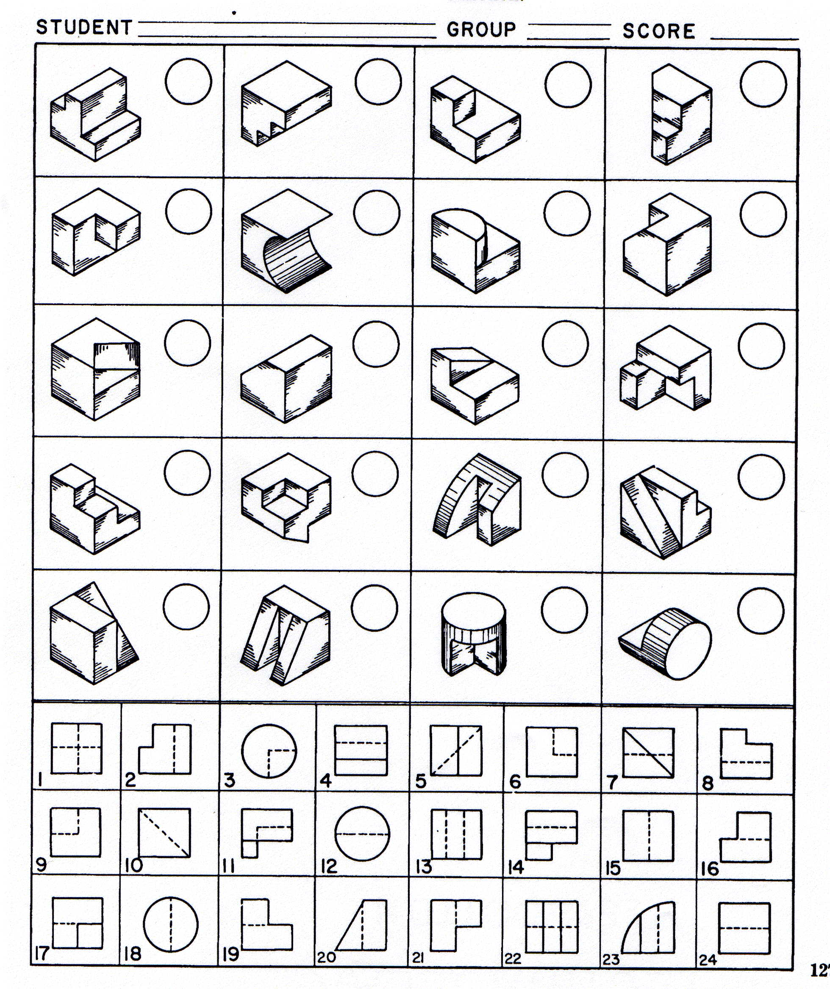
A
B
F
I
H
G
E
DD
C
K
J
P
L
O
N
M
T
S
R
Q

