For phase two of this project, you will be completing the production engineering for your product design. As a team you should complete the steps below in your design notebook:

- Create your production tooling.
  - Copy the following chart in your notebook and list each type of tooling needed to produce your product.
  - Remember that tooling can increase your speed and accuracy of your production and final product.
  - Create drawings and write descriptions of any jigs and fixtures you need.
  - Use the following chart design:
Part of Product | Material | Tool Needed | Tooling Needed
- Quality Control
  - Establish guidelines for quality control.
  - At what points of production will you do a quality control check and what will the criteria being checked be?
- Create a flow process chart using the flow process chart worksheet.
  - Show the step-by-step process for producing a single part.
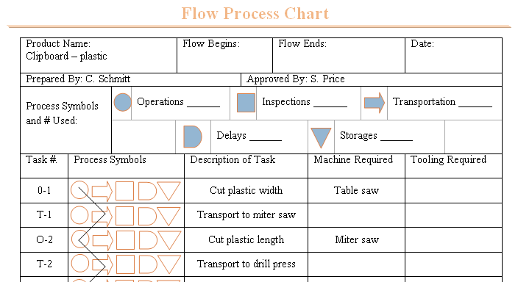
    - Describes the task
    - Provides a code number for each task
    - Identifies the machines used
    - Lists tooling needed for the task
  - Standard symbols are used to identify each task that were developed by the American Society of Mechanical Engineers (ASME)
- Create an operation process chart
  - An operation process chart shows how each part is made and then show the assembly of the product.
  - Transportation, delay, and storage tasks are not included in the chart.
  - The operations process chart is used in scheduling production. It shows what parts need to be finished at what time frame. This reduces the storage needed.
  - JIT- “Just is time” – parts arrive just in time for assembly. This helps reduce costs.

- Create a facility layout for your product.
  - Group machines by the processes they perform.
  - Most common in custom manufacturing and intermittent manufacturing
  - A plant can produce a number of different products and machines can be used for a variety of tasks.
- Compile all of your information into a PowerPoint presentation that will be presented to the class/company.

Production Engineering: Production Engineering
Criteria | Pts Avail | Pts Earned
Tooling Chart
All tooling outlined | 10 pts
Drawings and descriptions of tooling | 20 pts
Quality Control
QC checks identified | 10 pts
Criteria for QC checks | 10 pts
Flow Process Chart
Flow Process Chart Complete | 10 pts
Operation Process Chart
Operation Process Chart Complete | 10 pts
Facility Layout
Facility Layout Complete | 10 pts
PowerPoint Presentation
Overall presentation | 10 pts
Design Notebook
Design Notebook Documentation complete | 10 pts
Total Score

