Gracious Professionalism

Dr. Woodie Flowers is credited with coining the term "Gracious Professionalism."

Dr. Flowers is the FIRST (For Inspiration and Recognition of Science and Technology) National Advisor, and Professor Emeritus of Mechanical Engineering, Massachusetts Institute of Technology.

According to Dr. Flowers, “Gracious Professionalism” is part of the philosophy of FIRST. It's a group of actions that promotes quality work, emphasizes the value of others, and respects individuals and the community. While there may be fierce competition, mutual gain is not impossible. Gracious professionals learn to compete, but treat others with respect and admiration in the process. Everyone is a winner in some respect, but there are no “sticky-sweet platitudes” either. Knowledge, competition, and understanding are a comfortable blend. If an opposing team needs to borrow a tool, or some other assistance, by lending them a hand, you not only aid them, but help yourself as well. “Gracious Professionalism” is part of pursuing a meaningful life. You can add to the whole society and take pleasure in the satisfaction of knowing you have acted with integrity and sensitivity.

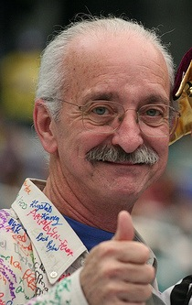 photographer: Jake Ingman description: This photo was taken at the 2006 FIRST Robotics National Competition in Atlanta, Georgia.

