Intro to Robotics: Chapter 1 Crossword Puzzle

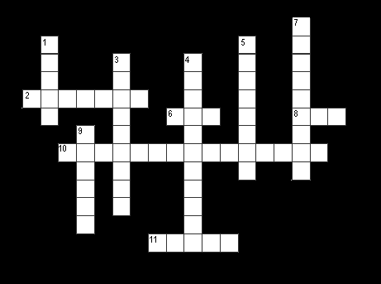

ACROSS:
2. CMU researchers formed a company to build robots called: ___________

6. Nickname for one of the foremost professors of robotics.

8. Most industrial robots are this type of robot.

10. Another name for the computer controller for robots.

11. Radioactive "___________" was created to clean up nuclear disaster sights.

DOWN:
- He created the first Robotics Competitions.

3. One of the three "D’s” that robots are invented to do.

4. The interdisciplinary study of the structure of regulatory systems.

5. The official name for the components responsible for a robot’s movement.

7. This CMU professor espouses the "Top Down" theory of robotics.

9. Best known for creating analog, BEAM, or mutant robots.

