Chapter 4 Teleoperated Crossword Puzzle

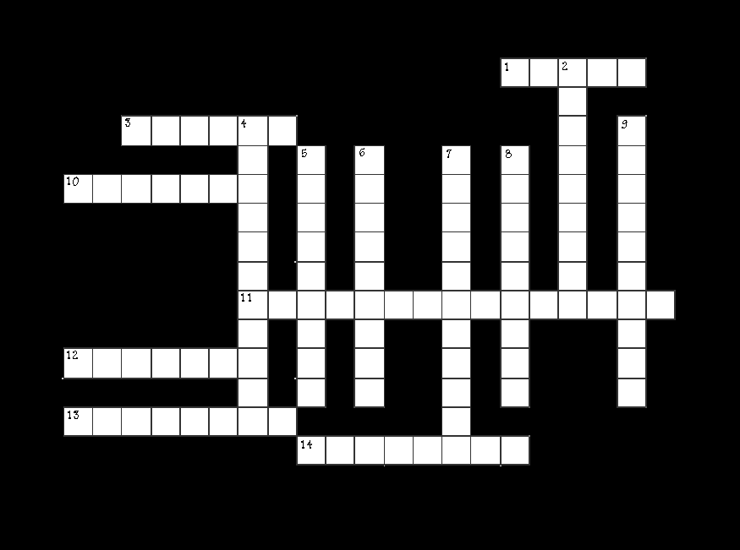

ACROSS:

1. Term given to frequency related to a time unit. Hertz
3. Device used to control a robot. Remote
10. Oscillator that vibrates at a given frequency. Crystal
11. Field of energy in which radio waves travel. Electromagnetic
- Transducer used to propagate a signal into the air. Antenna
13. Device on the robot that collects and relays signals to the robot. Receiver
14. Radio __________ . Term used to refer the set of all frequencies. Spectrum

DOWN:

2. Induction of vibrations by a vibrating source onto another object sharing the same resonant frequency. Resonance
4. To control by a remote transmitter. Teleoperate
5. Rate of oscillation. Frequency
6. Height of a signal from peak to peak. Amplitude
7. Device that sends control signals to a robot. Transmitter
- Movement of a signal out from the source. Propagate
9. Type of wave most signals take. Sinusoidal

