Chapter 4 Teleoperated Crossword Puzzle

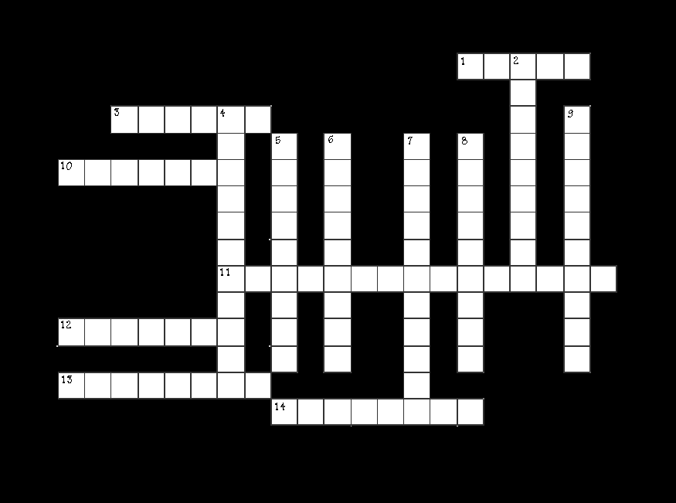

ACROSS:

1. Term given to frequency related to a time unit.
3. Device used to control a robot.
10. Oscillator that vibrates at a given frequency.
11. Field of energy in which radio waves travel.
- Transducer used to propagate a signal into the air.
13. Device on the robot that collects and relays signals to the robot.
14. Radio __________ . Term used to refer the set of all frequencies.

DOWN:

2. Induction of vibrations by a vibrating source onto another object sharing the same resonant frequency.
4. To control by a remote transmitter.
5. Rate of oscillation.
6. Height of a signal from peak to peak.
7. Device that sends control signals to a robot.
- Movement of a signal out from the source.
9. Type of wave most signals take.

