MICROID AUTOPSY

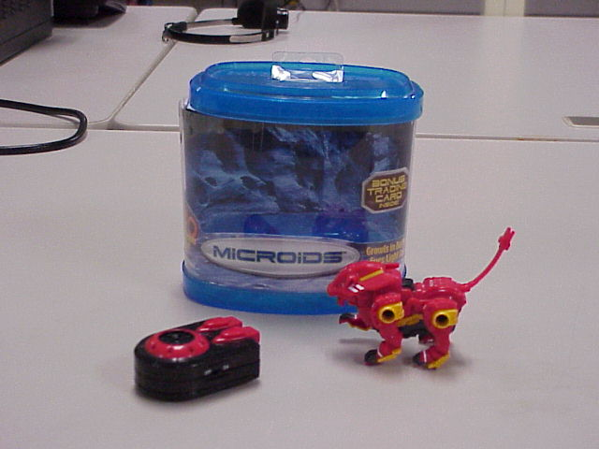

This is the autopsy report for a MICROID™, dissected on February 1, 2006 during 1st block Robotics class at SFHS. This particular toy is a palm sized infra-red remote controlled device. When the buttons are pushed on the controller, the beast roars and hops forward, or it hops in a curving pattern to one side. The eyes flash red.

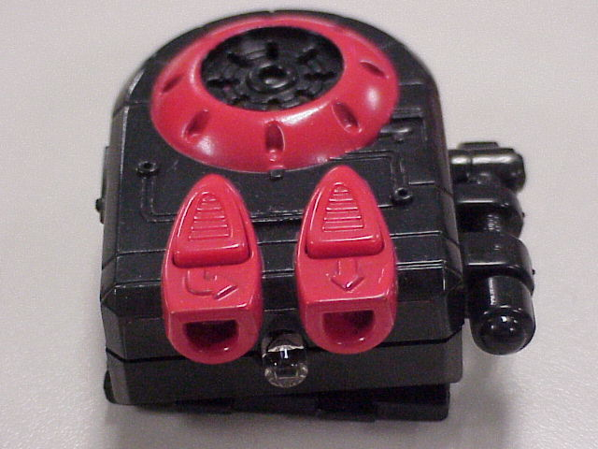

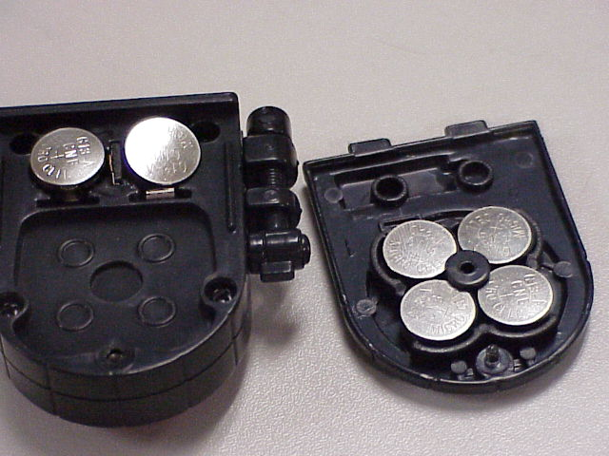
The infra-red controller possessed two buttons. I found it very interesting how many batteries were required to operate the controller.

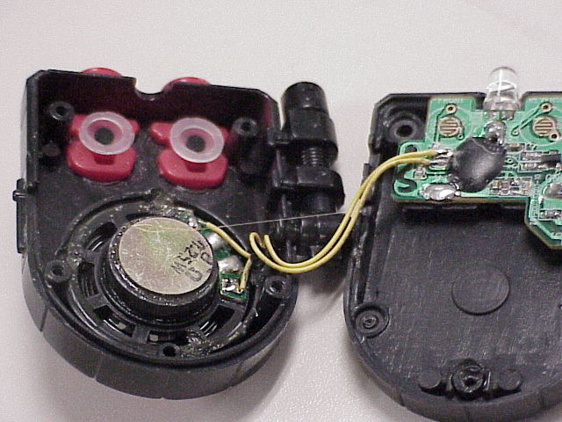
The controller PCB was beneath the buttons. The black center of each button was made of a conductive material that caused the connection between the traces, an interesting switch assembly. The speaker assembly was in the remote, where the operator could easily hear.

The four movable legs of the beast were held on with screws. When removed, the linkage between the legs was clearly visible. This caused the legs on either side to move in unison. Note the pin above the center-point of where the leg attaches to the body. This is the fulcrum, or pivot point for the leg to move.
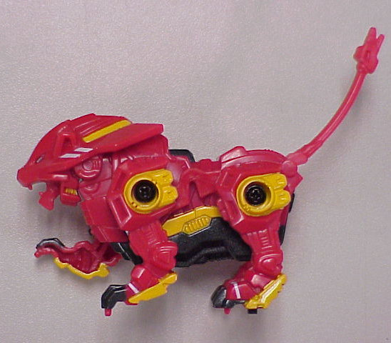
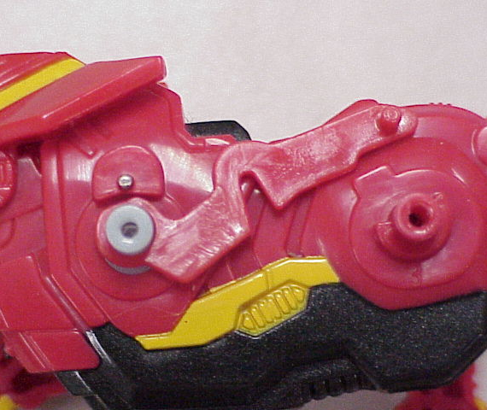

Looking at the white plastic part sticking out of the front shoulder, you will notice that the cylinder is offset. It is a cam. When the white piece moves in a circle, the portion that sticks out rotates around in an oblong path.

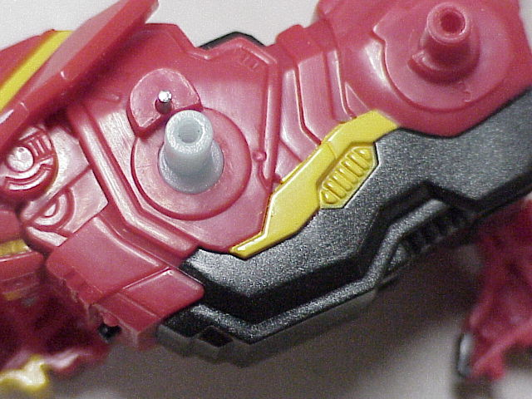

Upon opening the body cavity, you will discover a maze of moving parts, mostly gears. These gears are of varying sizes and types. The cam is much more visible now. You can also see the LED that causes the eyes to glow. There is a switch on the chest for turning the toy on and off. The infra-red sensor is above the shoulder cam in the middle of the back.

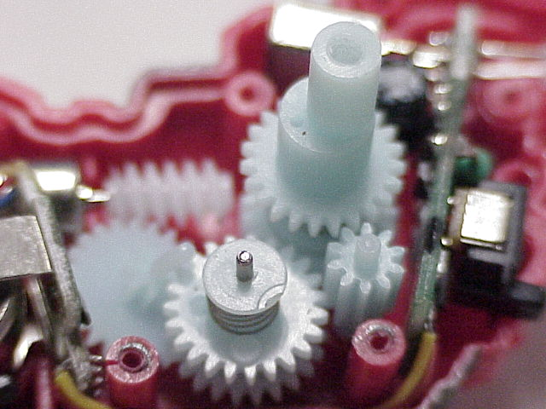
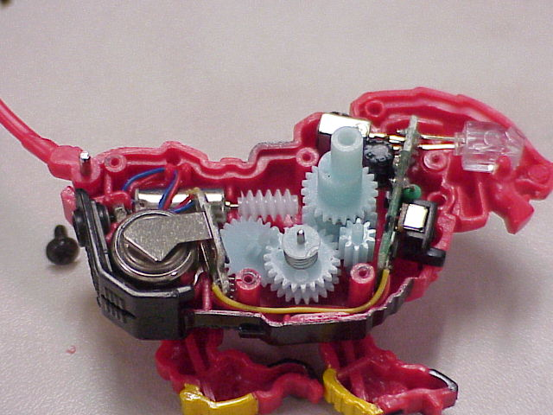

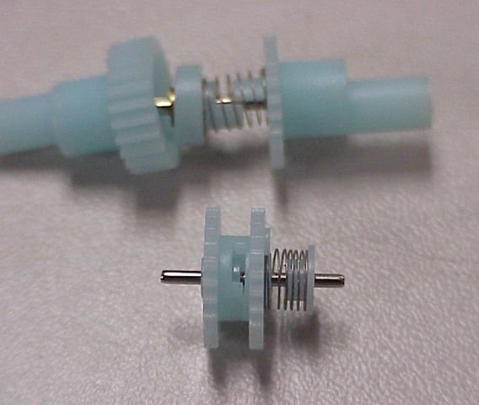
Some of the gears are two pieces. The construction is such that if one gear turns in one direction, the other side of the gear set must turn that direction also. If the gear is reversed, then the second side is allowed to slip. This is sort of like a transmission clutch assembly. This must be how the toy is able to hop to one side instead of straight forward.

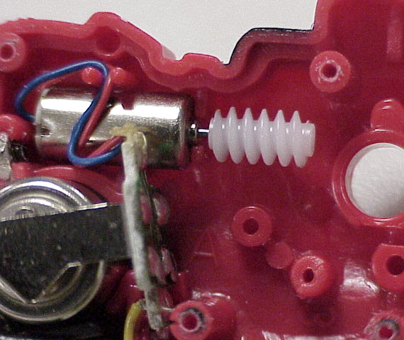

Notice the worm gear mounted to the tiny motor that transfers the electrical energy into mechanical energy.

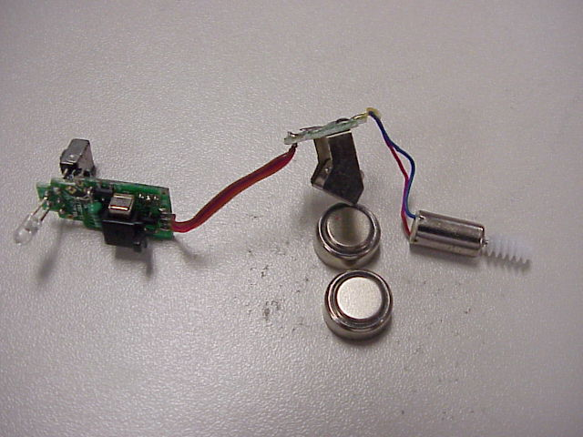

The electrical system of the creature includes the infra-red pickup, circuitry, motor, LED for the eyes, wiring and another two batteries.

This toy used many simple machine concepts, to include the lever, screw, axle, various gears, and cams.

