Basic Electronics

Use the Basic Electronic Worksheet to go with the Basic Electronic Power Point.

Directions: Fill in the blanks from the Basic Electronics PPT.

Basic Concept of a Circuit

Three requirements of a complete circuit

_Source_ of power

_Load____ (something which uses that energy)

Needs a ___Path__ to get the energy from source to load and back

Millions of small charges called _electrons __ move through the circuit.

When the switch is closed the __ electrons __ flow through the wires from the battery, to the switch, to the lamp, and back to the battery.
- What Charge is an electron? _negative_

When the circuit is complete or closed electrons flow through the wires from _ negative _ to __positive__.

_Switch_ provides a simple way to open and close a circuit.
- Is a switch necessary to have a complete circuit? _No___

Components: draw the symbols and fill in the blanks

SPST Switch – Single Pole Single Throw |  | DPST Switch – Double Pole Single Throw
Momentary Switch |  | Open/Closed Switch
Wires Connected Symbols | or  Wires Crossing (Not Connected) Symbols

 | Lamp |  |  | Speaker
 | (-)‏  (+)‏  Capacitor  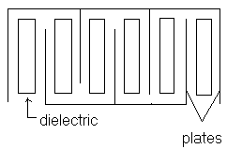 | Electrons are stored inside the capacitor causing it to act like a battery  Capacitance is measured in microfarads  Plates are the conductors inside the capacitor. Electrons move around the plates causing storage of energy that continues flowing even after all power has been disconnected.  Dielectric are the insulators inside the capacitor.  Discharging capacitors  Before working with a capacitor be sure it is discharged.  Touch a probe to each capacitor terminal for discharge.  Substituting capacitors  Replace the capacitors with exact voltage rating.  If impossible the voltage rating must be greater  If a lower rating is used the circuit will result in damage.
 | Resistors (R) | Opposes the flow of current (I)  Can be used as a fuse in a circuit  R are not polarity sensitive  Measured in Ohms
 | Variable Resistor: opposes the flow of current (I)  Designers use the pot to find the correct current (I) for a circuit  AB + BC = AC |  |  |  |  |  | A  B  Potentiometer
 | Photocell | Look at the photocell’s symbol & tell how the component operates.  Squiggly lines mean: resistance: opposing the flow of (I) current  Arrows pointing in means: the light comes from outside  the component
- One directional gate  - Has a anode and cathode |  |  |  |  |  | anode  cathode  Diode
(+)‏  (-)‏  LED |  |  | - LED: Light Emitting Diode  - Arrows pointing out means: light comes from the component  - Component symbol in the middle means: one directional gate
Anode  (+)‏  Cathode  (-)‏  C  A  Gate  SCR |  |  |  |  |  | SCR -- Silicon Controlled Rectifier  Voltage (E) to the gate turns the SCR on

Transistor: amplification of signal

Transistor – NPN |  |  |  |  |  | Transistor – PNP
IC – Integrated Circuit  555 alternates from turning the voltage  on & off  555 produces a square wave at its output  Frequency is step by the attached resistors &  capacitor  Circle or dot on the IC marks pin ONE |  |  |  |  |  | 1  2  3  4  6  8  5  7  555 Timer -- IC
Cell |  |  |  |  | two or more cells  Battery

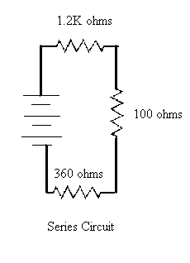

- If one resistor or component _burns_ out the circuit will be open and not operational.

- Total resistance = 1.2K + 100 + 360
= 1660 ohms

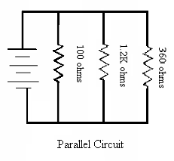

Circuit which contains two or more paths for electrons to flow from a common voltage source
- If one resistor burns out the other resistors will be closed and operational
1
- Total resistance = 1/1.2K + 1/100 + 1/360
= 73.46 ohms

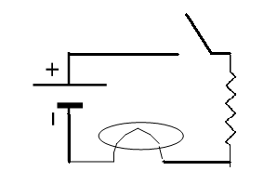  Draw an open Circuit using:  cell switch  lamp 1k ohm resistor | 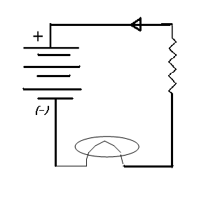  Draw a closed Circuit using:  battery switch  lamp 1k ohm resistor

Directions: Complete the following questions on your own. Score: __________

List four items of electricity in your everyday living.

Answers will vary

_____________________________________________________

_____________________________________________________

_____________________________________________________

The necessary part of a completed circuit includes:

Source, path, and load

Electricity and devices

Components and wires

The purpose of a switch is to:

Add components so the cost will increase

Allows easier opening and closing of the circuit

Must have a switch so the circuit can become closed

The movement of electricity is from:

Negative to positive

Positive to negative

Neutral to negative

In a circuit with a battery, the electrons flow:

Out of the positive terminal

Out of the negative terminal

From the battery acid

My flashlight has (two) 1.5-volt power sources. What should I call them cells or batteries? BATTERY

Draw symbols for each electrical component.
Cell  See above | Battery | Lamp | Wires crossing | Wires connected

Directions: Match the words to the correct definition.

_C_ Chemical  Energy  G Load  J Photocell  E Diode  F Insulator  B Capacitor  K Resistance  L Series  Circuit  I Parallel  Circuit  N Solder  M Schematic  A Batteries  D Conductors  H Multi  Meter | A two or more cell are combined a battery is formed  B Two conductors separated by an insulator or dielectric used  to store an electrical charge  C. electricity is generated through the use of chemicals and their  reaction with other materials  D. An item or material, which is used to carry current; a wire  E. allows electrons to follow in one direction and blocking flow from  the other direction; commonly know as a one way directional gate  F. object that will not allow current to flow  G. device that is being driven by the source of power; absorbs the  power from the supply voltage and converts it to heat, light, etc;  resistance connected across a circuit that determines the current  flow and energy used  H. electrical measuring device (I, E, & R)  I. circuit which contains two or more paths for electrons to flow  from a common voltage source  J. cell which will change its resistance when hit by light  K. Opposition to the flow of current  L circuit in which components are connect from end to end, and the current must flow through each tone in sequence to complete its path  M. electrical diagram that shows components as symbols and  electrical connections of components to each other  N. alloy of tin and lead used for providing a low resistance electrical  connection which is also mechanically strong

