Capacitor Lab

Name: ___________________________ Period: ____________

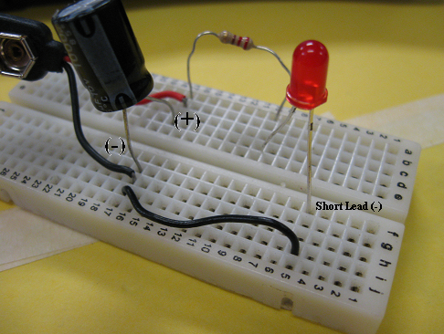
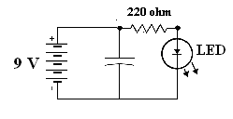

Directions: Connect the components of the capacitor circuit and answer the questions below to discover the operation of a capacitor.

- What type of charge is stored inside the capacitor and moves through the circuit? Electrons (-)

- The electrons travel along the plates located inside the capacitor. This makes the plates a/an (conductor or insulator) (circle the correct answer)

- There is also a dielectric inside the capacitor that keeps the electrons from jumping away from the plates. This makes the dielectric a/an (conductor or insulator) (circle the correct answer)

- The 220 ohm resistor (R) is protecting what component from too much current (I)? LED

- The capacitor and LED are in (series or parallel) of each other. (circle the correct answer)

- Leave the battery connected for 10 seconds then disconnect the battery; how long did the LED stay on?
Varies in seconds
- Replace the 220 ohm resistor with a 1K ohm resistor; how long did the LED stay on?
Varies in seconds – should be more than #6
- Now that you have seen what a capacitor can do explain why a technician will leave a computer off for 10 – 20 seconds to make sure that it goes through a true reset. The capacitor holds a charge and the charge must be drained through the components.

