Diode and Multi-Meter Lab

Directions: Build the circuit below, fill in all tables, and answer all questions.

- Diode will allow current to flow in one direction only.
- Diode has two leads:
  - Anode (+)
  - Cathode (-)
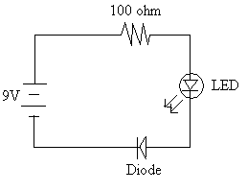

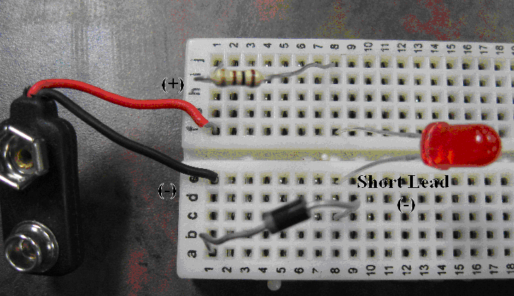

Parts List: battery connector,
100 ohm resistor
(brown/black/brown/gold),
diode, and LED

1. What happened when the battery was connected to the circuit? The LED comes on.

2. Remove the diode from the circuit. What happened? Led turns off

3. The diode circuit is: (a) series (b) parallel

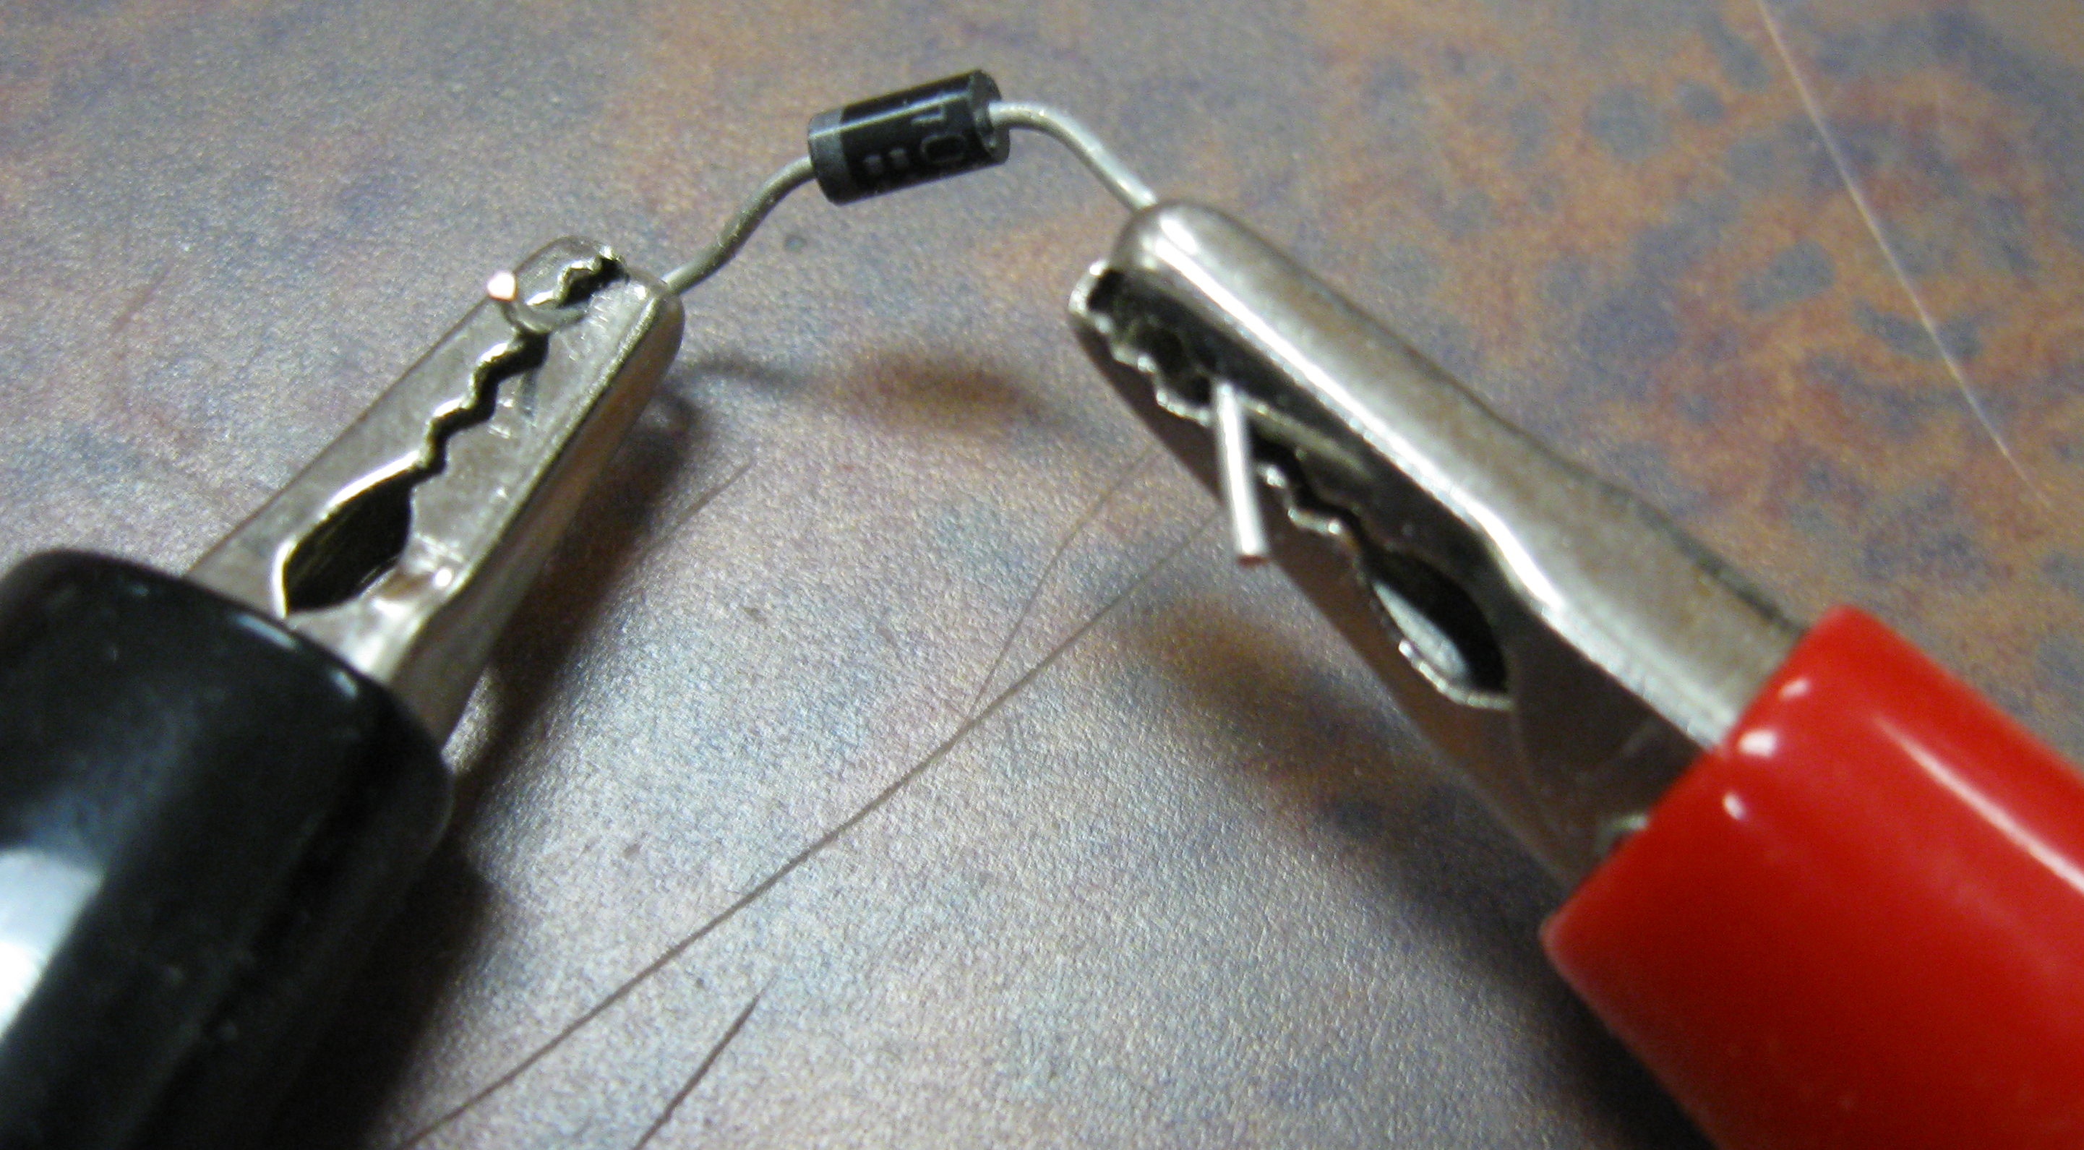
Set up the multimeter as shown in the picture with the selector pointing to the (music notes/diode symbol/speaker drawing) (continuity tester) in the ohm’s (resistance) section. Make sure the black lead is in the com or ground connector and the red lead is placed in the V/ohm connector. Take the diode and place the silver band side to the black lead and the opposite side to the red lead of the multimeter.

4. What reading is displayed on the multimeter? Answers will vary, but must have a reading of 0 to a low resistance reading.

5. Reverse the diode by placing the silver end on the red lead of the meter and the black end on the black lead. What reading is displayed on the meter now? Meter will not register a reading

6. What would it mean if the diode had the same reading in both directions? The diode is bad because you should only have a reading in one direction.

7. Now place the diode back into the circuit with the silver side in C8; what happened to the LED? No light

Place the diode back to the original direction in the circuit before completing the voltage chart below. The circuit is using a 9V battery so place the selector on DCV 20 to get an accurate reading.

Component | E(Voltage) Across
100 ohms | (8)
LED | (9)
Diode | (10)
Battery in circuit | (11)
Battery out of circuit | (12)

13-20

Resistor used | Resister reading from multimeter | Voltage (E) reading from multimeter  Measure across battery | Current (I) reading from multimeter | Ohms Law Check (I=E/R)
100 ohms | 100.2 | 9 | 200 ma is being used because the I reading is very small so you must multipy the display reading by .002 for the approitate amperage reading.  46.2 x .002 = .0924 A | I = 9/100.2  I = .0898 A
220

1K

Answers will vary depending on the actual readings of the resister and battery. Note that a multimeter that doen’t have the 200ma at the leads will not read this small of a current reading.

