Electronic Crossword

Name: ___________________________ Period #: _________________

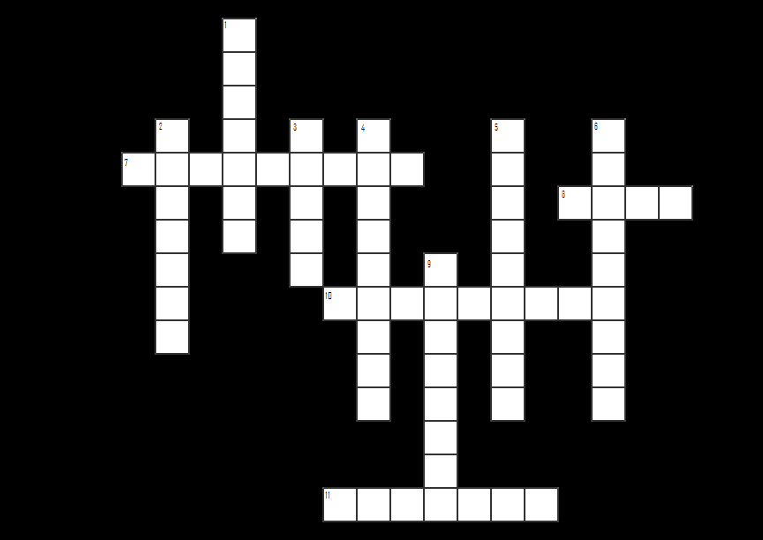

ACROSS

7. To store an electrical charge & has an insulator called a dielectric & conductor called a plate (capacitor)
8. Uses energy in an electronic circuit (load)
10. Electrical diagram that shows components as symbols & electrical connections of components to each other (schematic)
11. Intensity of the flow of electrons (current)

DOWN

1. Electromotive force (force the electrons flow through the circuit) (voltage)
2. Two or more cells (battery)
3. One directional gate (diode)
4. An item or material, which is used to carry current; a wire (conductor)
5. Object that will not allow current to flow (insulator)
6. Cell which will change its resistance when hit by light (photocell)
9. Opposition to the flow of current (resistor)

