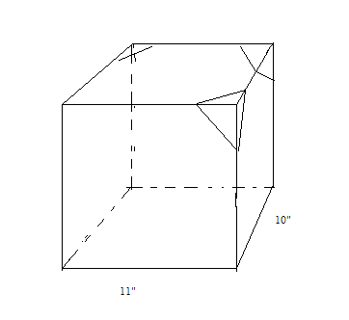
Material List

After the measurements are found add them together for material amounts.

1/4x1/4x36  Length of stick | # of 1/4x1/4 | Total in. | # of sticks needed  T# / 36 = | # of craft sticks | Total # of craft sticks
11” | 4 | 44 |  | 3/corner
10” | 4 | 40
 |  |  | 84/36= 2.33 sticks |  | 3x8=24
Material requirements |  |  | 3 ea |  | 24 ea

1/4x1/4x36  Length of stick | # of 1/4x1/4 | Total in. | # of sticks needed  T# / 36 = | # of craft sticks | Total # of craft sticks
Material requirements |  |  | ea |  | ea

