Photocell Lab

Directions: Build the photocell circuit using the symbol schematic or the breadboard picture then answer each question to discover how the photocell operates in each circuit.

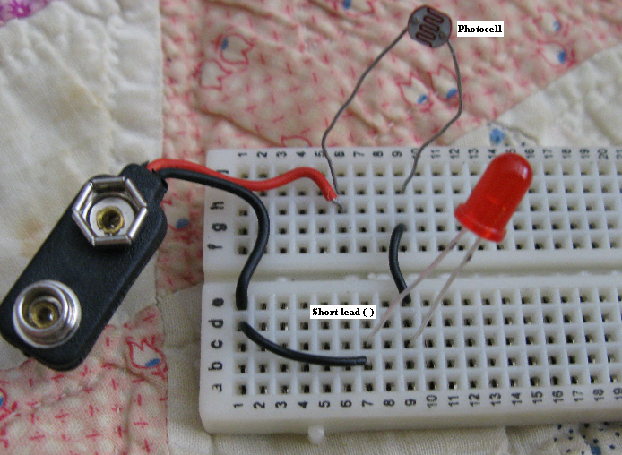

1. Explain what the arrows pointing toward the circle in the photocell mean. (light comes from an outside source to effect the component)
2. Explain why the arrows are pointing away from the LED circle instead of toward the circle as shown in the photocell symbol? (LED arrows mean the light emits from the LED/Photocell arrows mean the light comes from an outside source)

3. What is the symbol inside the photocell circle and explain what does it tell you about the component? (resistor symbol and that the light effects the resistance inside the photocell)

4. What happens when the photocell is in direct light? (the LED is on)

5. What happens when the photocell is covered by your finger? (resistance inside the photocell increases and the LED dims)

6. Normally a resister is placed on the positive side of the LED to protect the device from going bad. Discuss the reason a resistor was not placed on the positive lead of the photocell. (the photocell acts as the resistor to protect the LED from excess current)

7. Explain how light effects the internal workings of the photocell. (The more light placed on the photocell causes less resistance inside the photocell allowing more current and a brighter LED)

8. Instructors Signature: ____________________________
- The circuit operates correctly.
- The student can explain the circuit operation using their own words.

(I have the students explain the circuit to me in their own words before I sign off on the lab. This gives me one on one time with each student and it requires my students to slow down and digest the information instead of rushing through the labs and not learning the information.)

