Photocell Lab

Directions: Build the photocell circuit using the symbol schematic or the breadboard picture then answer each question to discover how the photocell operates in each circuit.

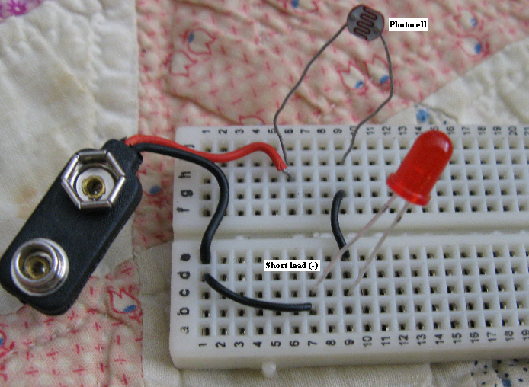

1. Explain what the arrows pointing toward the circle in the photocell mean.

2. Explain why the arrows are pointing away from the LED circle instead of toward the circle as shown in the photocell symbol?

3. What is the symbol called inside the photocell circle and explain what does it tell you about the component?

4. What happens when the photocell is in direct light?

5. What happens when the photocell is covered by your finger?

6. Normally a resister is placed on the positive side of the LED to protect the device from going bad. Discuss the reason a resistor was not placed on the positive lead of the photocell?

7. Explain how light effects the internal workings of the photocell.

8. Instructors Signature: ____________________________
- The circuit operates correctly.
- The student can explain the circuit operation using their own words.

