Resistor Notes Answers Score: __________

Resistors job:

1. Opposes the flow of current.

2. Can be used as a fuse in a circuit.

3. Resistance is measured in Ohms

Two types of resistors: Draw Symbol

4. Fixed 5.

6. Variable 7.

Resistors makeup:

- Molded composition or carbon resistor
  - Carbon material and a binder that holds the carbon together

- Metal film

- wire wound

- Used when large amounts of heat must be dissipated

11. The different sizes of carbon resistors tell the amount of heat that
a given resistor can transfer or dissipate to the outside air.
    - Size examples: 1/8, ¼, ½, 1 and 2 watts.

Resistor Color Code: Black 0 Bad
Brown 1 Boys
Red 2 Run
Orange 3 Our
Yellow 4 Young
Green 5 Girls
Blue 6 But
Violet 7 Violet
Gray 8 Goes
White 9 Willingly

Tolerance Value: Gold 5%
Silver 10%
No band 20%
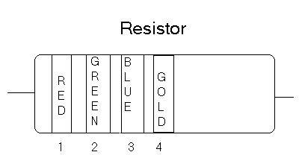

How to read a fixed resistor:
- Each color represents a number.
- Position the resistor with the bands at your left.
- Make a list of colors and their respective numbers.
  - Band 1 = Red = 2
  - Band 2 = Green = 5
  - Band 3 = Blue = 6
  - Band 4 = Gold = 5%
- Write band 1 and band 2 numbers in order
  - 25
- Band 3 tells how many zero’s to add to band 1 and band 2
  - Blue tells us to add 6 zero’s
    - 25,000,000 or 25 million or 25 megohms. (used in electronics)
- Band 4 tells what tolerance the resistor has.
  - 22,500,000 minimal to maximum of 27.5 Megohms

Different ways resistance can be written:
- 25,000,000 ohms = 25 megohms * 25,000 ohms = 25 K ohms
- 2,500,000 ohms = 2.5 megohms * 2,500 ohms = 2.5 K ohms
- 250,000 ohms = 250 K ohms * 250 ohms = 250 ohms

Band 5:
A fifth band is on a resistor is used to predict the percentage of failure per thousand hours of use. The manufacturer conducts the test.
Brown - 1.0 % Orange - 0.01% Red - 0.1 % Yellow - 0.001%

What are the colors?

25K Ohms 2.5K Ohms
Band 1: _Red_ Band 1: _Red_
Band 2: _Green__ Band 2: Green
Band 3: __Orange_ Band 3: Red

Variable Resistor
Potentiometer: know as a “pot”
Measured in Ohms
10K ohm (example)
Value from 0 ohms – 10K ohms
AC = the measurement of the entire
Potentiometer (10K ohm “pot”)
  - AB + BC = AC (entire potentiometer)
Score: ______________

Directions: Record the color of the bands on each resister and calculate the value and tolerance. Place your answers in the chart below. Instructor: complete the first resistor with your students.

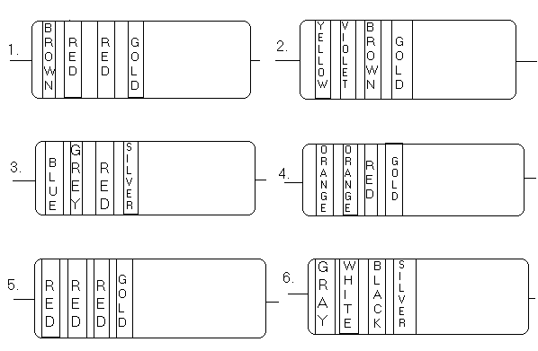

R# | First Color  & Value | Second Color  & Value | Third Color  & Value | Tolerance Color & Value | Resister Value | Tolerance  Minimum Maximum
1 | 1 | 2 | 00 | 5% | 1.2K | 60  1140 1260
2 | 4 | 7 | 0 | 5% | 470 | 23.5  446.5 493.5
3 | 6 | 8 | 00 | 10% | 6.8K | 680  6120 7484
4 | 3 | 3 | 00 | 5% | 3.3K | 165  3135 3465
5 | 2 | 2 | 00 | 5% | 2.2K Ohms | 110  2090 2310
6 | 8 | 9 |  | 10% | 89 Ohms | 8.9  80.1 97.9

Potentiometers are variable resistors. Score: ___________

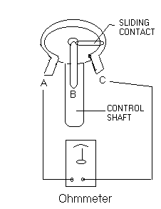 | Directions:  Turn the adjustment knob fully clockwise  and measure the resistance values between  all three leads. Repeat the process in the  fully counter clockwise direction, and  once again with the adjustment knob  about in the middle. Record your  measurements in the chart below.

Knob  Direction | Leads  Tested | Potentiometers
Clockwise | AB  BC  AC | Answers will vary depending on size of potentiometer
Counter-Clockwise | AB  BC  AC
Middle | AB  BC  AC

- Why is the measurement CCW and CC different? The sliding contact is in different place in relationship to the leads
- Explain how a potentiometer works and what they are made of. The sliding contact will move across the carbon causing a resistance, depending on the amount of carbon between the leads will determine the amount of resistance. AB + BC = AC

Test Your Knowledge score: ________________

- What is the basic unit of measure for capacitance?
Microfarads

- A potentiometer is another name for a:
  - Variable capacitor
  - Polarized capacitor
  - Fixed resistor
  - Variable resistor

- Place the number along side each color that corresponds to the color code found on a resistor.
  - White: ___9_
  - Orange: _3__
  - Gray: _8_
  - Red: _2_
  - Yellow: 4

- The fifth band on a resistor is used to describe:
  - Failure rate
  - How much current it will carry
  - How long the resistor will last

- When putting a resistor in a circuit, the end with the colored bands is:
  - Connected to (-) side of battery
  - Connected to (+) side of battery
  - Connected to either side of battery

- A capacitor:
  - Increases the current
  - Is used to store a charge in a circuit
  - Decreases the resistance of a circuit

- The three factors that affect capacitance are: (could be any answer, but A is best)
  - Surface area, distance between plates, and insulating material
  - Size, length, and voltage of the circuit
  - Material, timing, and size

- Before you pick up any capacitor, you should:
  - Touch the two leads together
  - Discharge it
- If exact replacement capacitors are not available, you should substitute:
  - Pick a lower working voltage
  - Capacitor with the same rating, but higher working voltage
  - Keep shopping

- Name three requirements of a complete circuit.

  - Source of power
  - Load
  - Path

- Define:

  - Dielectric: insulation inside a capacitor

  - Battery: 2 or more cells

  - Microfarad: measurement for capacitance

  - Ohms: measurement for resistance

- A wire wound resistor should be used when:
  - You run out of the other types.
  - Only when you need a variable resistor
  - When large amounts of heat must be dissipated to the surrounding air

