SCR Lab

Name: _____________________________ Period: ______________________

Directions: Follow the bread board image to build the SCR circuit and answer the questions.
Note: One side of the 1K ohm resistor is disconnected at the beginning of the lab.

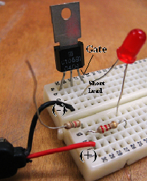

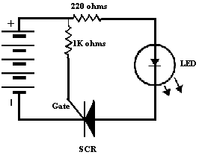

1. What happened to the LED when a 9 V battery was connected to the circuit?

2. Place the unconnected end of the 1K ohm resistor to (b26); what happened to the LED?

3. Disconnect the 1K ohm resistor from (b26): what happened to the LED?

4. Explain what must happen to the gate before the SCR will conduct and the resistor only plays a part of the solution.

5. The SCR is now conducting even when the 1K ohm resistor is disconnected; how does a technician turn off the SCR?

