SCR Lab

Name: _____________________________ Period: ______________________

Directions: Follow the bread board image to build the SCR circuit and answer the questions.
Note: One side of the 1K ohm resistor is disconnected at the beginning of the lab.

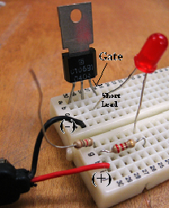

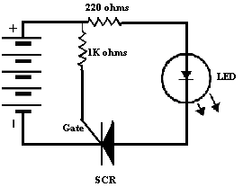

1. What happened to the LED when a 9 V battery was connected to the circuit? LED is off

2. Place the unconnected end of the 1K ohm resistor to (b26); what happened to the LED? LED turns on

3. Disconnect the 1K ohm resistor from (b26): what happened to the LED? LED stays on

4. Explain what must happen to the gate before the SCR will conduct and the resistor only plays a part of the solution. Voltage must be applied to the gate to make the SCR conductive, the resistor only limits/opposes the current in the circuit.

5. The SCR is now conducting even when the 1K ohm resistor is disconnected; how does a technician turn off the SCR? Turning off the source power

