Operating the Scorbot ER-3 Robotic Arm.

Lesson 1

Intro

The Scorbot ER-3 is an old robot. Perhaps older than you. Yes, Robots have been utilized in manufacturing for years now. This Trainer is very similar to many robots currently in use in many production capacities throughout the manufacturing industry.

Safety

The ER-3 is built of standard materials, and designed to be safe if handled properly. There is a danger of pinching at any joint, gear, belt, or gripper areas. Electrical shock is also a danger if someone tampers with the wiring setup.

Please do not move the robot by hand.
The ER-3 is made to be controlled by electronic means. It is carefully calibrated, and cost a lot to return to the manufacturer for recalibration.

Inventory

If you are ready to get started, we will begin with an introduction to the components of the ER-3 Robotics system.

- The Robotic arm.
- ControllerAzxzxcbvComputer w/ keyboard
- Wooden balls
- Ramp
- This manual

If any part of the system is missing, contact your instructor immediately. If any malfunction occurs with the robot inform your instructor immediately. Horseplay or any other misbehavior will result in your removal from the Scorbot operation portion of this project and your grade will suffer. You have been warned.

Robotic Arm components

The arm is a 5 axis robotic arm. By this we mean that there are 5 joints or points of control for you to manipulate. The more axis there are, the more control and dexterity your robotic arm will have.

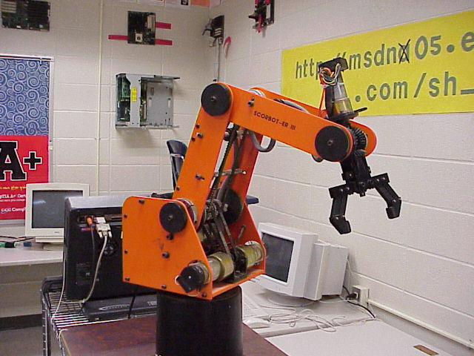

First axis

The first axis is the base. This allows the robot to rotate around the base stand that is it attached to. Notice the gearing mechanisms and motors used to move the robot arm. The robot is very heavy, so the motors and gears must be powerful. Imagine the pinch those can give. Stay away from them when they are in motion.

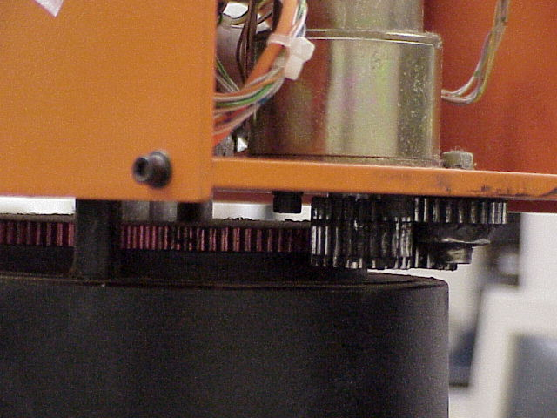

There is also a stop pin on the base that limits the movement to just under 360 degrees.

Second axis

The second axis is the shoulder. Many robotic components are referred to by their human counterparts: arms, shoulder, wrist, etc., because they act in a similar fashion.

The system is built using rubber pulley belts with gear teeth on them. This system provides the ability to reach a longer distance than one can access using a gearbox, and retain the non slipping aspects of gears. This is the most efficient way of working this type of control.

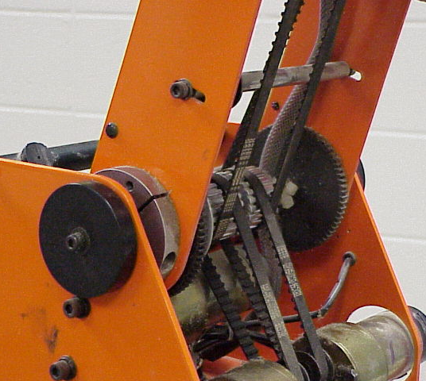
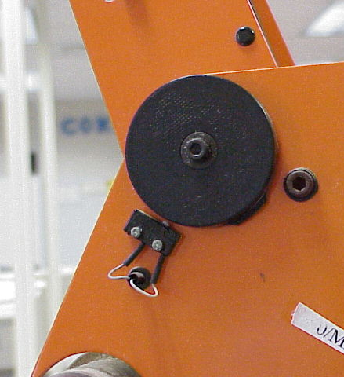

On the outside of the arm there is a plastic cover. It has a bump on it. When the arm moves to the point where that bump contacts the switch attached to the robot, it closes a circuit that turns off the movement of that axis in that direction. We call that a limit switch.

Third axis

The third axis is the elbow. This axis works much the same as the shoulder.

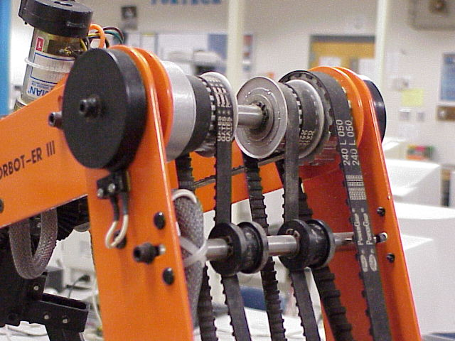

Fourth and fifth axis

The fourth axis is the wrist. This is often described as two axis in one location. Like the human wrist, the robot wrist can move up and down, in a waving motion. The fifth axis moves the wrist in a twisting, side to side motion. Unlike the human wrist, this rotational motion for some robots can be a full 360 degrees or more. This rotational movement is facilitated with the beveled gears in the wrist.

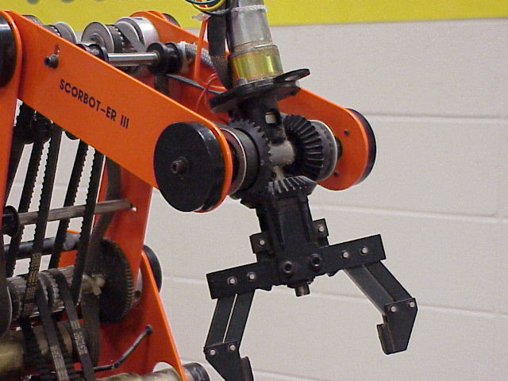

Effector

At the end of the robotic arm is a pair of grippers. They can be opened or closed. Grippers are not the only unit that can be at the end of a robotic arm. Since this is the case, the end is called an effector. Effectors can be grippers, electro magnets. Suction cups, welding tips, or even hypodermic syringes, just to name a few. Effectors are not considered an axis of movement, but are controlled much the same way as the other components.

Controller

The controller is the black box containing the electronic control parts that interface between the computer software and the robotic arm. It controls each motor, effector, and limit switch. There are switches for testing the motors and lights. Additional components such as lights, buzzers, etc. can be installed and controlled from the computer through this box.

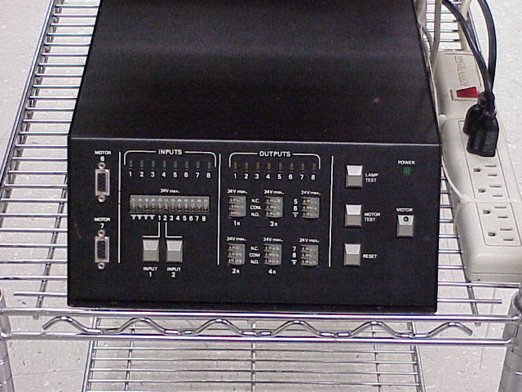

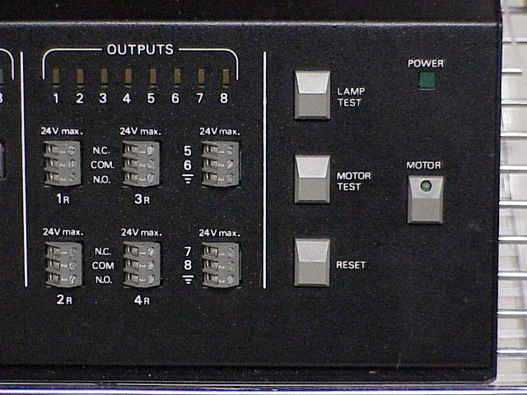

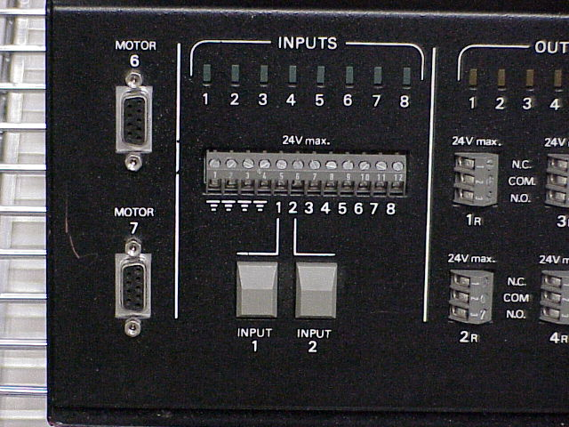
Lesson 2

Homing the Robot

The Scorbot ER3 is controlled by software run from a computer, or through a teach pendant. The software has been upgraded many times, but this model still uses a DOS based program. When you turn on the computer, it will automatically load.

- Plug in the system and turn on the computer.
- Turn on the controller box.
- Test the lights on the controller box by pressing the lamp test switch.
- Test the motors by first pressing the motor switch turning on the indicator light. Then press and hold the motor test switch. Each set of motors should go through a short movement test. Release when complete.
- When the computer finishes booting you should see the following menu on the screen.

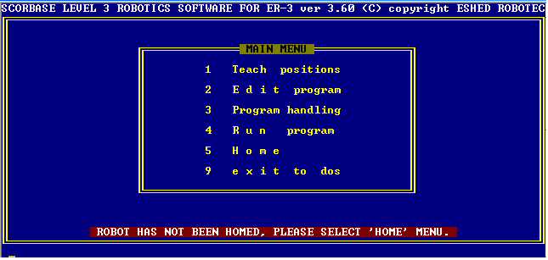

You will access each menu option by pressing the corresponding number button on the keyboard. To return to the main menu, press the ESC button.

You will notice that the menu has a warning displayed at the bottom in red. The robot has not been homed. When the robot is first turned on, it does not know exactly where any axis is in relation to any other axis. Home is a position from which all other movements are referenced from, so the first thing we must do is register Home on the system. We will have to do this each time we start to program. If we do not, the program may move and shift over time.
Step 1

Press the number 5 to go to the Home menu.

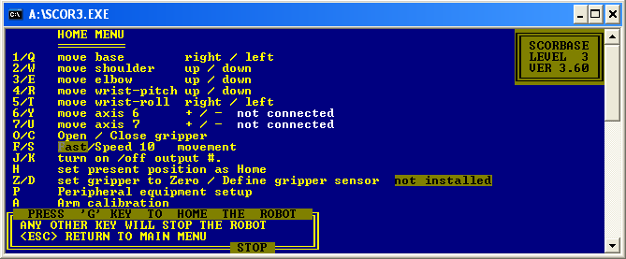

While you can move the robot using the keys as indicated on this menu, generally you would do this only if the robot is hanging up somewhere.

Step 2

Press the “G” key to home the robot

Step 3

Once the robot has been homed, press the ESC button.

You do not want to move the robot from within this menu.

Step 4

Press the 1 key to enter the Teach Position Menu.

For a robot to consistently and repeatedly move from position to position, the robot must have memorized a position to go to.
Lesson 3

Teaching Positions

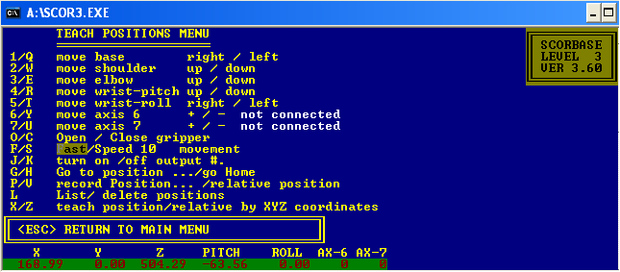

Home position can generally be considered to be somewhere in the mid range of any axis. To move a given axis, press one of the two buttons associated with it. (Example: press 1 or Q to rotate the arm on the base either clockwise or counterclockwise.)

Note axis 6 and 7 are not connected. These could be additional motors or devices added through the controller box.

If an axis is moved to its limits, the software will respond to the pressing of the limit switch by sending an error to the monitor. You must acknowledge the error before continuing.

Step 1

Try moving each of the axis.

Step 2

Home is a good position for a robot to remember. You can escape this menu, go to the Home menu and reset the robot to the home position since you have moved the robot. Do this now, and then return to this menu when the robot has been returned to its home position.

Step 3

With the robot in the Home position, press the “P” key. This will start the process of recording positions for the robot to remember. You will be given an option of entering a number between 1 and 100. Enter 1. NOTE: Movement of the robot can happen from any position to any other position. You can move from position 2 to position 73 to position 31 and back to 73. You can move in any order. The positions do not have to be sequential. We are marking the Home position as #1 as a good reference point from which we will always start and stop any program we run.

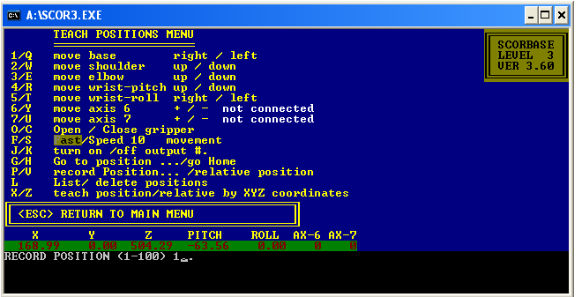

Step 4

You will notice we have not set the speed, nor opened or closed the gripper. This is only where we set the position. We will set these options during the program writing phase.
The speed may be adjusted to modify the rate at which you move the arm while teaching the positions. The options are between 1 – 10.

Move the robot using several different axis to a new position. Number this position #2.

Step 5

You now have two positions. Using the “G” key, tell the arm to go to position #1. Again use the “G” key and tell the robot to go to position #2. Now use the “H” key and tell the robot to go to the Home position. This should be the same as position #1.

“H” is useful for moving to home, but when programming, it is good to have it listed as a numbered position.

Step 6

Make several other positions and practice moving among them.
Step 7

By using the “L” key, you can list all the positions you have created and delete any you no longer wish to use. ESC from here returns you to the Teach Positions Menu.

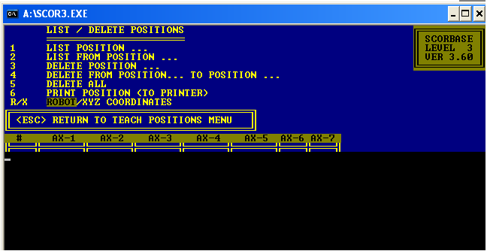

Lesson 4

Saving Positions

Step 1

You must escape the Teach Menu and return to the Main Menu. From there you need to enter the Program Handling Menu by pressing the “3” key.

From this menu you can save the positions you have created, so you can return at a later time and use these positions in a program.

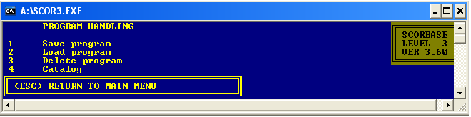

Step 2

Press the “1” key to save your program to the hard drive in the computer. You will be prompted for a name. You will return to this menu to load the program in the future.

Programs can be deleted, and a list, or catalog of saved programs can be seen here as well.

Lesson 5

Programming

Once a series of positions have been recorded, the movement between them can be programmed, as well as the speed, the opening and closing of the gripper, as well as the input or output devices connected to the controller box.

Step 1

From the Main Menu, press the “2” key to go to the program’s Edit Menu.
This menu looks similar to the other menus, but with a few different options.

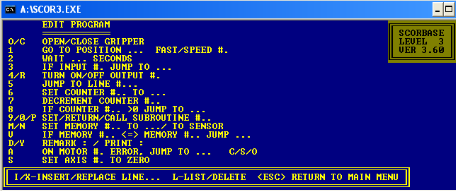

Step 2

Remember you should be starting all your programming from position #1. Using the “1” key, go to a given position. This will cause a line of programming to be written. You can adjust the speed of this movement by either entering the “F” for fast, or enter a speed number from 1 – 10.

Step 3

Repeat the process moving from position to position. If the grippers need to be changed from their “Open” or “Closed” state, press the “O” or “C” button before or after a given movement. There are other options we will not work with at this time.

Step 4

Lines can be removed or inserted, but this is frustrating and can generally be avoided if you think about your programming steps before you enter them.

Points to remember:

- The arm will move from position to position in the straightest line it can achieve.
- You may want to change the speed as you get close to picking up something.
- Extra positions can help smooth out a robot’s motions. Fewer positions are not always better.
- When trying to fine tune a position, change the speed to slow. You will see a finer control over the arms movement.
- Always start and end at Home.
- Save your program often.
- At the end of your time with the robot, Home it and turn everything off. Put away all loose materials and unplug the system.

Happy Programming ! !

