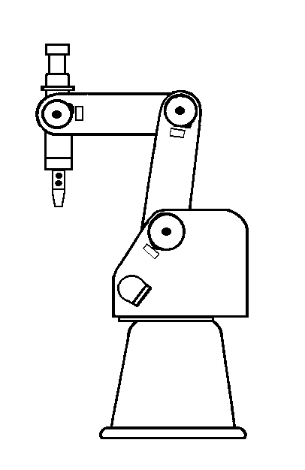
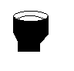
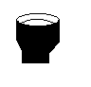
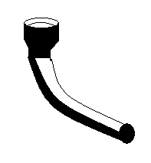





Position number worksheet:
***REMEMBER***:
Position and Open/Close of the claw are two different things.
Speed can be altered. Slow is better for fine tuning positions and running the drop/pickup points
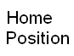

More positions provide smoother operations. You may add a few more if needed.
Make HOME position one.

