Boolean Worksheet

NAME:__________________________________

TASK:

Students will develop logic signal outputs to match the logic input.

1.
Output ?

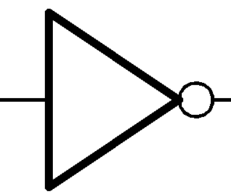
Input
1

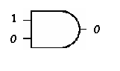
Input
A 1

B 0
2.
Output ?

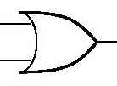
Input
A 1

B 0
Output ?
3.

4.

A B C
Input
A 1

B 0

5.
Input
A 1

B 0
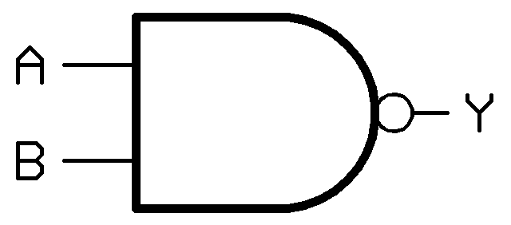
Output ?

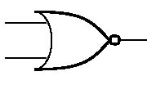
6.
Input
A 1

B 0

C 1
Output ?

A B C D
Input
A 1

B 0

C 1

7.

8.

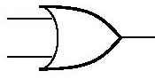
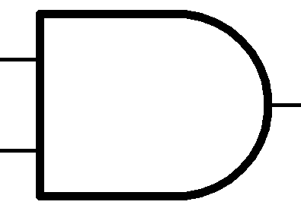
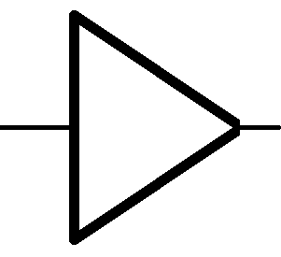
K
M
Input
A 1

B 1
1
D 1
F 0
Output ?
C
G
E
H
J
L
N

Boolean Worksheet Answers

- 0 An inverter will invert the 1 signal into a 0. Look for the O at the end of a gate. The triangle is most often left off.

- 0 AND gates will see the 1 and 0 input and give a 0 output. They must see 1s at all inputs to give an output of 1.

- 1 OR gates look for a 1 on any input. 1 in equals a 1 out.
A B C
1 0 0
- . AND gate. 1 + 0 = 0

- 1 Look at the end of the NAND gate. NANDs work like an AND gate in which the output is inverted after the ANDing (See the O at the end of the gate).

- 0 NOR gate. Works as above. Either of the 1 signals would generate a 1 output on an OR gate, but a NOR gate will NOT or invert the signal. YES, gates can have multiple inputs, not just the two you normally see demonstrated.

- 0 AND gate. Needs all three inputs to be 1s to give a 1 output.

- 1 Follow the signal flow. Inputs A & B on the AND gate J are 1s, so the output at C is 1. The output /now input C is ANDed in K with the 1 signal of D and gives a 1 output E. The 1 NOTed in the inverter L becomes 0 at G, and is combined with the F input of 0 in the OR gate M. Since 0 + 0 = 0 output H, combined with the input of 1 we determined at E in the NAND gate N will yield a 1 (0+1 in an AND gate is 0, NOTed in the NAND into a 1 output).

K
M
Input
A 1

B 1
1
D 1
F 0
Output ?
C
G
E
H
J
L
N

