Logic Circuits

NAME:__________________________________

TASK:

Students will use standard electronic components for simple circuitry to create a trainer to demonstrate logic gates and how they work. Students can create a NOT, OR, NAND, or NOR gate. An example of a system is shown below:

CRITERIA:

Students will mount their logic gate on a platform as determined by the instructor. This may be a piece of wood, plywood, foam-core, cardboard, or other base.

The system should be able to simulate the type of gate intended by lighting the bulb in the system using a standard dry cell battery for an energy source.

Individual gates should be constructed in such a manner as to allow other gates to be combined to create a more complex circuit.

Gates should have from 1 to 4 inputs. (yes, they could have even more, let’s keep it simple).

Components should be held down on the demonstration board in such a way as to facilitate removal at the end of the project allowing for the recycling of the components for future projects.
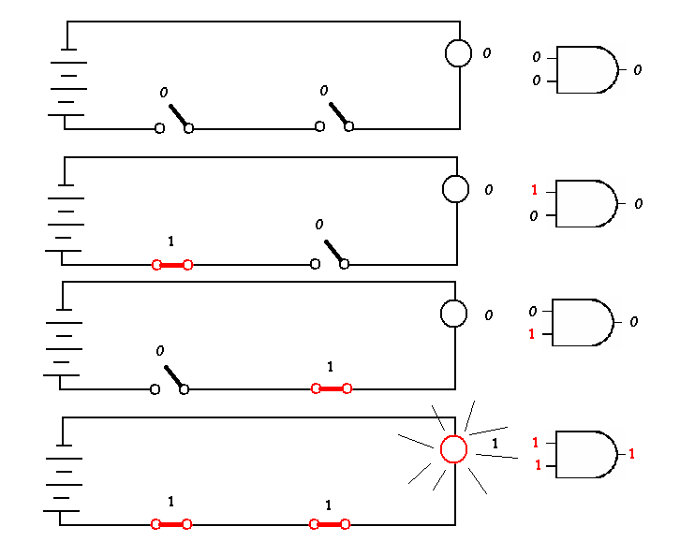
EXPERIMENT:

This is an example of an AND gate.

This requires a battery
Two switches, a lamp,
And some wire.

When no switch is thrown, the result of two zeros, or FALSE signals in yields a FALSE signal out (lamp).

Even when one switch is engaged, or turned to 1 or TRUE, the output remains False.

When both switches are engaged, or set to TRUE, then the AND gate send a TRUE signal out, and the lamp glows.

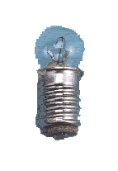
This is the truth table for the AND gate.
A B C
0 0 0
1 0 0
0 1 0
1 1 1
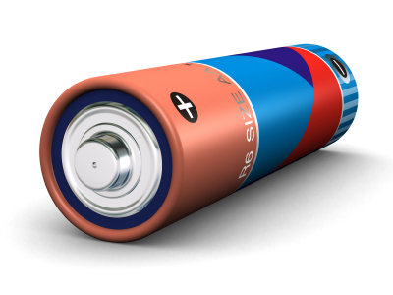

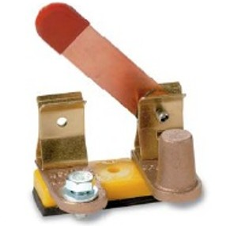

FOLLOWUP:

1. After demonstrating your logic gate, combine your gate with two other gates and as a team demonstrate the more complex setup. Create a truth table for your new logic circuit.

EVALUATION:

Points | 50 | 40 | 30 | 20
Gate  #1 | Gate constructed neatly; logically demonstrates the operations of the chosen gate; Truth table is accurate. | Gate constructed; demonstrates the operations of the chosen gate; and a Truth table is presented. One is possibly wrong or poorly done. | Gate constructed; demonstrates the operations of the chosen gate; and a Truth table is presented. More than one is possibly wrong or poorly done. | Gate not constructed; does not demonstrate the operations of the chosen gate; or the Truth table is missing. More than one or all possibly wrong or poorly done.  .
Followup  Gate  Experiment | Gate works with two other gates. Truth table is correct. | Gate works with one other gate. Truth table is correct or Gate works with two other gates, but Truth table is incorrect. | Gate works with one other gate. Truth table is incorrect. | Gate does not work with other gates. Truth table is incorrect.

