Robotic Sensors

http://www.robotshop.ca/sensors.html Contains LEGO, VEX, INEX, PHIGETS, and a slew of other custom components for robot construction.

http://www.robotstorehk.com/index.html Another supplier of parts. Authorized distributor for the MIT Handy Board. http://www.handyboard.com/ Handy Board is a stripped down (cheaper) version of the early RCX Lego controller, minus the case. Programs in a version of LOGO. Great for custom robotic projects.

NXT

http://mindstorms.lego.com/eng/Overview/default.aspx LEGO’s own site. Detailed information about the capabilities of each optional sensor, motor, or other attachment is ready to hand.

http://www.ortop.org/NXT_Tutorial/ This site has embedded flash video giving the essential, and advanced information on programming the LEGO NXT

http://en.wikipedia.org/wiki/Lego_Mindstorms Links to many programming languages that may be used instead of the NXT or older RCX software provided with the Mindstorm kits, and community links to educators, hobbyist, and others interested in robotics.

Sensors:

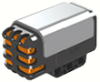
Sound sensors measure sound levels. If you are in a competition situation, or in a noisy classroom, this unit might not function quite as well as one would hope. Sound can also be an output, as well as an input. For instance, if programmed correctly, when a robot hits the wall and presses a touch sensor, the sound unit may emit a tone, or even play a wave file, “Ouch”.

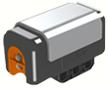
The light sensor can operate in two ways. It can shine a light from a red LED, which the sensor then reacts to the amount of light reflected back by a given surface. The other method is to use the sensor alone, and record the ambient light reflected from a surface.

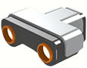
Ultrasonic sensors measure distance, and can often work in a range from 2 to 4 feet.

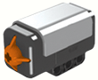
Touch sensors are simply switches located in appropriate locations to give feedback when pressed in, or when released.

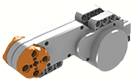
Motor / wheel rotations can be monitored through the built in motor sensors. This motion can be monitored in either full rotations or in degrees, +/- 1 degree (360 degrees in a full rotation) in either direction. Feedback can be monitored through software, a USB cable, and a computer.

VEX

http://www.vexrobotics.com/vex-sensors-products.shtml Vex robotic sensors from the manufacturer. Sensors include limit switches, bump switches, potentiometers, analog accelerometer, light sensor, line tracking kit, optical shaft encoder, and ultrasonic range finder. Many of these sensors require the purchase of a programming module, however one module may be used for multiple robots and programs.

http://www.chiefdelphi.com/forums/index.php Major VEX user forum. Many competition teams, mentors, and informed hobbyist post on these forums. Many answers can be found here, but if not, ask, and you shall receive some feedback.

http://www.vexforum.com/ Another fine forum dedicated to the VEX platform. Membership is free. Just register.

http://www.vexfan.com/ A community for Vex Robotics fans.

http://users.wpi.edu/~bamiller/VexProgramming.wmv A very good primer for EasyC programming. While it deals with motors only, it is a good point for starting with sensor setup & programming.

Sensors:

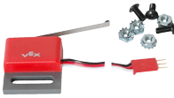
Limit switches are often used to signal the micro controller that a component such as an arm has reached the limit of its movement range.

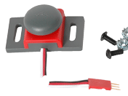
Bump switches operate the same as limit switches sending a signal to the micro controller. They are used often as bumpers, allowing mobile robots to “bump” into objects and send that info to the controller. They are ruggedly built to take the abuse.

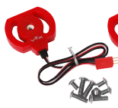
Potentiometers measure angular position, and therefore are useful in determining both position and direction of rotation.

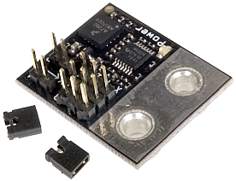
Analog accelerometers can measure acceleration on three axis simultaneously. The velocity of a robot and the distance traveled can be calculated. They are also useful in determining if a robot is moving, stopped, or has collided with something.

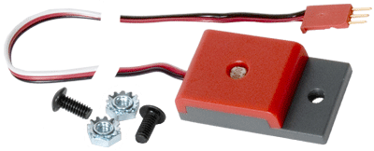
Light sensors use a photocell to detect and react to light. Following a light signal, or avoiding obstacles can be part of a program developed using this unit. Colored filters will allow even greater control over the robot.

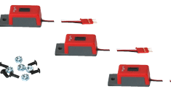
The Line tracking kit allows the robot to be programmed to follow a black line on a white background, or other light sensing operations.

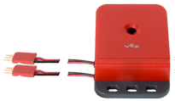
Optical shaft encoders provide two outputs, allowing for both direction of rotation and positioning of a shaft. You can measure distance or speed with greater accuracy than with an ultrasonic or IR units.

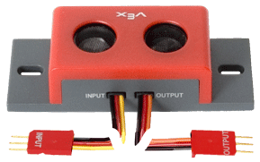
Ultrasonic range finders can determine range to objects and avoid them. The unit emits a high frequency sound wave that works similar to how bats catch bugs in mid flight, then swerve to avoid obstacles.

