Sensor Crossword Puzzle Answers

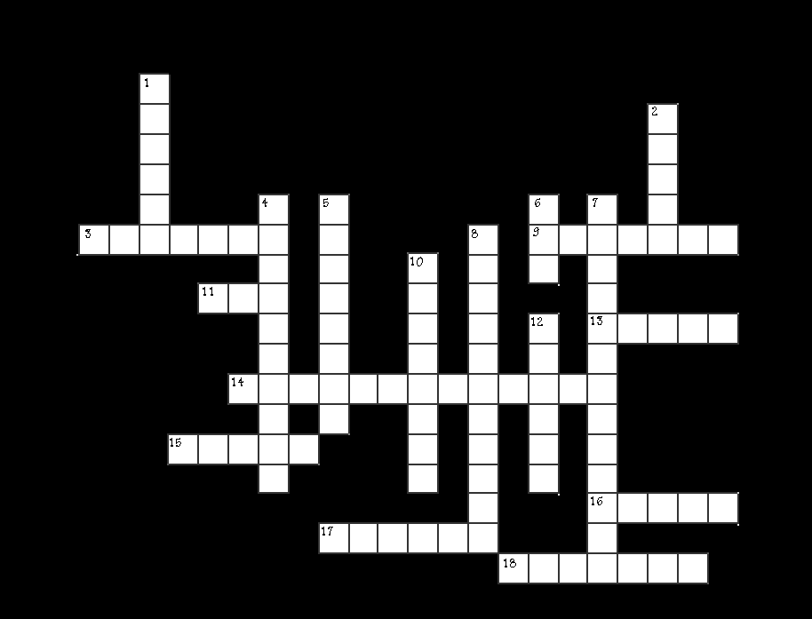

ACROSS

3. Signal that is based on 1 and 0; on and off digital
9. Device used to convert one type of signal into another encoder
11. Force sensing resistor FSR
13. Sensors that operate in the visible electro magnetic spectrum light
14. Variable resistor used to help select sensitivity of a unit potentiometer
15. Sensor or switch used to halt a robot at a range point limit
16. Sensors that operate through applying force touch
17. Motion that goes in a straight line linear
18. Rotation of a wheel can be broken down into these degrees

DOWN
1. Signals found in nature are of this type. Opposite of digital analog
2. Sensor that picks up audio waves humans can hear sound
4. Sensor that works in audio wave ranges humans cannot hear ultrasonic
5. Light frequency used for short distance communications infrared
6. Diode used for a visual indicator LED
7. Used to determine speed and direction accelerometer
8. Responsible for sending signals transmitter
10. Responsible for collecting sent signals receiver
12. Motion that goes around in a circle rotary

