Sensor Crossword Puzzle

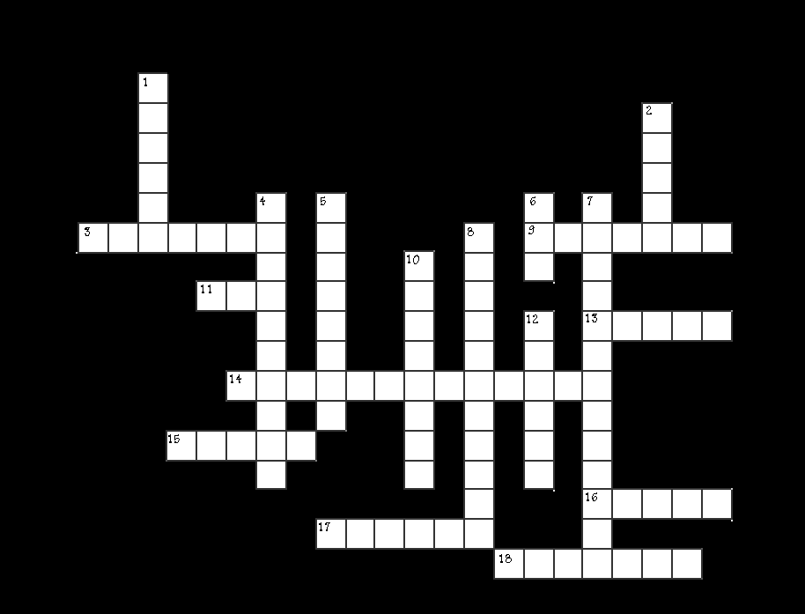

ACROSS

3. Signal that is based on 1 and 0; on and off
9. Device used to convert one type of signal into another
11. Force sensing resistor
13. Sensors that operate in the visible electro magnetic spectrum
14. Variable resistor used to help select sensitivity of a unit
15. Sensor or switch used to halt a robot at a range point
16. Sensors that operate through applying force
17. Motion that goes in a straight line
18. Rotation of a wheel can be broken down into these

DOWN
1. Signals found in nature are of this type. Opposite of digital
2. Sensor that picks up audio waves humans can hear
4. Sensor that works in audio wave ranges humans cannot hear
5. Light frequency used for short distance communications
6. Diode used for a visual indicator
7. Used to determine speed and direction
8. Responsible for sending signals
10. Responsible for collecting sent signals
12. Motion that goes around in a circle

