Fashion Capitals
Name________________________________________
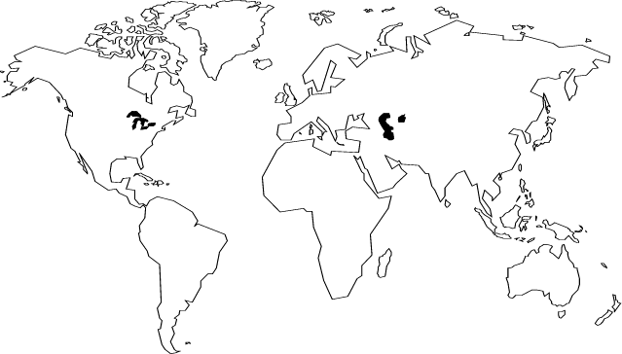
List the 5 fashion capitals and mark them on the map. Also list two designers from each capital.
1. Milan, Italy
Giorgio Armani
Versace

2. Paris, France
Chloe
Givenchy
Valentino

3. London, England
Bodymap
Nick Coleman
Pam Hogg

4. New York, U.S.A
Calvin Klein
Scaasi
Bill Blass

5. Tokyo, Japan
Jin Abe
Barbara Bui
Hanae Mori

