Merchandise Fixture Experience
Build a Department

Using the department floor plan prepare a layout. Trace the fixtures from Figure 1 on to the floor plan. Arrange the fixtures so that the department looks balanced, not lopsided. Stock the newest merchandise to the front of the department. Allow sufficient aisle space so that customers may move freely. Following are the merchandise items and fixtures needed. When you have developed a layout that you like, label each fixture symbol with the number that corresponds to the listed merchandise to be displayed on that fixture.

- New arrival coordinate group in black and white, on a quad.
- New arrival dresses, on a half-round rack.
- Clearance dresses, on a round rack.
- Clearance skirts, sweaters, louses, and pants, on a round rack.
- New arrival sweaters, bulky knits, on a round rack.
- Sweaters, on a round rack.
- New arrival coordinate group in red and gray, on a quad.
- Skirts, on a round rack.
- New arrival sweaters and blouses on a T-stand.
- New arrival coordinate group, black and white, on a T-stand.
- New arrival coordinate group, red and gray, on a T-stand.
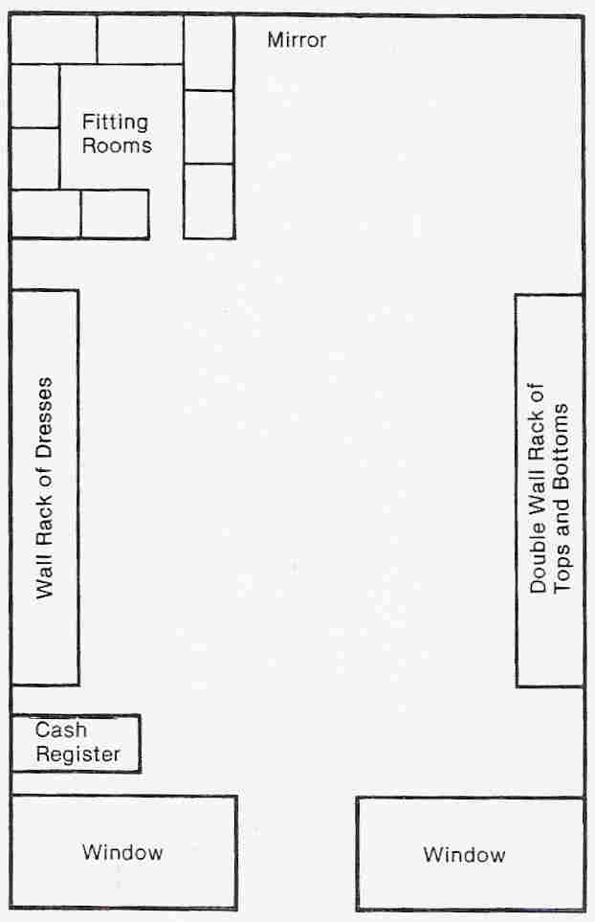
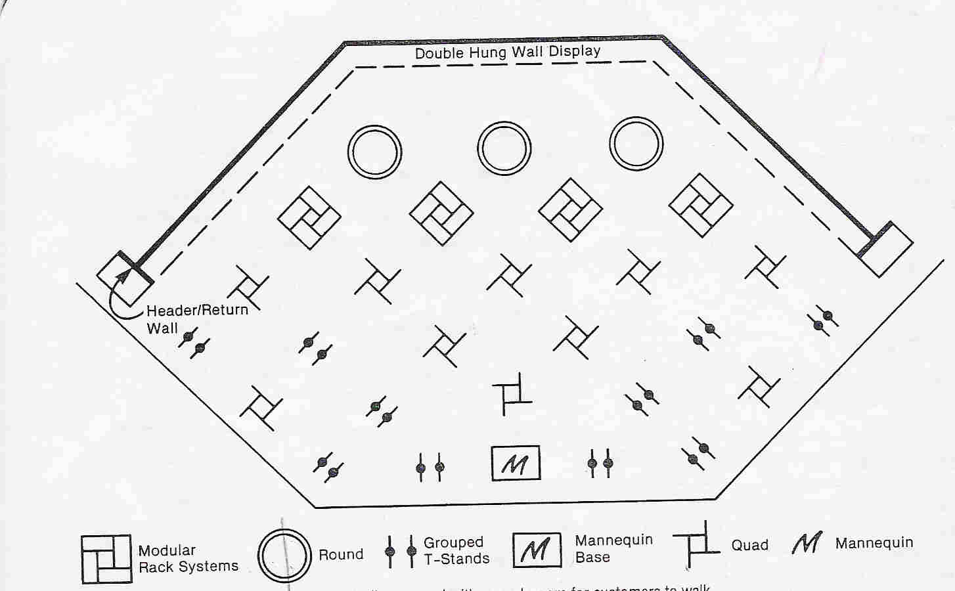
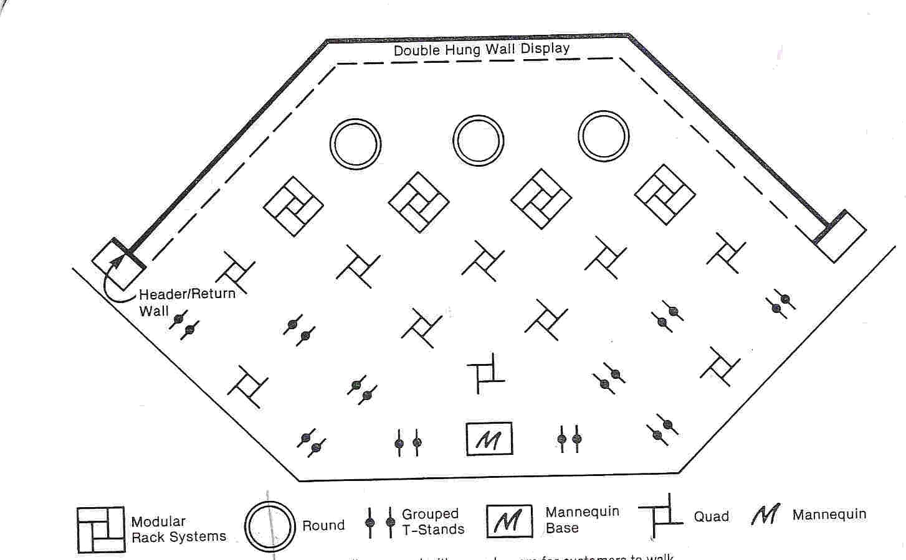
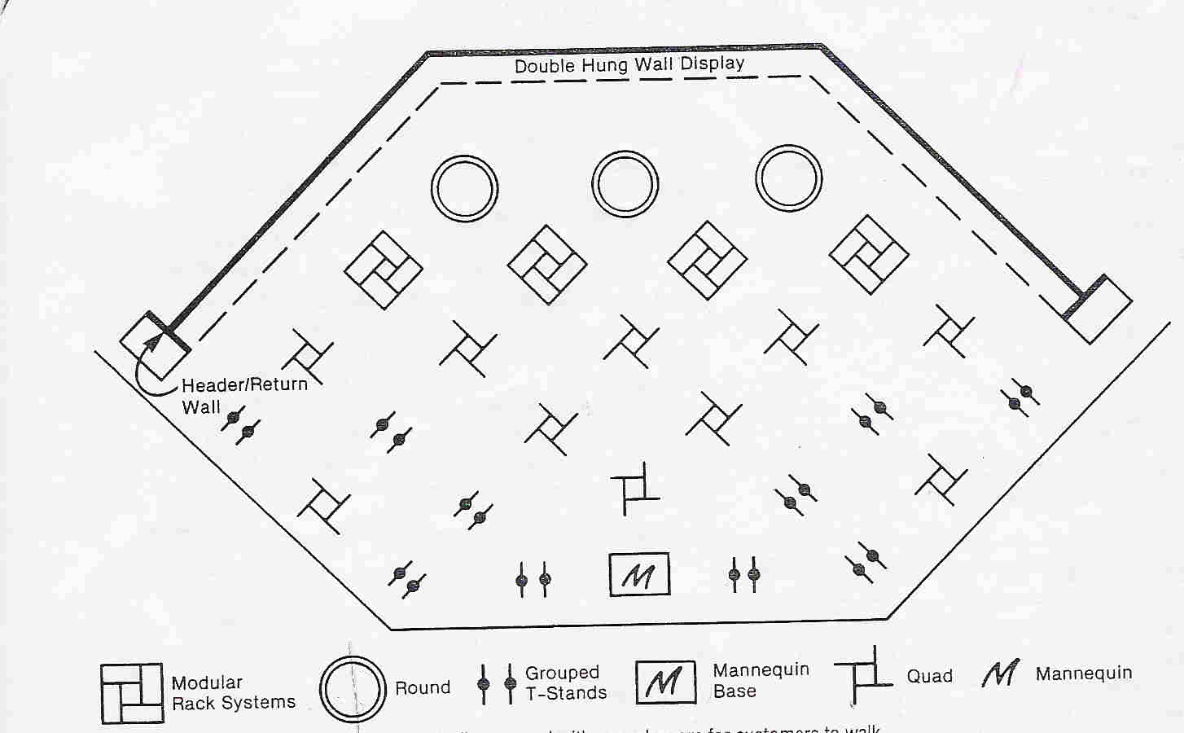
- New arrival dresses on a T-stand.
#1
#2
#3
#4
#5
#6
#7
#8
#9
#10
#11
#12
#13
#14
#15
- Jewelry rack, on a square rack.
- Jewelry rack, on a square rack (jewelry and scarf).
- Hosiery rack, on a square rack.

