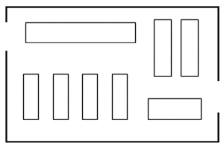
The straight floor plan is an excellent store layout for most any type of retail store. It makes use of the walls and fixtures to create small spaces within the retail store. The straight floor plan is one of the most economical store designs.
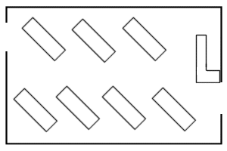
The diagonal floor plan is a good store layout for self-service types of retail stores. It offers excellent visibility for cashiers and customers. The diagonal floor plan invites movement and traffic flow to the retail store.

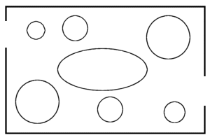
The angular floor plan is best used for high-end specialty stores. The curves and angles of fixtures and walls makes for a more expensive store design. However, the soft angles create better traffic flow throughout the retail store.
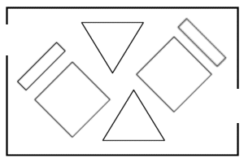
The geometric floor plan is a suitable store design for clothing and apparel shops. It uses racks and fixtures to create an interesting and out-of-the-ordinary type of store design without a high cost.

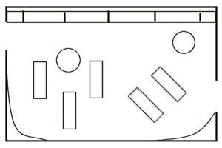
The mixed floor plan incorporates the straight, diagonal and angular floor plans to create the most functional store design. The layout moves traffic towards the walls and back of the store.

