Merchandise and Fixture Placement

Salespeople, department managers, and buyers make decisions daily about how merchandise and fixtures should be displayed in a department. How can new items receive the best customer exposure? How should the department be arranged so that customers feel comfortable? How much merchandise can a display fixture hold and still allow customers to easily examine the merchandise? How can shoplifting of the smaller items be reduced? When making these decisions, customer convenience, security, and ease of restocking are considered.

Merchandise Rotation and Arrangement

Merchandise items that are visible from the entrance of a department have a much better chance of being seen and purchased by customers. However, because there is limited space at the front of a department, merchandise must be rotated or moved. Merchandise that is not selling on quads or A-frames may become the hot item when displayed on T-stands at the front of the department. Moving merchandise to another rack is a better way to stimulate sales than mark-downs.

New merchandise should always be displayed in the front of the department. To motivate customers who are shopping for marked-down items to walk through the department, clearance racks should be in the back. Merchandise in the same classification should be grouped on adjacent fixtures. Related merchandise classification should be placed nearby. For example, the complete selection of moderately prided casual tops should be contained on fixtures that are next to each other casual bottoms should be displayed next to the casual tops, rather than next to unrelated items such as formal dresses or raincoats.

Most stores “remerchandise” their selling areas often, moving merchandise from one fixture to another. These floor moves give the department a fresh look. Regular customers get the feeling that there is always a selection of new merchandise in the store. Floor moves also consolidate remaining merchandise to make room for new goods.

Fixture Placement

Fixture placement affects the way customers move around the merchandise in a store. When racks are too close together, customers have trouble walking down the aisles and moving among the fixtures. A crowded arrangement makes it difficult for them to find coordinating merchandise, walk to the fitting room, or locate the cash register. Some guidelines for helping you plan fixture placements are:
- Place the lighter fixtures, such as T-stands, in the front of the area.
- Progress from the lighter fixtures to taller, heavier fixtures. For example, place quads behind T-stands. Place rounders after quads.
- Arrange fixtures in a symmetrical configuration within the area. (see Figure 1. below)
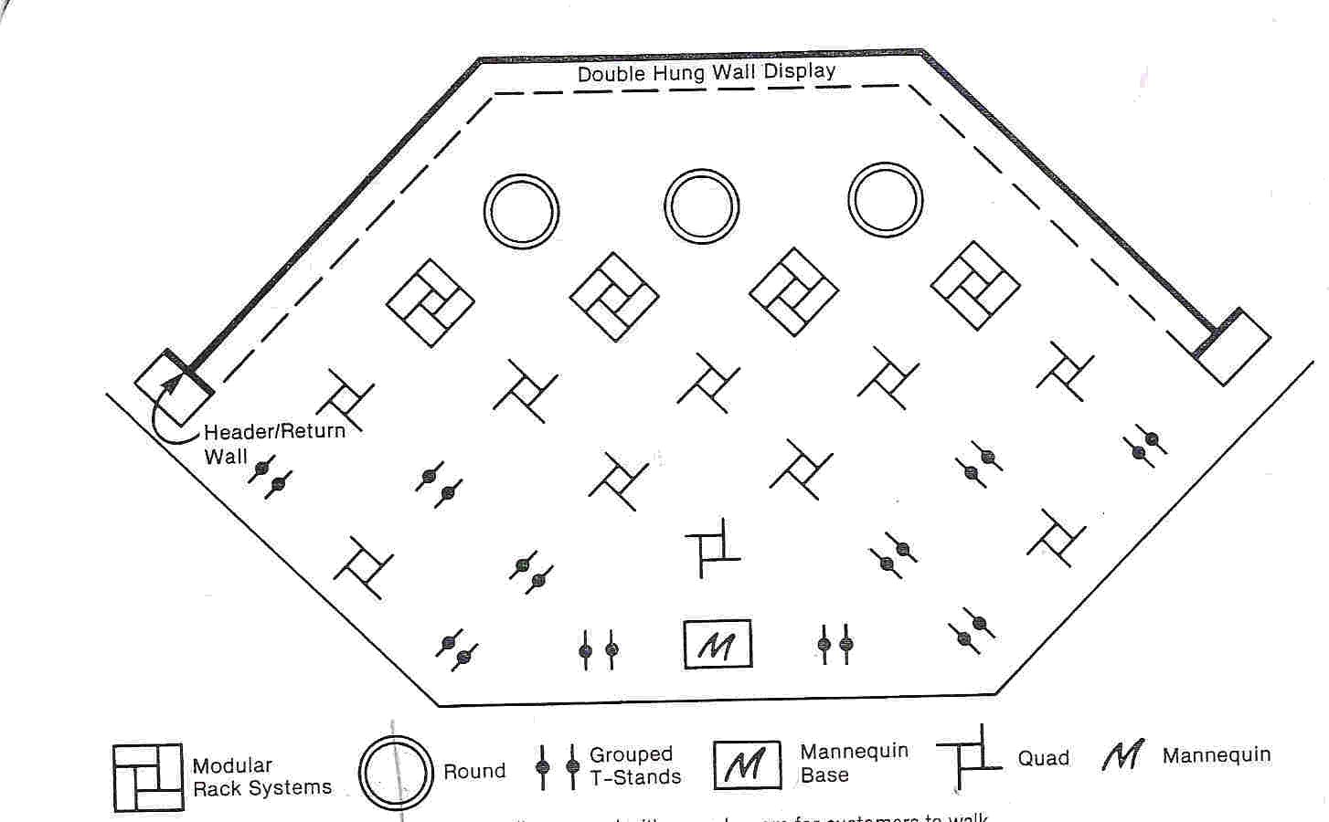
- Keep the aisles wide enough for rolling racks and bins containing new stock to move onto the selling floor.

Figure 1. This floor plan is symmetrically arranged with enough room for customers to walk around the fixtures and see the merchandise on display.

