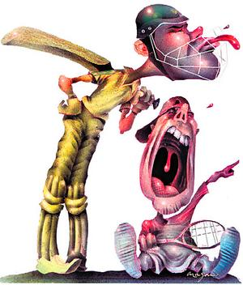

“Fat Head” Project

You will create a “Fat Head” of a professional sports player who played in the sports in college and research their career from amateur to professional. You may either trace your body and cut it out and draw it to look like the player or you may download an image from the Internet and use a transparency to trace it to the appropriate size.

You will then research the following information and include it on the back of your “Fat Head”:

Item | Description | (4) Excellent | (3) Good | (2) Fair | (1) Poor
Title/Introduction | - Definition of college, amateur, & professional sports  - NCAA description  - Economic Impact Description
Professional Athlete (from pro team) | - Choose pro athlete from pro team choice)  - Biography & History of Athlete  - Current/Recent agent  - Awards/Achievements  - Endorsements  - Community Outreach  - Economic Impact
Collegiate Team  -Describe the collegiate team the player began his/her career | - Location of team  - Brief background of team  - Athletic Director w/ brief biography  - Coach of Team  - Major Championships  - Description of financial impact of collegiate teams
Professional Team (  -Describe the professional team the player is currently playing sports | - Location of professional team  - Brief description of the team  - Owner of the team – brief biography  - General Manager/Coach of the team – brief biography  - Significant players (past & current)  - Championships  - Economic Impact
Credits | - Put all sources used to gather information as your credits

