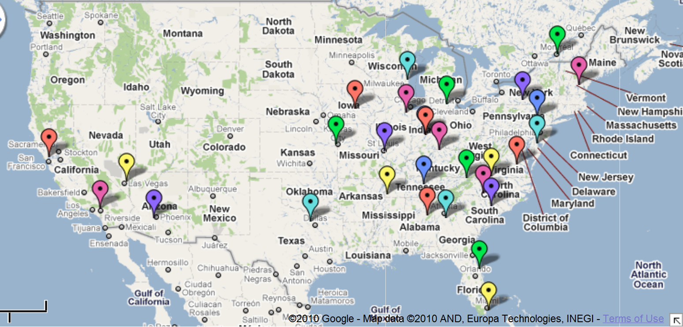
NASCAR Track Map

Infineon Raceway | Chicagoland Speedway | Talladega Superspeedway | Circuit Gilles Villenueve
Auto Club Speedway | Gateway International Raceway | Atlanta Motor Speedway | New Hampshire Motor Speedway
Las Vegas Motor Speedway | Memphis Motorsports Park | Daytona International Speedway | Watkins Glen International
Phoenix International Raceway | Michigan International Speedway | Homestead-Miami Speedway | Pocono Raceway
Texas Motor Speedway | O’Reilly Raceway Park | Bristol Motor Speedway | Dover International Speedway
Iowa Speedway | Indianapolis Motor Speedway | Martinsville Speedway | Richmond International Raceway
Kansas Speedway | Kentucky Speedway | Charlotte Motor Speedway
Road America | Nashville Superspeedway | Darlington Raceway

