The key stages of market research and new product development
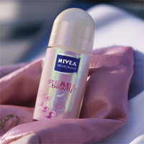
Market research involves the systematic gathering, recording and analyzing of data about customers, competitors and the market. This links marketers to consumers by supplying essential information to solve marketing challenges and help with marketing decisions.
Market research helps a company create and develop an up-to-date and relevant portfolio of products.

Creating new products
Beiersdorf's international Market Research team is based at company headquarters in Hamburg, Germany. The team's objective is to be the voice of the consumers within the organization. High-quality market research has helped secure the long-term future of the business. Analyzing and understanding the data gathered on consumers' behaviors, needs, attitudes and opinions minimizes the risks involved in making marketing decisions.
Market research in a global organization needs the help and support of the company's overseas affiliate companies. Most affiliate companies (in the UK for example) have dedicated Market Research Managers.
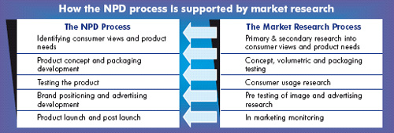
They help the central research team in gathering and interpreting consumer views. These views provide information or insights that ultimately result in the development of new products suitable for a global market.
This case study follows the development of a new NIVEA Deodorant called Pearl and Beauty aimed at young women. This case study will give you a clear picture of how market research has helped New Product Development (NPD).

Identifying consumer views and product needs – where to start?
Market research should start with the consumer and serves two purposes:
1) To inform companies about consumer needs and desires. What are the trends in the market? What do consumers want?
2) To give consumers the opportunity to talk to the providers of products and services so that their views are taken into account.

Businesses exist in a fast-moving world with increased consumer choice. It is essential that a company knows its market and its consumers before developing any new product. Lots of questions need answering.
Consumer insights drive New Product Development. This information takes into account their behaviors, attitudes and beliefs. It is an expression of their wishes and desires. Businesses use consumer insights to create opportunities for their brands. It is the starting point that enables brands to fit meaningfully into consumers' lives.
Across countries, consumers are different in terms of culture and lifestyle. NIVEA's challenge was to find similar insights from consumers across different countries. This was used to optimize product development.

Secondary research
In the deodorant category, NIVEA used many secondary research sources to discover consumers' views and their need for deodorants. These related to different markets and were supplied by local country market researchers. These included:
i. A consumer Usage and Attitude study. This had been conducted a few years earlier across various markets (UK, France and USA).
ii. An external study by Fragrance Houses. This covered the importance of scent and fragrance to people's well-being and mood.

Primary research
The research team felt therefore there was not enough recent knowledge about the consumer in the secondary research. They commissioned some primary qualitative research in key markets (Germany, France, UK and USA). This was aided by the local Market Research Manager. The aim was to understand the motivations for using deodorant amongst the female consumer.
Primary research is used when there is no existing data available to answer your questions.
The research involved small discussion groups of females. This helped researchers understand the beliefs and motivations of this group. There were several main findings:
- There is steady growth in females shaving. They wanted to look after their underarms throughout all seasons (not just in summer).
- Women cared increasingly about the condition of their underarms.
- Women desired attractive, neat underarms. This symbolized sensuality and femininity.
- The deodorant segment remained focused on functional rather than beautifying products.

Results of the research
The market research revealed an unexplored market potential for NIVEA Deodorant. The brand did not have a specific product that addressed 'underarm beauty' for the female consumer. No direct competitor was offering a product to meet these needs. So there was a clear opportunity to develop a new product. This would fit across different markets and with the current NIVEA Deodorant range.

Turning consumer insights into product concepts
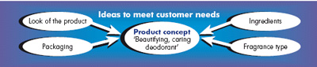
Consumers showed a need for a 'beautifying, caring deodorant'. The team generated ideas on how to address the consumer need.
From these ideas the marketing team created 'product concepts'. These describe the product benefits and how they will meet the consumer needs. Several concepts were written in different ways. These explained and expressed unique product attributes.
The company needed to know which concept was preferred by prospective consumers. It carried out market research to test whether the concepts would work. The research was conducted amongst the desired target market. For Pearl and Beauty, the desired target market was 18-35 year-old women who were beauty-orientated, followed fashion and looked for products with extra benefits.
Quantitative research on the concept was carried out in two test markets (France and Germany). An international company like Beiersdorf must test products in more than one market to assess properly the global appeal.
The concepts were tested monadically. Monadic testing means that the respondent of the test is only shown one concept. This stops the respondent being biased by seeing many variations of the same product concept.
A number of criteria were used to test the concepts:
1) Deodorant category performance measures. These included wetness, dryness, and fragrance. The new concept must deliver generic core benefits.
2) Product attributes specific to the new product and NIVEA core values. The new Pearl and Beauty product has additional benefits to a 'regular' deodorant. For example, it leaves your skin feeling silky and gives you beautiful underarms. Consumers needed to understand and see these benefits.
3) The product needed to be relevant and motivate a consumer to purchase it.
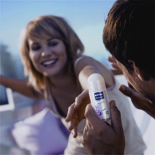
The team chose the 'winning' concept. This best conveyed beauty while remaining relevant to the deodorant category and NIVEA brand.
Next the research team tested various name ideas for the product and developed different designs for the packaging. Packaging design plays a very important role in helping to communicate the image of the product. Pearl and Beauty needed to communicate femininity and sophistication. Pink was a natural color choice for the packaging. They also used a soft pearlescent container to emphasize the 'pearl extracts' in the product.
Various design ideas were tested using quantitative market research. In addition, this helped to predict the volume of the new products that would be sold, the optimal selling price and the level of switching from existing NIVEA Deodorant and competitor products.

Testing the product, brand positioning and advertising
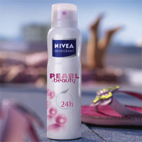

Testing
The stages described so far produced a product concept that consumers felt was relevant and which they were willing to buy. The next stage was to test the product on actual customers. Many product launches fail, despite great advertising. A big reason is because the product fails to live up to the promises made.
The Market Research Team conducted a product usage test. A de-branded sample of the proposed new product was given to the target consumer of females in several countries. De-branded means the deodorant was in a blank container so that the consumers did not know who made the product or what type it was. Very often consumers form opinions about products and services from advertising and packaging. This can sometimes be very strong and creates a bias in what they think of a product before trying it.
The consumers were asked to use the new deodorant for a week. They kept a diary of when they used it and scored the performance of the deodorant against a list of criteria. These included:
- Did it keep you dry all day?
- Did you have to reapply it?
- Did you like the fragrance?
- Did it last all day?
- Was the deodorant reliable?
Consumers applied the 'de-branded' deodorant under their right armpit and continued to use their current deodorant under their left armpit. This helped the users gauge if it was as good as or better than the brand they normally used. This gave a measure of how likely the consumer would be to swap brands.
The results of the test were very positive. Most consumers loved the fragrance and the feel of the product on their skin. They felt it performed as well as their current deodorant. Most said they would swap their brands after trying the product.

Brand positioning
Now the marketing team had a new product idea that consumers liked. It had a name and packaging design that were well received. They now needed to check how this fitted with the rest of the NIVEA Deodorant brand positioning and range.
The brand position is the specific niche in the market that the brand defines itself as occupying.
The NIVEA Deodorant Pearl and Beauty adds a touch of feminine sophistication and elegance to the NIVEA Deodorant brand's personality. This built on the core deodorant positioning. It made NIVEA Deodorant more appealing, modern and unique to trendy, young female consumers.

Using qualitative research to inform advertising
The next stage was to brief an advertising agency to develop communication to support the launch of the new product. Through market research the team could check whether the advertisements positively supported and communicated the new product.
The company conducted qualitative research on some advertising ideas amongst various groups of the target consumers. It presented ideas in the form of 'storyboards' of what a TV advert could look like. The objective was to evaluate which ideas were best in terms of:
- Did they stand out as exciting or different?
- Were they relevant to the consumer?
- Did they communicate the right things about the new product?
- Did they persuade the consumer to want to purchase the product?

Evaluating success
Once the product is launched and the consumer can actually purchase it, the research process does not stop.
Continuous consumer tracking can be carried out to find out consumers' views of the new product. This involves interviewing people every day to find out whether they are using the product, what they think of it and why they would purchase it.
Beiersdorf uses other, secondary data sources such as consumer panel data and EPOS (electronic point of sale) data. These monitor the sales effectiveness of the product throughout the launch phase and through the product life cycle.

Conclusion
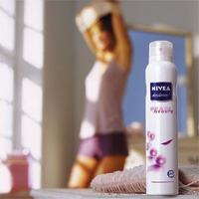
New product development should start with an insight based on consumer needs.
Throughout the NPD process, market research is a valuable tool for Beiersdorf to check viability and minimize the risk of the product launches.
Being an international company, it is essential that Beiersdorf develops new products using the insights of consumers across markets and cultures. This ensures the products are relevant to a large number of global consumers and will deliver the maximum return when launched.
This maximizes return on investment for the company and results in happy, satisfied and loyal consumers

