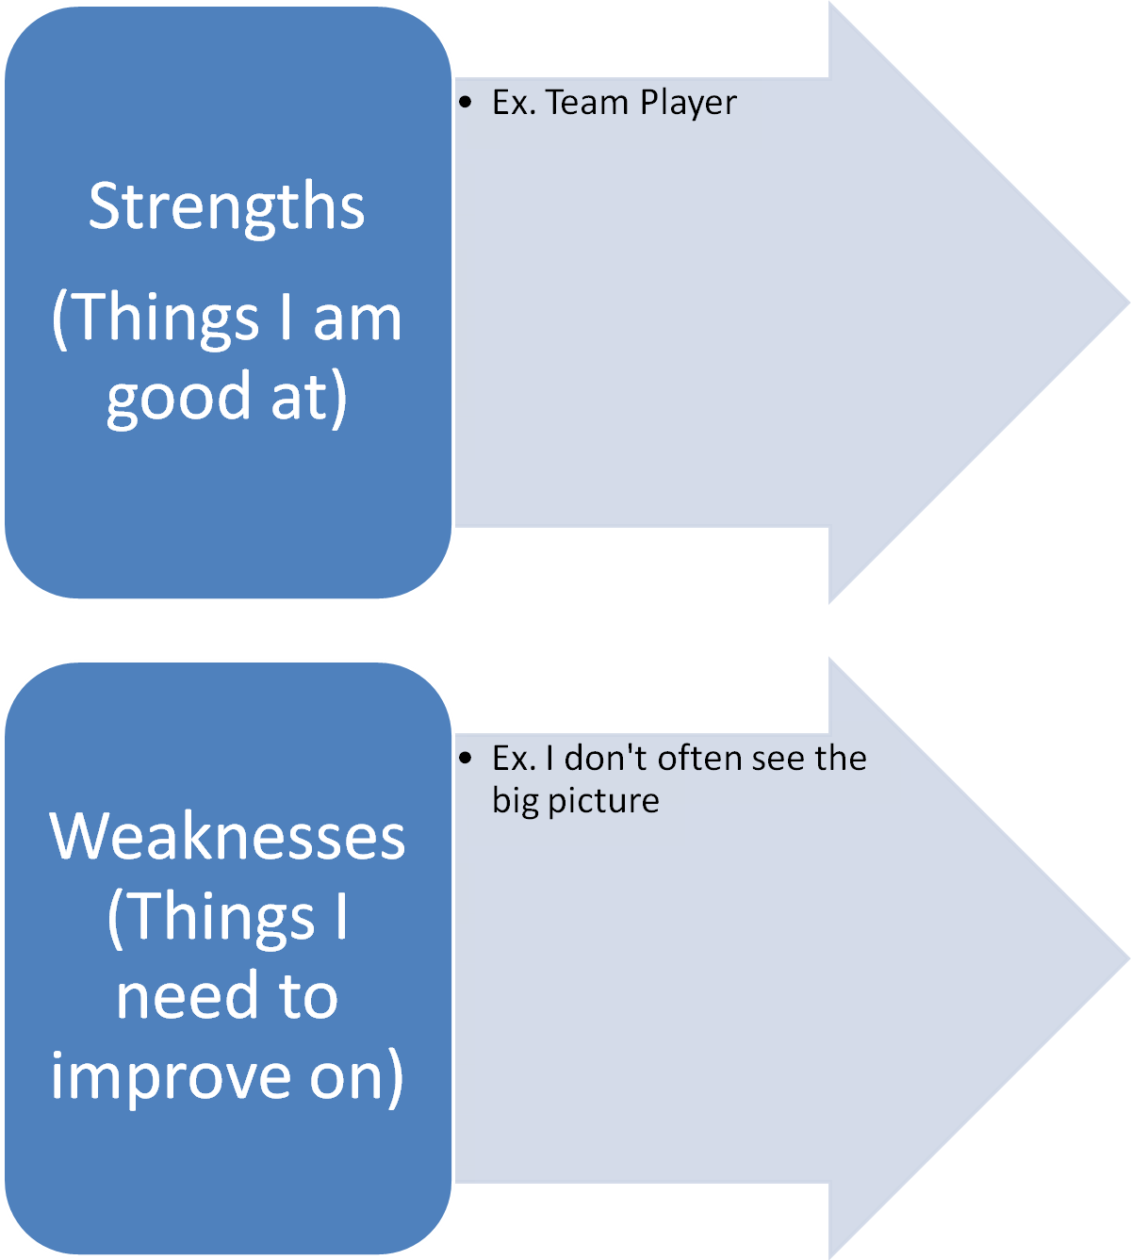

List your strengths one more time in the list below. For each strength, brainstorm at least two ideas for a business that could work for you.

Strength | Business Idea

Go through your business ideas above and strike out any that would not work because of your weaknesses. For example, if your strength is creating hairstyles but you need to improve on listening to others, then you should strike out the idea of a salon. This will be done better with a partner so you can get a second opinion.

Now, you should list below the top 3 business ideas that you came up with that are good for your strengths.

1.

2.

3.

