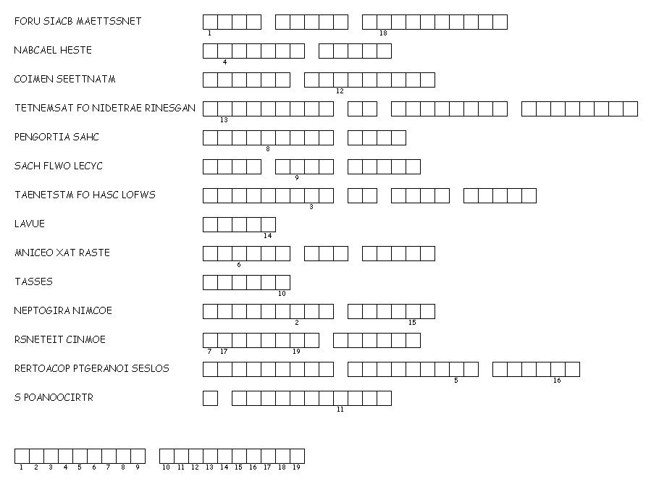
DIRECTIONS FOR TEACHER: Read the definitions of the terms aloud to the students. Students are to guess the correct word for each definition given.

ANSWER KEY:
FOUR BASIC STATEMENTS
BALANCE SHEET
INCOME STATEMENT
STATEMENT OF RETAINED EARNINGS
OPERATING CASH
CASH FLOW CYCLE
STATEMENT OF CASH FLOWS
VALUE
INCOME TAX RATES
ASSETS
OPERATING INCOME
INTEREST INCOME
CORPORATE OPERATING LOSSES
S CORPORATION

OVERALL PUZZLE ANSWER AT THE BOTTOM OF THE PAGE FOR NUMBERS 1-19

FINANCIAL STATEMENTS

