ETHNOCENTRIC HUMAN RESOURCE MANAGEMENT

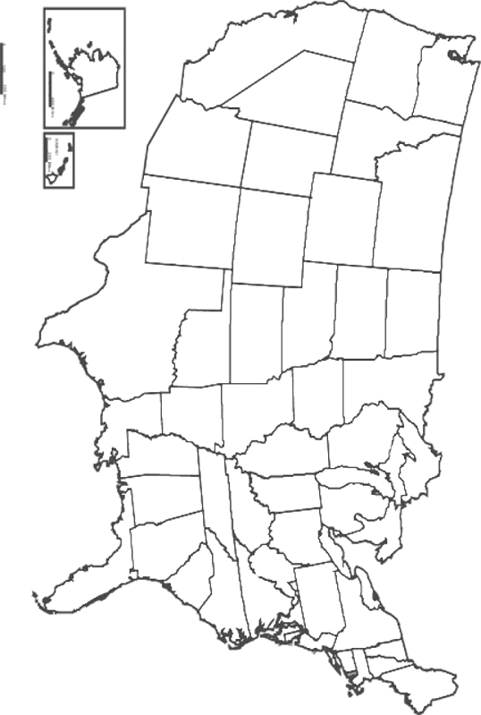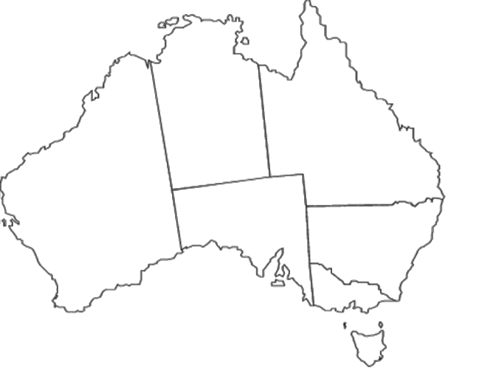
United States Australia

REGIOCENTRIC HUMAN RESOURCE MANAGEMENT
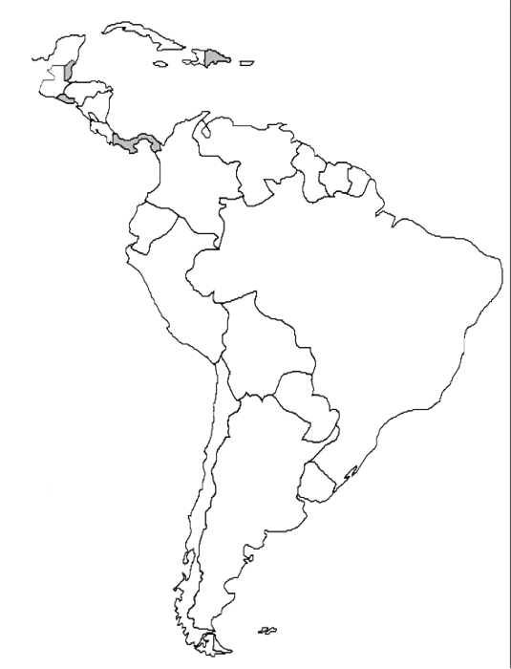
United States Latin America

POLYCENTRIC HUMAN RESOUCE MANAGEMENT

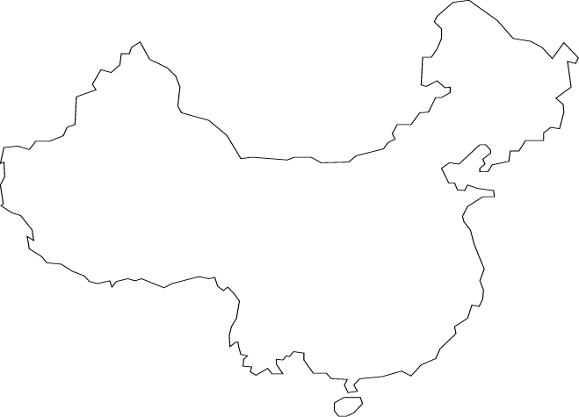
United States China

GEOCENTRIC HUMAN RESOURCE MANAGEMENT

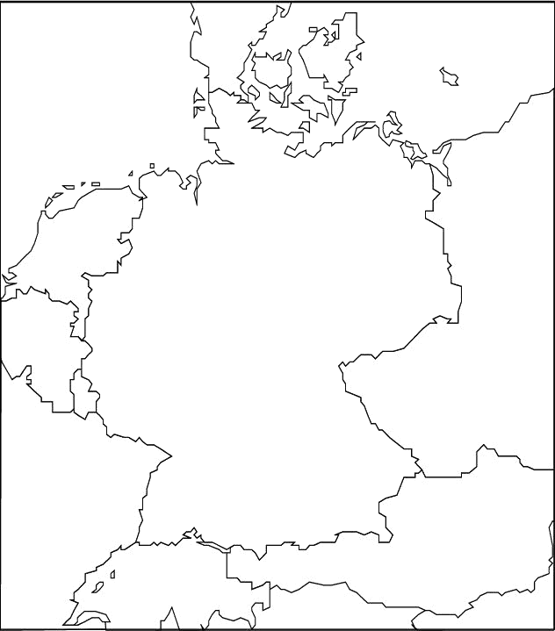
United States Germany

